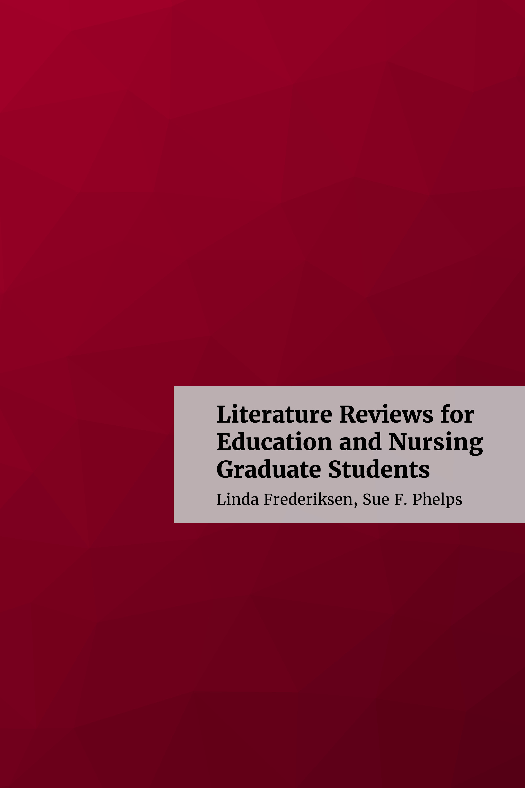

Literature Reviews for Education and Nursing Graduate Students

Literature Reviews for Education and Nursing Graduate Students

Linda Frederiksen, Sue F. Phelps

Literature Reviews for Education and Nursing Graduate Students by Linda Frederiksen is licensed under a Creative Commons Attribution 4.0 International License, except where otherwise noted.

Contents
- Preface
- Chapter 1: Introduction
- Chapter 2: What is a Literature Review?
- Chapter 3: How to Get Started
- Chapter 4: Where to Find the Literature
- Chapter 5: Evaluating Sources
- Chapter 6: Documenting Sources
- Chapter 7: Synthesizing Sources
- Chapter 8: Writing the Literature Review
- Conclusion
- Appendix
- References (By Chapter)
- Image Attributions (By Chapter)
- About the Authors
- Accessibility Assessment
- Review Statement
- Version History

Preface
Congratulations! You applied and were accepted into a graduate-level program at [fill in the blank] university. In your first research methods class, your assignment is to do a comprehensive literature review on a topic of your choice. It sounds easy enough – just find a few articles related to your topic and summarize, right? You probably did this type of annotated bibliography as an undergraduate and are pretty optimistic about doing another one. As the professor and other classmates talk more about the demands and expectations for this literature review, however, you may begin to feel less confident. If it’s any consolation, you are not alone.
Writing a literature review involves a synthesis of a complex range of analytical and rhetorical skills as well as academic writing skills, and an understanding of what is meant by critical analysis and argument.(Turner & Bitchener, 2008).
At the same time, there is often a disconnect between what faculty expect in terms of research and writing skills and what incoming graduate students understand about how to conduct a literature review. At the graduate level, and especially when preparing a thesis or dissertation, the literature review is a high-stakes document that introduces the novice researcher to the scholarly conversation of his/her discipline for the first time. Students are often surprised that the specific research and writing skills needed to do a graduate-level literature review aren’t taught in class, while faculty may assume students already have these skills (Harris, 2011). As a result, “most graduate students receive little or no formal training in how to analyze and synthesize the research literature in their field” (Boote & Beile, 2005, p. 5). It is for these students that we write this book.
Literature Reviews for Education and Nursing Graduate Students introduces you to the components of the stand-alone literature review and prepares you to write one of your own. This open textbook is designed to help students in graduate-level nursing and education programs recognize the significant role the literature review plays in the research process and synthesize and cite key sources with confidence. Although specific examples are generally nursing or education related, most of the content is also applicable to other students in the social sciences. Likewise, this textbook is openly licensed, meaning it is available at no cost to anyone in the world who would like to use it. Instructors (and others) may freely edit or modify it and assign as much or as little as needed.
Literature Reviews for Education and Nursing Graduate Students is written for new graduate students and novice researchers just entering the work of their chosen discipline. It is meant to assist “students who can complete course assignments to scholars who can make a contribution to their respective fields.” (Switzer & Perdue, 2011, p. 12). The book was written by two librarians with expertise guiding nursing and education graduate students through the literature review research and writing process. We include in the book examples from the literature of nursing and education to facilitate a greater understanding of what it means to be a successful graduate student. Our intent is to promote the idea that the literature review is a dynamic and complex synthesis of research and writing that is quite different than an annotated bibliography.
Literature Reviews for Education and Nursing Graduate Students covers topics related to literature review research and writing. Chapter 1 provides an overview of literature reviews and their purpose. Chapters 2 and 3 relate to getting started with the review, including how to develop a research question or hypothesis. Chapters 4 and 5 deal with the research process, that is, where to find relevant sources and how to evaluate their credibility. Chapters 6 and 7 discuss how to document sources and, one of the most difficult tasks novice researchers face, how to synthesize information. Chapter 8 is focused on writing your own literature review. A short conclusion and an answer key to questions asked in previous chapters complete the text. Each chapter begins with a summary of learning objectives for that chapter and concludes with a set of questions to assess your understanding of the topics covered. Examples, tutorials, videos, additional resources, websites and/or activities are provided. Finally, at the end of each chapter you will find a list of works cited as well as image attributions.
Although this textbook does not contain all of the answers you will need to successfully write a literature review, the authors hope that when used in combination with all of the other experiences you will have as a graduate student, it will help you to become the researcher and scholar you want to be.

References
Boote, D.N., & Beile, P. (2005). Scholars before researchers: On the centrality of the dissertation literature review in research preparation. Educational Researcher 34(6), 3-15.
Harris, C.S. (2011). The case for partnering doctoral students with librarians: A synthesis of the literatures. Library Review 60(7), 599-620.
Switzer, A., & Perdue, A.S. (2011). Dissertation 101: A research and writing intervention for education graduate students. Education Libraries 34(1), 4-14.
Turner, E., & Bitchener, J. (2008). An approach to teaching the writing of literature reviews. Zeitschrift Schreiben. https://zeitschrift-schreiben.eu/globalassets/zeitschrift-schreiben.eu/2008/turner_approach_teaching.pdf

Chapter 1

Chapter 1: Introduction

Learning Objectives
At the conclusion of this chapter, you will be able to:
- Identify the purpose of the literature review in the research process
- Distinguish between different types of literature reviews

1.1 What is a Literature Review?
Pick up nearly any book on research methods and you will find a description of a literature review. At a basic level, the term implies a survey of factual or nonfiction books, articles, and other documents published on a particular subject. Definitions may be similar across the disciplines, with new types and definitions continuing to emerge. Generally speaking, a literature review is a:
- “comprehensive background of the literature within the interested topic area…” (O’Gorman & MacIntosh, 2015, p. 31).
- “critical component of the research process that provides an in-depth analysis of recently published research findings in specifically identified areas of interest.” (House, 2018, p. 109).
- “written document that presents a logically argued case founded on a comprehensive understanding of the current state of knowledge about a topic of study” (Machi & McEvoy, 2012, p. 4).
As a foundation for knowledge advancement in every discipline, it is an important element of any research project. At the graduate or doctoral level, the literature review is an essential feature of thesis and dissertation, as well as grant proposal writing. That is to say, “A substantive, thorough, sophisticated literature review is a precondition for doing substantive, thorough, sophisticated research…A researcher cannot perform significant research without first understanding the literature in the field.” (Boote & Beile, 2005, p. 3). It is by this means, that a researcher demonstrates familiarity with a body of knowledge and thereby establishes credibility with a reader. An advanced-level literature review shows how prior research is linked to a new project, summarizing and synthesizing what is known while identifying gaps in the knowledge base, facilitating theory development, closing areas where enough research already exists, and uncovering areas where more research is needed. (Webster & Watson, 2002, p. xiii)
A graduate-level literature review is a compilation of the most significant previously published research on your topic. Unlike an annotated bibliography or a research paper you may have written as an undergraduate, your literature review will outline, evaluate and synthesize relevant research and relate those sources to your own thesis or research question. It is much more than a summary of all the related literature.
It is a type of writing that demonstrate the importance of your research by defining the main ideas and the relationship between them. A good literature review lays the foundation for the importance of your stated problem and research question.
Literature reviews:
- define a concept
- map the research terrain or scope
- systemize relationships between concepts
- identify gaps in the literature (Rocco & Plathotnik, 2009, p. 128)
The purpose of a literature review is to demonstrate that your research question is meaningful. Additionally, you may review the literature of different disciplines to find deeper meaning and understanding of your topic. It is especially important to consider other disciplines when you do not find much on your topic in one discipline. You will need to search the cognate literature before claiming there is “little previous research” on your topic.
Well developed literature reviews involve numerous steps and activities. The literature review is an iterative process because you will do at least two of them: a preliminary search to learn what has been published in your area and whether there is sufficient support in the literature for moving ahead with your subject. After this first exploration, you will conduct a deeper dive into the literature to learn everything you can about the topic and its related issues.

Literature Review Tutorial



This video is licensed under a CC BY-NC-SA 3.0 by NCSU Libraries.
.

1.2 Literature Review Basics
An effective literature review must:
- Methodologically analyze and synthesize quality literature on a topic
- Provide a firm foundation to a topic or research area
- Provide a firm foundation for the selection of a research methodology
- Demonstrate that the proposed research contributes something new to the overall body of knowledge of advances the research field’s knowledge base. (Levy & Ellis, 2006).
All literature reviews, whether they are qualitative, quantitative or both, will at some point:
- Introduce the topic and define its key terms
- Establish the importance of the topic
- Provide an overview of the amount of available literature and its types (for example: theoretical, statistical, speculative)
- Identify gaps in the literature
- Point out consistent finding across studies
- Arrive at a synthesis that organizes what is known about a topic
- Discusses possible implications and directions for future research

1.3 Types of Literature Reviews
There are many different types of literature reviews, however there are some shared characteristics or features. Remember a comprehensive literature review is, at its most fundamental level, an original work based on an extensive critical examination and synthesis of the relevant literature on a topic. As a study of the research on a particular topic, it is arranged by key themes or findings, which may lead up to or link to the research question. In some cases, the research question will drive the type of literature review that is undertaken.
The following section includes brief descriptions of the terms used to describe different literature review types with examples of each. The included citations are open access, Creative Commons licensed or copyright-restricted.

1.3.1 Types of Review

1.3.1.1 Conceptual
Guided by an understanding of basic issues rather than a research methodology. You are looking for key factors, concepts or variables and the presumed relationship between them. The goal of the conceptual literature review is to categorize and describe concepts relevant to your study or topic and outline a relationship between them. You will include relevant theory and empirical research.
Examples of a Conceptual Review:
- Education: The formality of learning science in everyday life: A conceptual literature review. (Dohn, 2010).
- Education: Are we asking the right questions? A conceptual review of the educational development literature in higher education. (Amundsen & Wilson, 2012).

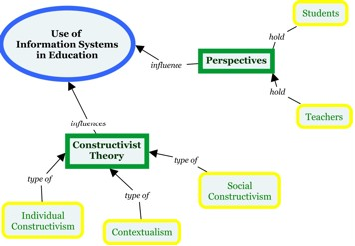

1.3.1.2 Empirical
An empirical literature review collects, creates, arranges, and analyzes numeric data reflecting the frequency of themes, topics, authors and/or methods found in existing literature. Empirical literature reviews present their summaries in quantifiable terms using descriptive and inferential statistics.
Examples of an Empirical Review:
- Nursing: False-positive findings in Cochrane meta-analyses with and without application of trial sequential analysis: An empirical review. (Imberger, Thorlund, Gluud, & Wettersley, 2016).
- Education: Impediments of e-learning adoption in higher learning institutions of Tanzania: An empirical review (Mwakyusa & Mwalyagile, 2016).

1.3.1.3 Exploratory
Unlike a synoptic literature review, the purpose here is to provide a broad approach to the topic area. The aim is breadth rather than depth and to get a general feel for the size of the topic area. A graduate student might do an exploratory review of the literature before beginning a synoptic, or more comprehensive one.
Examples of an Exploratory Review:
- Education: University research management: An exploratory literature review. (Schuetzenmeister, 2010).
- Education: An exploratory review of design principles in constructivist gaming learning environments. (Rosario & Widmeyer, 2009).



1.3.1.4 Focused
A type of literature review limited to a single aspect of previous research, such as methodology. A focused literature review generally will describe the implications of choosing a particular element of past research, such as methodology in terms of data collection, analysis and interpretation.
Examples of a Focused Review:
- Nursing: Clinical inertia in the management of type 2 diabetes mellitus: A focused literature review. (Khunti, Davies, & Khunti, 2015).
- Education: Language awareness: Genre awareness-a focused review of the literature. (Stainton, 1992).

1.3.1.5 Integrative
Critiques past research and draws overall conclusions from the body of literature at a specified point in time. Reviews, critiques, and synthesizes representative literature on a topic in an integrated way. Most integrative reviews are intended to address mature topics or emerging topics. May require the author to adopt a guiding theory, a set of competing models, or a point of view about a topic. For more description of integrative reviews, see Whittemore & Knafl (2005).
Examples of an Integrative Review:
- Nursing: Interprofessional teamwork and collaboration between community health workers and healthcare teams: An integrative review. (Franklin, Bernhardt, Lopez, Long-Middleton, & Davis, 2015).
- Education: Exploring the gap between teacher certification and permanent employment in Ontario: An integrative literature review. (Brock & Ryan, 2016).

1.3.1.6 Meta-analysis
A subset of a systematic review, that takes findings from several studies on the same subject and analyzes them using standardized statistical procedures to pool together data. Integrates findings from a large body of quantitative findings to enhance understanding, draw conclusions, and detect patterns and relationships. Gather data from many different, independent studies that look at the same research question and assess similar outcome measures. Data is combined and re-analyzed, providing a greater statistical power than any single study alone. It’s important to note that not every systematic review includes a meta-analysis but a meta-analysis can’t exist without a systematic review of the literature.
Examples of a Meta-Analysis:
- Education: Efficacy of the cooperative learning method on mathematics achievement and attitude: A meta-analysis research. (Capar & Tarim, 2015).
- Nursing: A meta-analysis of the effects of non-traditional teaching methods on the critical thinking abilities of nursing students. (Lee, Lee, Gong, Bae, & Choi, 2016).
- Education: Gender differences in student attitudes toward science: A meta-analysis of the literature from 1970 to 1991. (Weinburgh, 1995).

1.3.1.7 Narrative/Traditional
An overview of research on a particular topic that critiques and summarizes a body of literature. Typically broad in focus. Relevant past research is selected and synthesized into a coherent discussion. Methodologies, findings and limits of the existing body of knowledge are discussed in narrative form. Sometimes also referred to as a traditional literature review. Requires a sufficiently focused research question. The process may be subject to bias that supports the researcher’s own work.
Examples of a Narrative/Traditional Review:
- Nursing: Family carers providing support to a person dying in the home setting: A narrative literature review. (Morris, King, Turner, & Payne, 2015).
- Education: Adventure education and Outward Bound: Out-of-class experiences that make a lasting difference. (Hattie, Marsh, Neill, & Richards, 1997).
- Education: Good quality discussion is necessary but not sufficient in asynchronous tuition: A brief narrative review of the literature. (Fear & Erikson-Brown, 2014).
- Nursing: Outcomes of physician job satisfaction: A narrative review, implications, and directions for future research. (Williams & Skinner, 2003).

1.3.1.8 Realist
Aspecific type of literature review that is theory-driven and interpretative and is intended to explain the outcomes of a complex intervention program(s).
Examples of a Realist Review:
- Nursing: Lean thinking in healthcare: A realist review of the literature. (Mazzacato, Savage, Brommels, 2010).
- Education: Unravelling quality culture in higher education: A realist review. (Bendermacher, Egbrink, Wolfhagen, & Dolmans, 2017).

1.3.1.9 Scoping
Tend to be non-systematic and focus on breadth of coverage conducted on a topic rather than depth. Utilize a wide range of materials; may not evaluate the quality of the studies as much as count the number. One means of understanding existing literature. Aims to identify nature and extent of research; preliminary assessment of size and scope of available research on topic. May include research in progress.
Examples of a Scoping Review:
- Nursing: Organizational interventions improving access to community-based primary health care for vulnerable populations: A scoping review. (Khanassov, Pluye, Descoteaux, Haggerty, Russell, Gunn, & Levesque, 2016).
- Education: Interdisciplinary doctoral research supervision: A scoping review. (Vanstone, Hibbert, Kinsella, McKenzie, Pitman, & Lingard, 2013).
- Nursing: A scoping review of the literature on the abolition of user fees in health care services in Africa. (Ridde, & Morestin, 2011).

1.3.1.10 Synoptic
Unlike an exploratory review, the purpose is to provide a concise but accurate overview of all material that appears to be relevant to a chosen topic. Both content and methodological material is included. The review should aim to be both descriptive and evaluative. Summarizes previous studies while also showing how the body of literature could be extended and improved in terms of content and method by identifying gaps.
Examples of a Synoptic Review:
- Education: Theoretical framework for educational assessment: A synoptic review. (Ghaicha, 2016).
- Education: School effects research: A synoptic review of past efforts and some suggestions for the future. (Cuttance, 1981).

1.3.1.11 Systematic Review
A rigorous review that follows a strict methodology designed with a presupposed selection of literature reviewed. Undertaken to clarify the state of existing research, the evidence, and possible implications that can be drawn from that. Using comprehensive and exhaustive searching of the published and unpublished literature, searching various databases, reports, and grey literature. Transparent and reproducible in reporting details of time frame, search and methods to minimize bias. Must include a team of at least 2-3 and includes the critical appraisal of the literature. For more description of systematic reviews, including links to protocols, checklists, workflow processes, and structure see “A Young Researcher’s Guide to a Systematic Review“.
Examples of a Systematic Review:
- Education: The potentials of using cloud computing in schools: A systematic literature review (Hartmann, Braae, Pedersen, & Khalid, 2017)
- Nursing: Is butter back? A systematic review and meta-analysis of butter consumption and risk of cardiovascular disease, diabetes, and total mortality. (Pimpin, Wu, Haskelberg, Del Gobbo, & Mozaffarian, 2016).
- Education: The use of research to improve professional practice: a systematic review of the literature. (Hemsley-Brown & Sharp, 2003).
- Nursing: Using computers to self-manage type 2 diabetes. (Pal, Eastwood, Michie, Farmer, Barnard, Peacock, Wood, Inniss, & Murray, 2013).

1.3.1.12 Umbrella/Overview of Reviews
Compiles evidence from multiple systematic reviews into one document. Focuses on broad condition or problem for which there are competing interventions and highlights reviews that address those interventions and their effects. Often used in recommendations for practice.
Examples of an Umbrella/Overview Review:
- Education: Reflective practice in healthcare education: An umbrella review. (Fragknos, 2016).
- Nursing: Systematic reviews of psychosocial interventions for autism: an umbrella review. (Seida, Ospina, Karkhaneh, Hartling, Smith, & Clark, 2009).
For a brief discussion see “Not all literature reviews are the same” (Thomson, 2013).

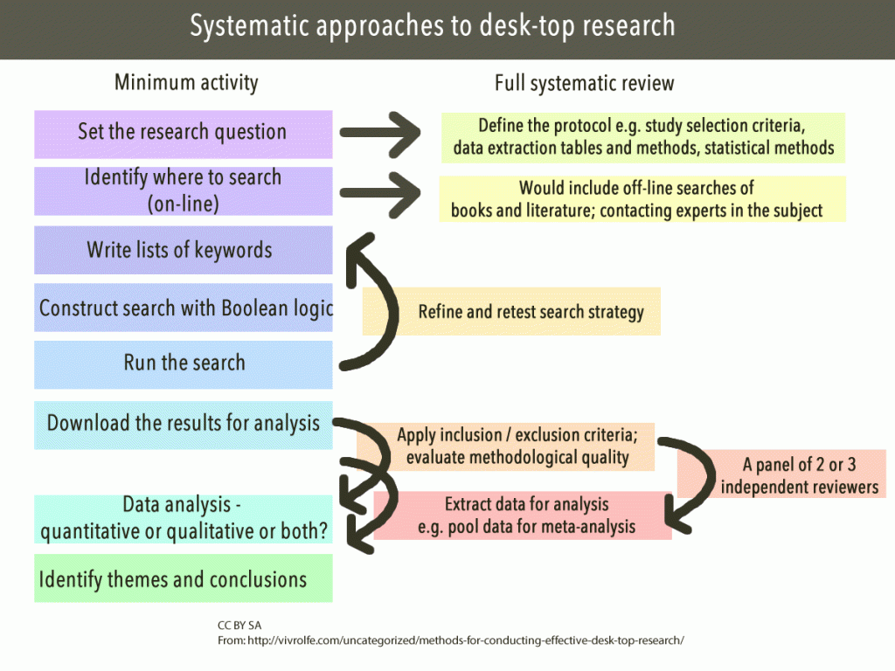

1.4 Why do a Literature Review?
The purpose of the literature review is the same regardless of the topic or research method. It tests your own research question against what is already known about the subject.

1.4.1 First – It’s part of the whole. Omission of a literature review chapter or section in a graduate-level project represents a serious void or absence of critical element in the research process.
The outcome of your review is expected to demonstrate that you:
- can systematically explore the research in your topic area
- can read and critically analyze the literature in your discipline and then use it appropriately to advance your own work
- have sufficient knowledge in the topic to undertake further investigation

1.4.2 Second – It’s good for you!
- You improve your skills as a researcher
- You become familiar with the discourse of your discipline and learn how to be a scholar in your field
- You learn through writing your ideas and finding your voice in your subject area
- You define, redefine and clarify your research question for yourself in the process

1.4.3 Third – It’s good for your reader. Your reader expects you to have done the hard work of gathering, evaluating and synthesizes the literature. When you do a literature review you:
- Set the context for the topic and present its significance
- Identify what’s important to know about your topic – including individual material, prior research, publications, organizations and authors.
- Demonstrate relationships among prior research
- Establish limitations of existing knowledge
- Analyze trends in the topic’s treatment and gaps in the literature

1.4.4 Why do a literature review?
- To locate gaps in the literature of your discipline
- To avoid reinventing the wheel
- To carry on where others have already been
- To identify other people working in the same field
- To increase your breadth of knowledge in your subject area
- To find the seminal works in your field
- To provide intellectual context for your own work
- To acknowledge opposing viewpoints
- To put your work in perspective
- To demonstrate you can discover and retrieve previous work in the area

1.5 Common Literature Review Errors
Graduate-level literature reviews are more than a summary of the publications you find on a topic. As you have seen in this brief introduction, literature reviews are a very specific type of research, analysis, and writing. We will explore these topics more in the next chapters. Some things to keep in mind as you begin your own research and writing are ways to avoid the most common errors seen in the first attempt at a literature review. For a quick review of some of the pitfalls and challenges a new researcher faces when he/she begins work, see “Get Ready: Academic Writing, General Pitfalls and (oh yes) Getting Started!”.
As you begin your own graduate-level literature review, try to avoid these common mistakes:
- Accepts another researcher’s finding as valid without evaluating methodology and data
- Contrary findings and alternative interpretations are not considered or mentioned
- Findings are not clearly related to one’s own study, or findings are too general
- Insufficient time allowed to define best search strategies and writing
- Isolated statistical results are simply reported rather than synthesizing the results
- Problems with selecting and using most relevant keywords, subject headings and descriptors
- Relies too heavily on secondary sources
- Search methods are not recorded or reported for transparency
- Summarizes rather than synthesizes articles
In conclusion, the purpose of a literature review is three-fold:
- to survey the current state of knowledge or evidence in the area of inquiry,
- to identify key authors, articles, theories, and findings in that area, and
- to identify gaps in knowledge in that research area.
A literature review is commonly done today using computerized keyword searches in online databases, often working with a trained librarian or information expert. Keywords can be combined using the Boolean operators, “and”, “or” and sometimes “not” to narrow down or expand the search results. Once a list of articles is generated from the keyword and subject heading search, the researcher must then manually browse through each title and abstract, to determine the suitability of that article before a full-text article is obtained for the research question.
Literature reviews should be reasonably complete, and not restricted to a few journals, a few years, or a specific methodology or research design. Reviewed articles may be summarized in the form of tables, and can be further structured using organizing frameworks such as a concept matrix.
A well-conducted literature review should indicate whether the initial research questions have already been addressed in the literature, whether there are newer or more interesting research questions available, and whether the original research questions should be modified or changed in light of findings of the literature review.
The review can also provide some intuitions or potential answers to the questions of interest and/or help identify theories that have previously been used to address similar questions and may provide evidence to inform policy or decision-making. (Bhattacherjee, 2012).



Practice
Read Abstract 1. Refer to Types of Literature Reviews. What type of literature review do you think this study is and why? See the Answer Key for the correct response.
Nursing: To describe evidence of international literature on the safe care of the hospitalised child after the World Alliance for Patient Safety and list contributions of the general theoretical framework of patient safety for paediatric nursing.
An integrative literature review between 2004 and 2015 using the databases PubMed, Cumulative Index of Nursing and Allied Health Literature (CINAHL), Scopus, Web of Science and Wiley Online Library, and the descriptors Safety or Patient safety, Hospitalised child, Paediatric nursing, and Nursing care.
Thirty-two articles were analysed, most of which were from North American, with a descriptive approach. The quality of the recorded information in the medical records, the use of checklists, and the training of health workers contribute to safe care in paediatric nursing and improve the medication process and partnerships with parents.
General information available on patient safety should be incorporated in paediatric nursing care. (Wegner, Silva, Peres, Bandeira, Frantz, Botene, & Predebon, 2017).
Read Abstract 2. Refer to Types of Literature Reviews. What type of lit review do you think this study is and why? See the Answer Key for the correct response.
Education: The focus of this paper centers around timing associated with early childhood education programs and interventions using meta-analytic methods. At any given assessment age, a child’s current age equals starting age, plus duration of program, plus years since program ended. Variability in assessment ages across the studies should enable everyone to identify the separate effects of all three time-related components. The project is a meta-analysis of evaluation studies of early childhood education programs conducted in the United States and its territories between 1960 and 2007. The population of interest is children enrolled in early childhood education programs between the ages of 0 and 5 and their control-group counterparts. Since the data come from a meta-analysis, the population for this study is drawn from many different studies with diverse samples. Given the preliminary nature of their analysis, the authors cannot offer conclusions at this point. (Duncan, Leak, Li, Magnuson, Schindler, & Yoshikawa, 2011).

Test Yourself
See Answer Key for the correct responses.

Question 1
The purpose of a graduate-level literature review is to summarize in as many words as possible everything that is known about my topic.
- True
- False

Question 2
A literature review is significant because in the process of doing one, the researcher learns to read and critically assess the literature of a discipline and then uses it appropriately to advance his/her own research.
- True
- False

Question 3
Read the following abstract and choose the correct type of literature review it represents.
Nursing: E-cigarette use has become increasingly popular, especially among the young. Its long-term influence upon health is unknown. Aim of this review has been to present the current state of knowledge about the impact of e-cigarette use on health, with an emphasis on Central and Eastern Europe. During the preparation of this narrative review, the literature on e-cigarettes available within the network PubMed was retrieved and examined. In the final review, 64 research papers were included. We specifically assessed the construction and operation of the e-cigarette as well as the chemical composition of the e-liquid; the impact that vapor arising from the use of e-cigarette explored in experimental models in vitro; and short-term effects of use of e-cigarettes on users’ health. Among the substances inhaled by the e-smoker, there are several harmful products, such as: formaldehyde, acetaldehyde, acroleine, propanal, nicotine, acetone, o-methyl-benzaldehyde, carcinogenic nitrosamines. Results from experimental animal studies indicate the negative impact of e-cigarette exposure on test models, such as ascytotoxicity, oxidative stress, inflammation, airway hyper reactivity, airway remodeling, mucin production, apoptosis, and emphysematous changes. The short-term impact of e-cigarettes on human health has been studied mostly in experimental setting. Available evidence shows that the use of e-cigarettes may result in acute lung function responses (e.g., increase in impedance, peripheral airway flow resistance) and induce oxidative stress. Based on the current available evidence, e-cigarette use is associated with harmful biologic responses, although it may be less harmful than traditional cigarettes. (Jankowski, Brożek, Lawson, Skoczyński, & Zejda, 2017).
- Meta-analysis
- Exploratory
- Narrative
- Empirical

Question 4
Read the following abstract and choose the correct type of literature review it represents.
Education: In this review, Mary Vorsino writes that she is interested in keeping the potential influences of women pragmatists of Dewey’s day in mind while presenting modern feminist re readings of Dewey. She wishes to construct a narrowly-focused and succinct literature review of thinkers who have donned a feminist lens to analyze Dewey’s approaches to education, learning, and democracy and to employ Dewey’s works in theorizing on gender and education and on gender in society. This article first explores Dewey as both an ally and a problematic figure in feminist literature and then investigates the broader sphere of feminist pragmatism and two central themes within it: (1) valuing diversity, and diverse experiences; and (2) problematizing fixed truths. (Vorsino, 2015).
- Scoping
- Exploratory
- Synoptic
- Focused

References

Image Attributions

Chapter 2

Chapter 2: What is a Literature Review?

Learning Objectives
At the conclusion of this chapter, you will be able to:
- Recognize how information is created and how it evolves over time.
- Identify how the information cycle impacts the reliability of the information.
- Select information sources appropriate to information need.

2.1 Overview of information
Because a literature review is a summary and analysis of the relevant publications on a topic, we first have to understand what is meant by ‘the literature’. In this case, ‘the literature’ is a collection of all of the relevant written sources on a topic. It will include both theoretical and empirical works. Both types provide scope and depth to a literature review.

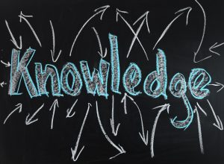

2.1.1 Disciplines of knowledge
When drawing boundaries around an idea, topic, or subject area, it helps to think about how and where the information for the field is produced. For this, you need to identify the disciplines of knowledge production in a subject area.
Information does not exist in the environment like some kind of raw material. It is produced by individuals working within a particular field of knowledge who use specific methods for generating new information. Disciplines are knowledge-producing and -disseminating systems which consume, produce and disseminate knowledge. Looking through a course catalog of a post-secondary educational institution gives clues to the structure of a discipline structure. Fields such as political science, biology, history and mathematics are unique disciplines, as are education and nursing, with their own logic for how and where new knowledge is introduced and made accessible.
You will need to become comfortable with identifying the disciplines that might contribute information to any search strategy. When you do this, you will also learn how to decode the way how people talk about a topic within a discipline. This will be useful to you when you begin a review of the literature in your area of study.
For example, think about the disciplines that might contribute information to a the topic such as the role of sports in society. Try to anticipate the type of perspective each discipline might have on the topic. Consider the following types of questions as you examine what different disciplines might contribute:
- What is important about the topic to the people in that discipline?
- What is most likely to be the focus of their study about the topic?
- What perspective would they be likely to have on the topic?
In this example, we identify two disciplines that have something to say about the role of sports in society: allied health and education. What would each of these disciplines raise as key questions or issues related to that topic?

2.1.1.1 Nursing
- how sports affect individuals’ health and well-being
- assessing and treating sports injuries
- physical conditioning for athletes

2.1.1.2 Education
- how schools privilege or punish student athletes
- how young people are socialized into the ideal of team cooperation
- differences between boys’ and girls’ participation in organized sports
We see that a single topic can be approached from many different perspectives depending on how the disciplinary boundaries are drawn and how the topic is framed. This step of the research process requires you to make some decisions early on to focus the topic on a manageable and appropriate scope for the rest of the strategy. (Hansen & Paul, 2015).
‘The literature’ consists of the published works that document a scholarly conversation in a field of study. You will find, in ‘the literature,’ documents that explain the background of your topic so the reader knows where you found loose ends in the established research of the field and what led you to your own project. Although your own literature review will focus on primary, peer-reviewed resources, it will begin by first grounding yourself in background subject information generally found in secondary and tertiary sources such as books and encyclopedias. Once you have that essential overview, you delve into the seminal literature of the field. As a result, while your literature review may consist of research articles tightly focused on your topic with secondary and tertiary sources used more sparingly, all three types of information (primary, secondary, tertiary) are critical to your research.

2.1.2 Definitions
- Theoretical – discusses a theory, conceptual model or framework for understanding a problem.
- Empirical – applies theory to a behavior or event and reports derived data to findings.
- Seminal – “A classic work of research literature that is more than 5 years old and is marked by its uniqueness and contribution to professional knowledge.” (Houser, 4th ed., 2018, p. 112).
- Practical – “…accounts of how things are done” (Wallace & Wray, 3rd ed., 2016, p. 20). Action research, in Education, refers to a wide variety of methods used to develop practical solutions. (Great Schools Partnership, 2017).
- Policy – generally produced by policy-makers, such as government agencies.
- Primary – published results of original research studies .
- Secondary – interpret, discuss, summarize original sources
- Tertiary – synthesize or distill primary and secondary sources. Examples include: encyclopedias, directories, dictionaries, handbooks, guides, classification, chronology, and other fact books.
- Grey literature – research and information released by non-commercial publishers, such as government agencies, policy organizations, and think-tanks.
‘The literature’ is published in books, journal articles, conference proceedings, theses and dissertations. It can also be found in newspapers, encyclopedias, textbooks, as well as websites and reports written by government agencies and professional organizations. While these formats may contain what we define as ‘the literature’, not all of it will be appropriate for inclusion in your own literature review.
These sources are found through different tools that we will discuss later in this section. Although a discovery tool, such as a database or catalog, may link you to the ‘the literature’ not every tool is appropriate to every literature review. No single source will have all of the information resources you should consult. A comprehensive literature review should include searches in the following:
- Multiple subject and article databases
- Library and other book catalogs
- Grey literature sources

2.2 Information Cycle
To get a better idea of how the literature in a discipline develops, it’s useful to see how the information publication lifecycle works. These distinct stages show how information is created, reviewed, and distributed over time.
Follow the image link to view the full tutorial.
The following chart can be used to guide you in searching literature existing at various stages of the scholarly communication process (freely accessible sources are linked, subscription or subscribed sources are listed but not linked):
Guide to searching for literature at various stages of the scholarly communication process
Steps in the Scholarly Communication Process | Publication Cycle | Access Points
Research and develop idea | Unpublished documents such as lab notebooks, personal correspondence, graphs, charts, grant proposals, and other ‘grey literature’
Present preliminary findings | Preliminary reports: letters to the editor or journals, brief (short) communication submitted to a primary journal | PubMed
Report research | Conference literature: preprints, conference proceedings
 | Research reports: master’s theses, doctoral dissertations, interim or technical reports | Dissertations & Theses
Publish research | Research paper (scholarly journal articles): research papers published in peer-reviewed/refereed journals | PubMed
Popularize research findings | Newspapers, popular magazines, TV news reports, trade publications, web sites | PubMed
Compact and repackage information | Reviews, systematic reviews, guidelines, textbooks, handbooks, yearbooks, encyclopedias | Cochrane Library

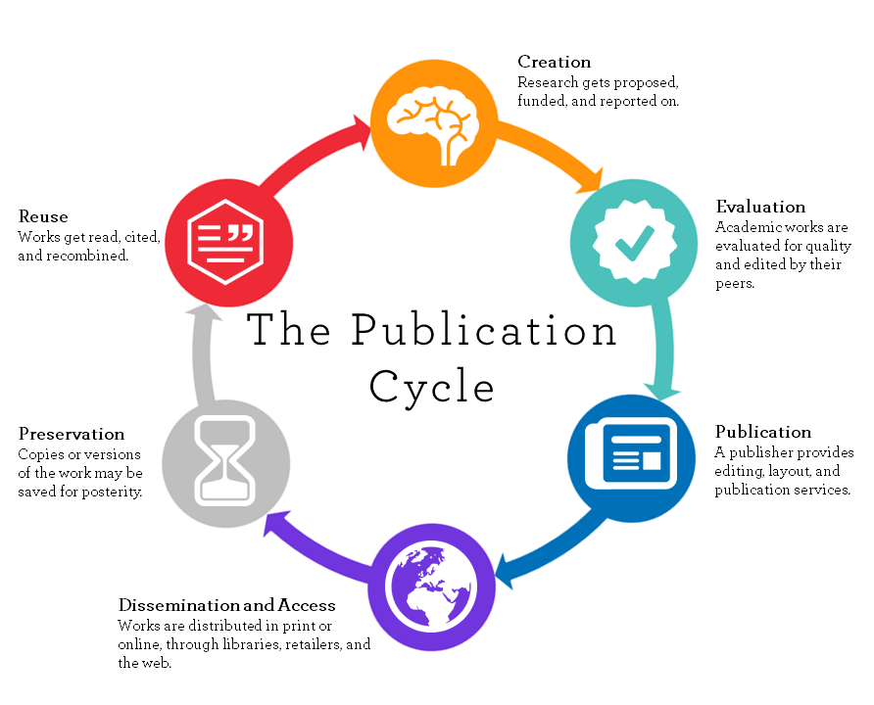

2.3 Information Types
To continue our discussion of information sources, there are two ways published information in the field can be categorized:
- Articles by the type of periodical in which an article it is published, for example, magazine, trade, or scholarly publications.
- Where the material is located in the information cycle, as in primary, secondary, or tertiary information sources.

2.3.1 Popular, Trade, or Scholarly publications

2.3.1.1 Types of Periodicals
Journals, trade publications, and magazines are all periodicals, and articles from these publications they can all look similar article by article when you are searching in the databases. It is good to review the differences and think about when to use information from each type of periodical.

2.3.1.2 Magazines
A magazine is a collection of articles and images about diverse topics of popular interest and current events.
Features of magazines:
- articles are usually written by journalists
- articles are written for the average adult
- articles tend to be short
- articles rarely provides a list of reference sources at the end of the article
- lots of color images and advertisements
- the decision about what goes into the magazine is made by an editor or publisher
- magazines can have broad appeal, like Time and Newsweek, or a narrow focus, like Sports Illustrated and Mother Earth News.
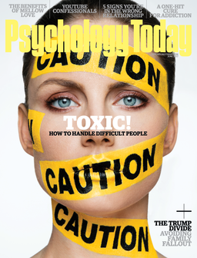
Popular magazines like Psychology Today, Sports Illustrated, and Rolling Stone can be good sources for articles on recent events or pop-culture topics, while Harpers, Scientific American, and The New Republic will offer more in-depth articles on a wider range of subjects. These articles are geared towards readers who, although not experts, are knowledgeable about the issues presented.

2.3.1.3 Trade Publications
Trade publications or trade journals are periodicals directed to members of a specific profession. They often have information about industry trends and practical information for people working in the field.
Features of trade publications:
- Authors are specialists in their fields
- Focused on members of a specific industry or profession
- No peer review process
- Include photographs, illustrations, charts, and graphs, often in color
- Technical vocabulary
Trade publications are geared towards professionals in a discipline. They report news and trends in a field, but not original research. They may provide product or service reviews, job listings, and advertisements.

2.3.1.4 Scholarly, Academic, and Scientific Publications
Scholarly, academic, and scientific publications are a collections of articles written by scholars in an academic or professional field. Most journals are peer-reviewed or refereed, which means a panel of scholars reviews articles to decide if they should be accepted into a specific publication. Journal articles are the main source of information for researchers and for literature reviews.
Features of journals:
- written by scholars and subject experts
- author’ credentials and institution will be identified
- written for other scholars
- dedicated to a specific discipline that it covers in depth
- often report on original or innovative research
- long articles, often 5-15 pages or more
- articles almost always include a list of sources at the end (Works Cited, References, Sources, or Bibliography) that point back to where the information was derived
- no or very few advertisements
- published by organizations or associations to advance their specialized body of knowledge
Scholarly journals provider articles of interest to experts or researchers in a discipline. An editorial board of respected scholars (peers) reviews all articles submitted to a journal. They decide if the article provides a noteworthy contribution to the field and should be published. There are typically few little or no advertisements. Articles published in scholarly journals will include a list of references.

2.3.1.5 A word about open access journals
Increasingly, scholars are publishing findings and original research in open access journals. Open access journals are scholarly and peer-reviewed and open access publishers provide unrestricted access and unrestricted use. Open access is a means of disseminating scholarly research that breaks from the traditional subscription model of academic publishing. It is free of charge to readers and because it is online, it is available at anytime, anywhere in the world, to anyone with access to the internet. The Directory of Open Access Journals (DOAJ) indexes and provides access to high-quality, peer-reviewed scholarly articles.
In summary, newspapers and other popular press publications are useful for getting general topic ideas. Trade publications are useful for practical application in a profession and may also be a good source of keywords for future searching. Scholarly journals are the conversation of the scholars who are doing research in a specific discipline and publishing their research findings.

2.3.1.6 Primary, Secondary, and Tertiary Sources
Primary sources of information are those types of information that come first. Some examples of primary sources are:
- original research, like data from an experiment with plankton.
- diaries, journals, photographs
- data from the census bureau or a survey you have done
- original documents, like the constitution or a birth certificate
- newspapers are primary sources when they report current events or current opinion
- speeches, interviews, email, letters
- religious books
- personal memoirs and autobiographies
- art work
- pottery or weavings
There are different types of primary sources for different disciplines. In the discipline of history, for example, a diary or transcript of a speech is a primary source. In education and nursing, primary sources will generally be original research, including data sets.
Secondary sources are written about primary sources to interpret or analyze them. They are a step or more removed from the primary event or item. Some examples of secondary sources are:
- commentaries on speeches
- critiques of plays, journalism, or books
- a journal article that talks about a primary source such as an interpretation of Steinbeck’s The Grapes of Wrath, or the flower symbolism of Monet’s water garden paintings
- textbooks (can also be considered tertiary)
- biographies
- encyclopedias
- websites
Tertiary sources are further removed from the original material and are a distillation and collection of primary and secondary sources. Some examples are:
- bibliography of critical works about an author
- textbooks (also considered secondary)
- factbooks
- guidebooks
- manuals
A comparison of information sources across disciplines:
SUBJECT | PRIMARY | SECONDARY | TERTIARY
Education | Journal article reporting on quantitative study of after school programs | Article in Teacher Magazine about after school programs | Handbook of afterschool programming ERIC database
Nursing | Journal article reporting on a Cclinical trial of a treatment or device | Cochrane Database of Systematic Reviews | Encyclopedia of Nursing Research
Psychology | Patient notes taken by clinical psychologist | Magazine article about the patient’s psychological condition | Textbook on clinical psychology

2.4 Information Sources
In this section, we discuss how to find not only information, but the sources of information in your discipline or topic area. As we see in the graphic and chart above, the information you need for your literature review will be located in multiple places. How and where research and publication occurs drives how and where the information is located, which in turn determines how you will discover and retrieve it. When we talk about information sources for a literature review in education or nursing, we generally mean these five areas: the internet, reference material and other books, empirical or evidence-based articles in scholarly, peer-reviewed journals, conference proceedings and papers, dissertations and theses, and grey literature.

2.4.1 Web
The World Wide Web can be an excellent place to satisfy some initial research needs.
- It is a good resource for background information and for finding keywords for searching in the library catalog and databases.
- It is a good tool for locating professional organizations and searching for information and the names of experts in a given discipline.
- Google Scholar is a useful discovery tool for citations, especially if you are trying to get the lay of the land surrounding your topic or if you are having a problem with keywords in the databases. You can find some information to refine your search terms. It is NOT acceptable to depend on Google Scholar for finding articles because of the spotty coverage and lack of adequate search features.

2.4.2 Books and Reference Sources
Reference materials and books are available in both print and electronic formats. They provide gateway knowledge to a subject area and are useful at the beginning of the research process to:
- Get an overview of the topic, learn the scope, key definitions, significant figures who are involved, and important timelines
- Discover the foundations of a topic
- Learn essential definitions, vocabulary terms, and keywords you can use in your literature searching strategy

2.4.3 Scholarly Articles in Journals
Another major category of information sources is scholarly information produced by subject experts working in academic institutions, research centers and scholarly organizations. Scholars and researchers generate information that advances our knowledge and understanding of the world. The research they do creates new opportunities for inventions, practical applications, and new approaches to solving problems or understanding issues.
Academics, researchers and students at universities make their contributions to scholarly knowledge available in many forms:
- masters’ theses
- doctoral dissertations
- conference papers
- journal articles and books
- individual scholars’ web pages
- web pages developed by the researcher’s’ home institution (Hansen & Paul, 2015).
Scholars and researchers introduce their discoveries to the world in a formal system of information dissemination that has developed over centuries. Because scholarly research undergoes a process of “peer review” before being published (meaning that other experts review the work and pass judgment about whether it is worthy of publication), the information you find from scholarly sources meets preset standards for accuracy, credibility and validity in that field.
Likewise, scholarly journal articles are generally considered to be among the most reliable sources of information because they have gone through a peer-review process.

2.4.5 Conference Papers & Proceedings
Conferences are a major source of emerging research where researchers present papers on their current research and obtain feedback from the audience. The papers presented in the conference are then usually published in a volume called a conference proceeding. Conference proceedings highlight current discussion in a discipline and can lead you to scholars who are interested in specific research areas.
A word about conference papers: several factors contribute to making these documents difficult to find. It may be months before a paper is published as a journal article, or it may never be published. Publishers and professional associations are inconsistent in how they publish proceedings. For example, the papers from an annual conference may be published as individual, stand-alone titles, which may be indexed in a library catalog, or the conference proceedings may be treated more like a periodical or serial and, therefore, indexed in a journal database.
It is not unusual that papers delivered at professional conferences are not published in print or electronic form, although an abstract may be available. In these cases, the full paper may only be available from the author or authors.
The most important thing to remember is that if you have any difficulty finding a conference proceeding or paper, ask a librarian for assistance.

2.4.6 Dissertations and Theses
Dissertations and theses can be rich sources of information and have extensive reference lists to scan for resources. They are considered gray literature, so are not “peer reviewed”. The accuracy and validity of the paper itself may depend on the school that awarded the doctoral or master’s degree to the author.

2.5 Conclusion
In thinking about ‘the literature’ of your discipline, you are beginning the first step in writing your own literature review. By understanding what the literature in your field is, as well as how and when it is generated, you begin to know what is available and where to look for it.
We briefly discussed seven types of (sometimes overlapping) information:
- information found on the web
- information found in reference books and monographs
- information found in scholarly journals
- information found in conference proceedings and papers
- information found in dissertations and theses
- information found in magazines and trade journals
- information that is primary, secondary, or tertiary.
By conceptualizing or scoping how and where the literature of your discipline or topic area is generated, you have started on your way to writing your own literature review.

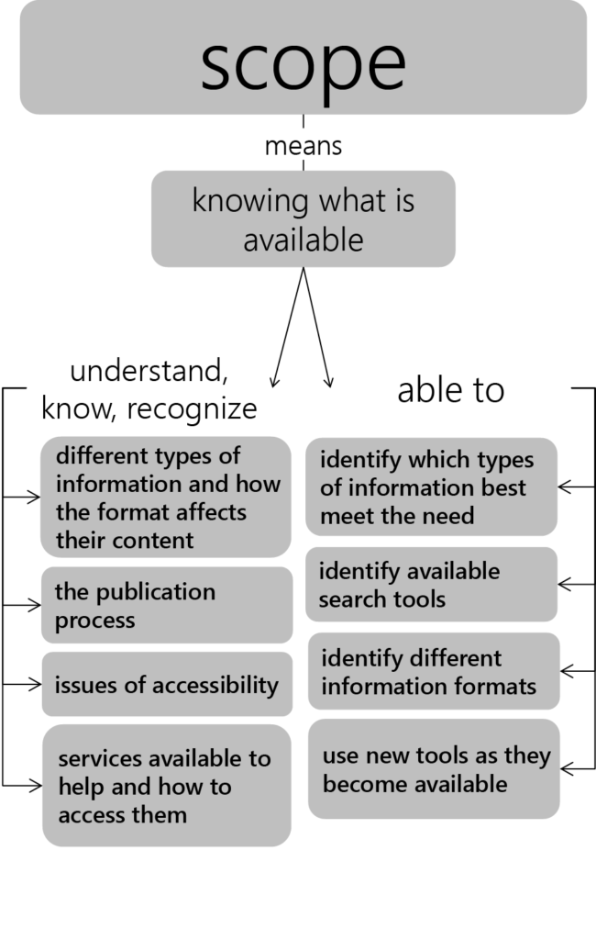

Finally, remember:
“All information sources are not created equal. Sources can vary greatly in terms of how carefully they are researched, written, edited, and reviewed for accuracy. Common sense will help you identify obviously questionable sources, such as tabloids that feature tales of alien abductions, or personal websites with glaring typos. Sometimes, however, a source’s reliability—or lack of it—is not so obvious…You will consider criteria such as the type of source, its intended purpose and audience, the author’s (or authors’) qualifications, the publication’s reputation, any indications of bias or hidden agendas, how current the source is, and the overall quality of the writing, thinking, and design.” (Writing for Success, 2015, p. 448).
We will cover how to evaluate sources in more detail in Chapter 5.

Practice
For each of these information needs, indicate what resources would be the best fit to answer your question. There may be more than one source so don’t feel like you have to limit yourself to only one. See Answer Key for the correct response.
- You are to write a brief paper on a theory that you only vaguely understand. You need some basic information. Where would you look?
- If you heard something on the radio about a recent research involving an herbal intervention for weight loss where could you find the actual study?
- You are going to be doing an internship in a group home for young men. You have heard that one issue that comes up for them is anger. Where would you look for practical interventions to help you manage this problem if it came up?
- You have the opportunity to work on a research project through a grant proposal. You need to justify the research question and show that there is an interest and a need for this research. What resources would you cite in your application?
- You have been assigned a project to find primary sources about classroom discipline used in early 20th-century schools. What primary sources could you use and where would you find them?
- You have an idea for a great thesis but you are afraid that it has been done before. Since you would like to do something original, where could you find out if someone else has done the project?
- There was a post on Facebook that welfare recipients in Arizona were recently tested for drug use with only three in 140,000 having positive results. Where can I find out if this number is accurate?

Test Yourself

Question 1 Match the type of periodical to its content
Trade publication
Scholarly journal
Magazine
- Contains articles about a variety of topics of popular interest; also contains advertising.
- Has information about industry trends and practical information for professionals in a field.
- Contains articles written by scholars in an academic field and reviewed by experts in that field.

Question 2: Given what you know about information types and sources, put the following information sources in order from the least accurate and reliable to the most accurate and reliable. (1 least accurate/4 most accurate)
- Books and encyclopedias
- News broadcasts and social media directly following an event.
- Analysis of an event in the news media or popular magazine weeks after an event.
- Articles written by scholars and published in a journal.

Question 3: What is information called that is either a diary, a speech, original research, data, artwork, or a religious book.
- Primary
- Secondary
- Tertiary
- Empirical

Question 4: To find the best information in the databases you need to use keywords that are used by the scholars. Where do you find out what keywords to try?
- From websites
- In journal articles
- In Books
- All of the above

Question 5: Which of the following is NOT true about scholarly journals?
- They contain the conversation of the scholars on a particular subject.
- They are of interest to the general public.
- The articles are followed by an extensive reference list.
- They contain reports of original research.

References

Image Attribution

Chapter 3

Chapter 3: How to Get Started

Learning Objectives
At the conclusion of this chapter, you will be able to:
- Develop and refine a viable research question for your literature review

3.1 Topic selection
If the longest journey begins with the first step, most graduate-level literature reviews begin with choosing a relevant, appropriate, interesting topic about which to do the review. Whether the topic is assigned, chosen from a list of possible options, or (most likely) developed on your own, a good way to begin your thinking is to take a general issue or subject and formulate it into a question. You may want to start to think about a single aspect in your field or discipline that might be interesting to pursue, such as ‘science education’ or ‘diabetes treatment.’
A good topic selection plan begins with a general orientation into the subject you are interested in pursuing in more depth. Although finding a good research question may initially feel like looking for a needle in a haystack, choosing a general topic is the first step.
Things to think about when choosing a topic area:
- Pick an area of interest; pick an area of experience; or, pick an area where you know there is a need for more research.
- It may be easier to start with “what” and “why” questions and expand on those. For example, in Nursing: what is current research on obesity and why is it significant to nursing and health sciences? Or, in Education: what is media literacy and why is it significant to education sciences?
- If you are a teacher or other education practitioner, you might think about a current problem in the workplace such as, classroom management or parent interaction and expand from there. Nurses may want to consider a current issue in a clinical or hospital setting, like hand washing or patient falls.
Other suggestions for choosing a topic include:
- Ask a professor, preferably one active in research, about possible topics
- Read departmental information on research interests of the faculty. Faculty research interests areas vary widely, so do some research on their past publications. Most departmental websites post faculty CVs.
- Read a research paper that interests you. The paper’s literature review or background section will provide insight into the research question the author was seeking to address with his/her study. Is the research incomplete, imprecise, biased, or inconsistent? As you’re reading the paper, look for what’s missing. These may be “gaps in the literature” that you might explore in your own study. The conclusion or discussion section at the end may also offer some questions for future exploration. A recent blog posting in Science (Pain, 2016) provides several tips from researchers and graduate students on how to effectively read these papers.
- Think about papers you enjoyed researching and writing as an undergraduate and choose a topic that reflects those interests
- Sift through the table of contents of annual reviews journals in your area of interest – such as, the Annual Review of Psychology, the Annual Review of Immunology, the Review of Research in Education, or the Annual Review of Nursing Research.
- Identify and browse journals related to your research interests. Faculty and librarians can help you identify relevant journals in your field and specific areas of interest.
Although it’s a good idea to avoid subjects that are too personal or emotional as these can interfere with an unbiased approach to the research, it’s also important to make sure you have more than a passing interest in the topic. You will be with this literature review for an extended period of time and it will be difficult to stick with it even under the best circumstances. A graduate student in psychology said, “‘My advice would be to NOT choose a topic that is an unappealing offshoot of your adviser’s work or a project that you have lukewarm feelings about in general…It’s important to remember that this is a marathon, not a sprint, and lukewarm feelings can turn cold quickly.’” (Dittman, 2005).

3.2 Question formulation
Now, take that general idea and begin to think about it in terms of a question. What do you really want to know about the topic? As a warm-up exercise, try dropping a possible topic idea into one of the blank spaces below. The questions may help bring your subject into sharper focus and provide you with the first important steps towards developing your topic. The type of paper you want to write (Definition, Analysis, Narration, etc.) can also be a useful way to begin thinking about your research question. For example, if you’re interested in parent involvement in early childhood education, your research question might be “What are the various features of parent involvement in early childhood education?” Or, if you want to do an evaluative literature review, your research question could be “What is the value of infant vaccination?”
- What does ___ mean? (Definition)
- What are the various features of ___? (Description)
- What are the component parts of ___? (Simple analysis)
- How is ___ made or done? (Process analysis)
- How should ___ by made or done? (Directional analysis)
- What is the essential function of ___? (Functional analysis)
- What are the causes of ___? (Causal analysis)
- What are the consequences of ___? (Causal analysis)
- What are the types of ___? (Classification)
- How is ___ like or unlike ___? (Comparison)
- What is the present status of ___? (Comparison)
- What is the significance of ___? (Interpretation)
- What are the facts about ___? (Reportage)
- How did ___ happen? (Narration)
- What kind of person is ___? (Characterization/Profile)
- What is the value of ___? (Evaluation)
- What are the essential major points or features of ___? (Summary)
- What case can be made for or against ___? (Persuasion)
- What is the relationship between _____ and the outcome of ____? (Explorative)
For more information about how to form a research question, check out this video tutorial:
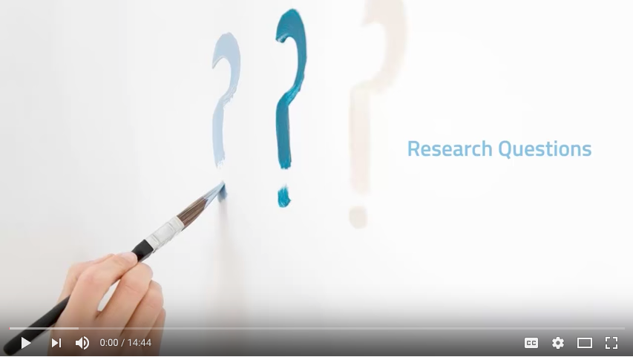
At this point, you will want to do an initial review of the existing literature to see what resources on your topic or question already exist. Based on what you find, you may decide to alter your question in some way before going too far along a path that perhaps has already been well-covered by other scholars.

3.3 Research Question or Hypothesis?
Some things to keep in mind at this beginning stage of the research process is whether your literature review will be in the form of a research question or a hypothesis. One way to determine that outcome is to compare the two and decide which format will work best for you. For example, if the area you are researching is a relatively new field, and there is little or no existing literature or theory that indicates what you will find, then your literature review will likely be based on a research question.

3.3.1 Research question criteria:
The question should express a relationship between two or more variables – for example, how is A related to B? It should be clearly stated in a question form – such as, “How do grades (A) affect participation in class (B)?” or “How does parental education level (A) affect children’s vaccination status (B)?” Your literature review, in turn, may become:
Grades as a classroom participation motivator: A literature review, or
Education level and vaccinations: A literature review
Your question should also imply possibilities for empirical testing–remember, metaphysical questions are not measurable and a variable that cannot be clearly defined cannot be tested.

3.3.2 Hypothesis criteria:
If, however, your literature review tests something based on the findings of a large amount of previous literature or a well-developed theory, your literature review will be to test of a hypothesis, rather than answer a question. The statement should indicate an expected relationship between variables and it must be testable. State your hypothesis as simply and concisely as possible. For example, if A, then B, as in: “If patient is obese, he/she will also be deaf.” (Dhanda & Taheri, 2017). Or, “For those who stutter, unusual temperament or anxiety is a causal factor.” (Kefalianos, 2012)
Hypothesis criteria
Research Question | Hypothesis
Is A related to B? | If A, then B
How are A and B related to C? | If A & B, then C
How is A related to B under conditions C and D? | If A, then B under conditions C and D
Decide what type of relationship you would like to study between the variables. Now, try to express the relationship between the concepts as a single sentence–in the form of either a research question or a hypothesis.

3.4 Refining the question
Once you have selected your topic area and reviewed literature related to it, you may need to narrow it to something that can be realistically researched and answered. In addition to asking Who, What, When, Where, Why, and How questions, other types of questions you might begin to ask to further refine your topic include those that are: Descriptive, Differential or Comparative, Associative or Relational.
You might beginning by asking a series of PICO questions. Although the PICO method is used primarily in the health sciences, it can also be useful for narrowing/refining a research question in the social sciences as well. A way to formulate an answerable question using the PICO model could look something like this:
- Patient, Population or Problem: What are the characteristics of the patient or population? For example, gender, age, other demographics. What is the situation or disease you are interested in? For example, diabetes or classroom management
- Intervention or exposure: What do you want to do with the patient, person, or population (e.g. treat, diagnose, observe)? Such as, observe classroom behavior or reaction to a specific type of treatment
- Comparison: What is the alternative to the intervention (e.g. placebo, different drug, surgery)? For example, how does a sample group that is assigned homework compare to a similar group that is not assigned homework?
- Outcome: What are the relevant outcomes (e.g. morbidity, death, complications)? For example, how do lower cholesterol numbers or improved scores in spelling impact the target population?
Some examples of how the PICO method is used to refine a research question include:
- Education: “Is play-based learning an effective approach in early childhood education? – Population (early childhood) / Intervention (play-based learning),” or “Can music therapy help autistic students improve their communication skills? – Population (autistic students / intervention (music therapy)”
- Nursing: “What is the effect of a dressing with silver in its composition on the treatment of diabetic foot ulcers? – Population (patients with diabetes) / Intervention (dressings made with silver)” or “How effective are antidepressive medications on anxiety and depression? – Intervention (antidepressants) / Population (patients with anxiety and depression)”
Another mnemonic technique used in the social sciences for narrowing a topic is SPICE. An example of how SPICE factors can be used to develop a research question is given below:
Setting – for example, Canada
Perspective – for example, Adolescents
Intervention – for example, Text message reminders
Comparisons – for example, Telephone message reminders
Evaluation – for example, Number of homework assignments turned in after text message reminder compared to the number of assignments turned in after a telephone reminder
Likewise, developing a concept map or mind map around your topic may help you analyze your question and determine more precisely what you want to research. Using this technique, start with the broad topic, issue, or problem, and begin writing down all the words, phrases and ideas related to that topic that come to mind and then ‘map’ them to the original idea.

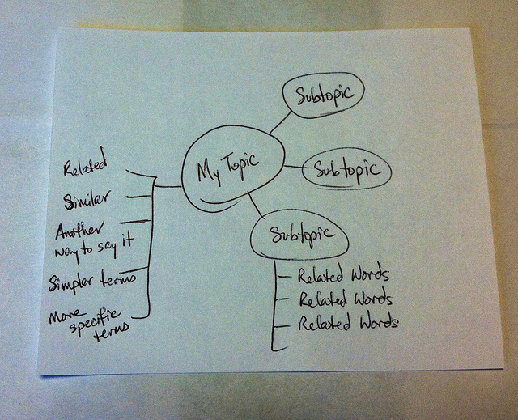

This mapping technique aims to improve the “description of the breadth and depth of literature in a domain of inquiry. It also facilitates identification of the number and nature of studies underpinning mapped relationships among concepts, thus laying the groundwork for systematic research reviews and meta-analyses.” (Lesley, Floyd, & Oermann, 2002; D’Antoni & Pinto Zipp, G., 2006). Its purpose, like the other methods of question refining, is to help you organize, prioritize, and integrate material into a workable research area; one that is interesting, answerable, realistic in terms of resource availability and time management, objective, scholarly, original, and clear.
Check out this YouTube video for more basic information on how to map your research question:
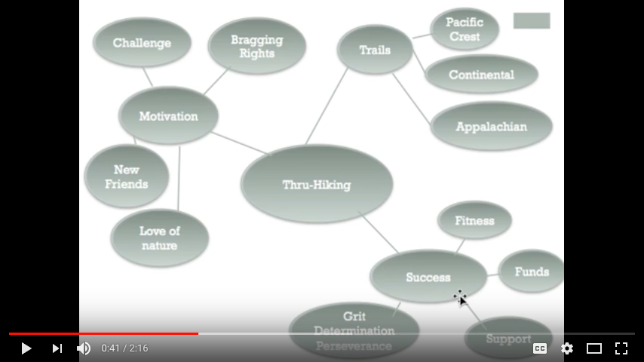
In addition to helping you get started with your own literature review, the techniques described here will give you some keywords and concepts that will be useful when you begin searching the literature for relevant studies and publications on your topic.

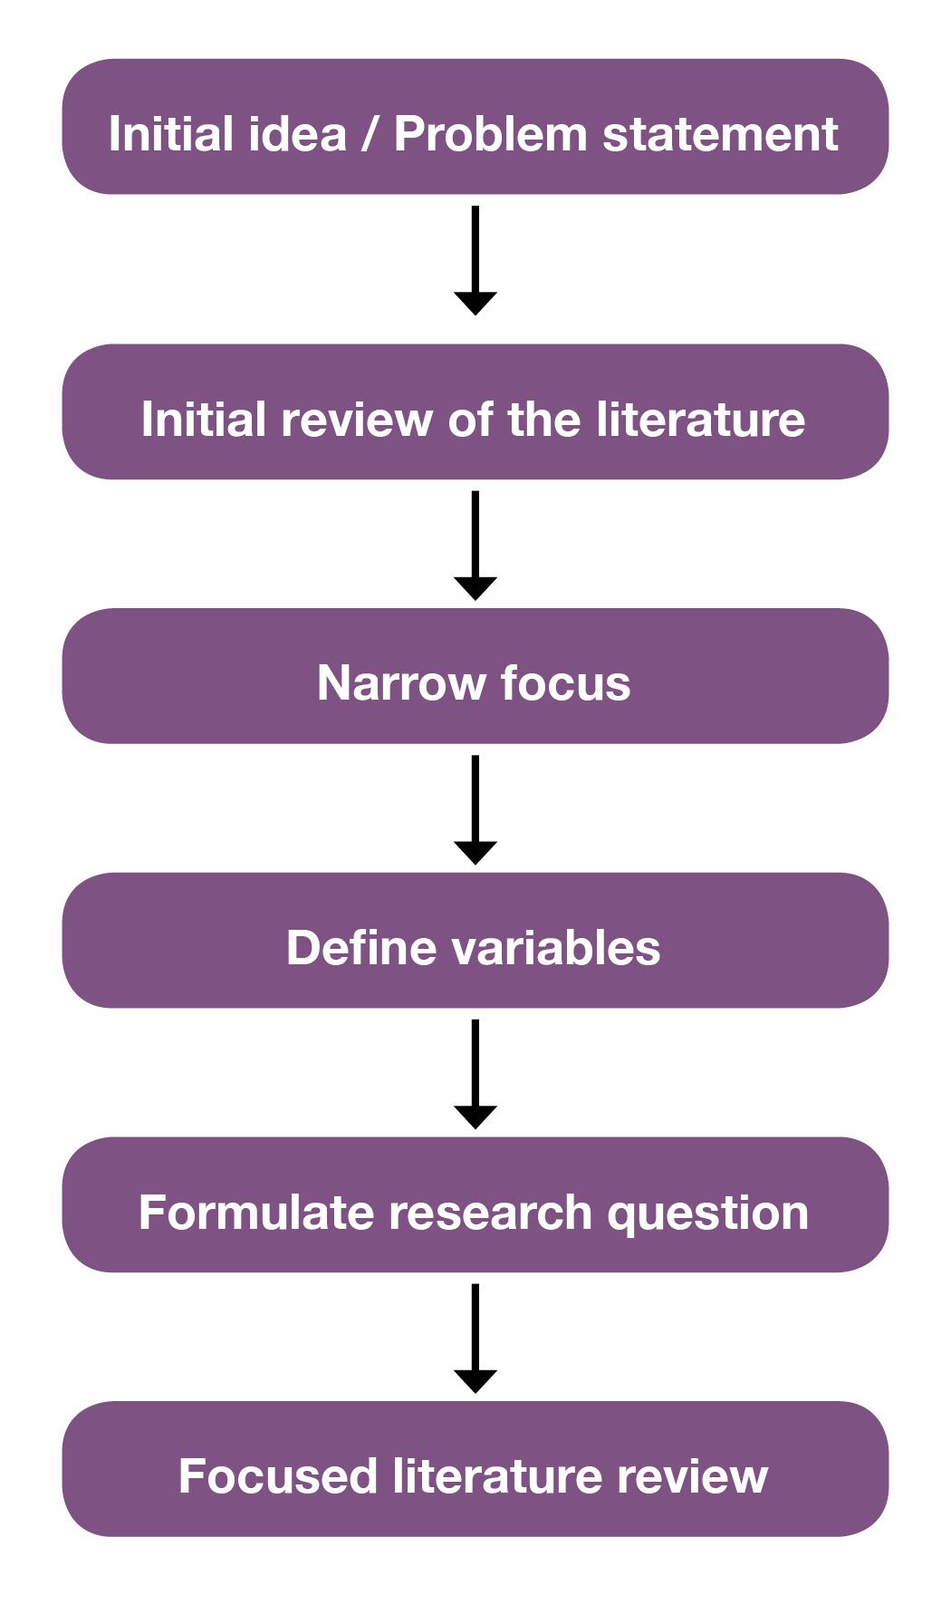

For example, perhaps your initial idea or interest is ‘how to prevent obesity.’ After an initial search of the relevant nursing literature, you realize the topic of ‘obesity’ is too broad to adequately cover in the time you have to do your literature review. You decide to narrow your focus to ‘causes of childhood obesity.’ Using PICO factors you further narrow your search to ‘the influence of family factors on overweight children.’ A potential research question might then be “What maternal factors are associated with toddler obesity in the United States?” You’re now ready to begin searching the literature for studies, reports, cases, and other information sources that relate to this question.
Similarly, for a broad topic like ‘school performance’ or ‘grades,’ and after an initial literature search that provides some variables, examples of a narrow research question might be:
- “To what extent does parental involvement in children’s education relate to school performance over the course of the early grades?”
- “Do parental involvement levels differ by family social, demographic, and contextual characteristics?”
- “ What forms of parent involvement are most highly correlated with children’s outcomes? What factors might influence the extent of parental involvement?” (Early Childhood Longitudinal Program, 2011).

Practice
Take a general topic such as “Reading Comprehension” or “Hospital Falls” and identify a slightly more narrow concept by using the questions provided in the worksheet.
- Next refine your topic further by choosing one of the PICO factors
- Now practice writing your topic as a research question or hypothesis
- Is your question or hypothesis interesting, answerable, and clear? Ask a classmate to read your question or hypothesis and explain to you what the research will be.
Good question? | Bad question? | Why?
Each of the questions below has advantages and disadvantages. Based on some of the criteria for formulating a research question discussed in this section, which of the following questions seems the most viable for further study and why? See the Answer Key for the correct responses
- Education: Do adult learners in a rural adult education setting have characteristics that are similar to adult learners in general
- Education: What are the characteristics of rural adult learners in an adult education program?
- Education: How does the U.S. Department of Education serve rural learners?
Look at these recent publications in the literature for nursing and education. Can you spot the research question? Which PICO factors were used in each example?
- Nursing: Workplace Hazards Faced by Nursing Assistants in the United States: A Focused Literature Review. (Walton, A., & Rogers, B., 2017).
- Nursing: What are the family needs when a parent has mental health problems? Evidence from a systematic literature review. (Wahl, et al., 2017).
- Education: Music in Peacebuilding: A Critical Literature Review (Sandoval, 2016).
- Nursing: Health literacy programs for older adults: A systematic literature review (Manafo & Wong, 2012).
- Education: English language learners and reading instruction: A review of the literature. (Snyder, Witmer, & Schmitt, 2017).
- Nursing: Cultural interventions to treat addictions in indigenous populations: Findings from a scoping study. (Rowan et al, 2014).

Test Yourself
See the Answer Key for the correct response.

Question 1: This is an effective research question: Do school breakfast programs in Washington and Oregon differ? Choose True or False
- True False

Question 2. Which of the two questions below is more effective? Choose A or B
- Are females smarter than males?
- Do females aged 18-36 score higher on the Graduate Record Exam than adult males between the ages of 18-35?

Question 3. Which of the following research question is more effective? Choose A or B
- Five methods of assessing nursing students’ critical thinking skills within the context of clinical practice are: 1) Observation, 2) Questions, 3) Conferences, 4) Problem-solving strategies, and 5) written assignments. The literature is reviewed on each of these methods.
- Critical thinking is an important competency needed by nursing students. Varied methods can be used for assessing critical thinking.

Question 4. This is the research question: What impact has the No Child Left Behind (NCLB) program had on high school graduation rates?

What information sources will I need to find to begin my literature review? Choose A, B, C, or D.
- statistics on graduation rates before and after the program went into effect
- statistics on the success or failure of other retention programs
- information about government education programs before and after the era of NCLB
- all of the above

Question 5. Is the scope of this information reasonable:
I will review 30 online nursing training programs developed over a span of 10 years? Choose Yes or No
Yes or No

Question 6. PICO questions are a good way to narrow your research focus. What does PICO mean? Choose 1, 2, 3, or 4
- Parents, Intermediaries, Corporations, Oscillations
- Populations, Interventions, Comparisons, Outcomes
- Problems, Instruments, Channels, Operations
- Patients, Interference, Courses, Origins

References

Image Attribution

Chapter 4

Chapter 4: Where to Find the Literature

Learning Objectives
At the conclusion of this chapter, you will be able to:
- Search a library catalog to locate electronic and print books.
- Search databases to find scholarly articles, dissertations, and conference proceedings.
- Retrieve a copy or the full text of information sources
- Identify and locate core resources in your discipline or topic area

4.1 Overview of discovery
Discovery, or background research, is something that happens at the beginning of the research process when you are just learning about a topic. It is a search for general information to get the big picture of a topic for exploration, ideas about subtopics and context for the actual focused research you will do later. It is also a time to build a list of distinctive, broad, narrow, and related search terms.
Discovery happens again when you are ready to focus in on your research question and begin your own literature review. There are two crucial elements to discovering the literature for your review with the least amount of stress as possible: the places you look and the words you use in your search.
The places you look depend on:
- The stage you are in your research
- The disciplines represented in your research question
- The importance of currency in your research topic
Review the information and publication cycles discussed in Chapter 2 to put those sources of this information in context.
The words you use will help you locate existing literature on your topic, as well as topics that may be closely related to yours. There are two categories for these words:
- Keywords – the natural language terms we think of when we discuss and read about a topic
- Subject terms – the assigned vocabulary for a catalog or database
The words you use during both the initial and next stage of discovery should be recorded in some way throughout the literature search process. Additional terms will come to light as you read and as your question becomes more specific. You will want to keep track of those words and terms, as they will be useful in repeating your searches in additional databases, catalogs, and other repositories. Later in this chapter, we will discuss how putting the two elements (the places we look and the words we use) together can be enhanced by the use of Boolean operators and discipline-specific thesauri.
Discovery is an iterative process. There is not a straight, bright line from beginning to end. You will go back into the literature throughout the writing of your literature review as you uncover gaps in the evidence and as additional questions arise.



4.2 Finding sources: Places to look
Let’s take some time to look at where the information sources you need for your literature review are located, indexed, and stored. At this stage, you have a general idea of your research area and have done some background searching to learn the scope and the context of your topic. You have begun collecting keywords to use in your later searching. Now, as you focus in on your literature review topic, you will take your searches to the databases and other repositories to see what the other researchers and scholars are saying about the topic.
The following resources are ordered from the more general and established information to the more recent and specific. Although it is possible to find some of these resources by searching the open web, using a search engine like Google or Google Scholar, this is not the most efficient or effective way to search for and discover research material. As a result, most of the resources described in this section are found from within academic library catalogs and databases, rather than internet search engines.

4.2.1 Finding books and ebooks

4.2.1.1 Books
Look to books for broad and general information that is useful for background research. Books are “essential guides to understanding theory and for helping you to validate the need for your study, confirm your choice of literature, and certify (or contradict) its findings.” (Fink, 4th ed., 2014, p. 77). In this section, we will consider print and electronic books as well as print and electronic encyclopedias.
Most academic libraries use the Library of Congress classification system to organize their books and other resources. The Library of Congress classification system divides a library’s collection into 21 classes or categories. A specific letter of the alphabet is assigned to each class. More detailed divisions are accomplished with two and three letter combinations. Book shelves in most academic libraries are marked with a Library of Congress letter-number combination to correspond to the Library of Congress letter-number combination on the spines of library materials. This is often referred to as a call number and it is noted in the catalog record of every physical item on the library shelves. (Bennard et al, 2014a)
The Library of Congress (LC) classification for Education (General) is L7-991, with LA, LB, LC, LD, LE, LG, LH, LJ, and LT subclasses. For example,
LB3012.2.L36 1995
Beyond the Schoolhouse Gate: Free Speech and the Inculcation of Values
In Nursing, the LC subject range is RT1-120. A book with this LC call number might look like: R121.S8 1990 Stedman’s Medical Dictionary. Areas related to nursing that are outside that range include:
R121 Medical dictionaries
R726.8 Hospice care
R858-859.7 Medical informatics
RB37 Diagnostic and laboratory tests
RB115 Nomenclature (procedural coding – CPT, ICD9)
RC69-71 Diagnosis
RC86.7 Emergency medicine
RC266 Oncology nursing
RC952-954.6 Geriatrics
RD93-98 Wound care
RD753 Orthopedic nursing
RG951 Maternal child nursing / Obstetrical nursing
RJ245 Pediatric nursing
RM216 Nutrition and diet therapy
RM301.12 Drug guides
In most libraries, there is a collection of reference material kept in a specific section. These books, consisting of encyclopedias, dictionaries, thesauri, handbooks, atlases, and other material contain useful background or overview information about topics. Ask the librarian for help in finding an appropriate reference book. Although reference material can only be used in the library, other print books will likely be in what’s called the “circulating collection,” meaning they are available to check out.

4.2.1.2 Ebooks
The library also provides access to electronic reference material. Some are subject specific and others are general reference sources. Although each resource will have a different “look” just as different print encyclopedias and dictionaries look different, each should have a search box. Most will have a table of contents for navigation within the work. Content includes pages of text in books and encyclopedias and occasionally, videos. In all cases you will be able to collect background information and search terms to use later.
North American academic libraries buy or subscribe to individual ebook titles as well as collections of ebooks. Ebooks appear on various publisher and platforms, such as Springer, Cambridge, ebrary (ProQuest), EBSCO, and Safari to name a few. Although access to these ebooks varies by platform, you can find the ebook titles your library has access to through the library catalog. You can generally read the entire book online, and you can often download single chapters or a limited number of pages. You may be able to download an entire ebook without restrictions, or you may have to ‘check it out’ for a limited period of time. Some downloads will be in PDF format, others use another type of free ebook viewing software, like ePUB. Unlike public library ebook collections, most academic library ebooks are not be downloadable to ereader devices, such as Amazon’s Kindle

4.2.1.3 The Library Catalog
In general, everything owned or licensed by a library is indexed in “the library catalog”. Although most library catalogs are now sophisticated electronic products called ‘integrated library systems’, they began as wooden card filing cabinets where researchers could look for books by author, title, or subject.



While the look and feel of current integrated library systems vary between libraries, they operate in similar ways. Most library catalogs are quickly found from a library’s home page or website. The library catalog is the quickest way to find books and ebooks on your topic.
Here are some general tips for locating books in a library catalog:
- Use the search box generally found on a library’s home page to start a search.
- Type a book title, author name, or subject keywords into the search box.
- You will be directed to a results page.
- If you click on a book title or see an option to see more details about the book, you can look at its full bibliographic record, which provides more information about the book, as well as where to find the book. Pay particular attention to subjects associated with the item, adding relevant and appropriate terms to your list of search terms for future use.
- If you want to have more control over search results, you can try an “Advanced Search” within the library catalog
  - Look for an “Advanced Search” option near the basic or single search box
  - The options within the advanced catalog search window allow you to limit searches by:
    - Publication Year
    - Subject
    - Call number
    - And more…

- There is generally a “Format” list on the advanced search page screen. This list will give you options for limiting format to Print Books or Ebooks.
- You can limit searches to a specific library or libraries to narrow by location or ‘search everything’ to broaden your search.

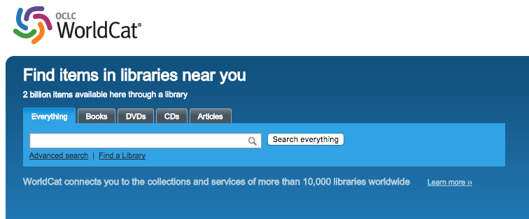

OCLC WorldCat (https://www.worldcat.org/) is the world’s largest network of library content and it provides another way to search for books and ebooks. For students who do not have immediate access to an academic library catalog, WorldCat is a way to search many library catalogs at once for an item and then locate a library near you that may own or subscribe to it. Whether you will be able check the item out, request it, place an interlibrary loan request for it, or have it shipped will depend on local library policy. Note that like your own library catalog, WorldCat has a single search box, an Advanced search feature, and a way to limit by format and location.

4.2.2 Finding scholarly articles
While books and ebooks provide good background information on your topic, the main body of the literature in your research area will be found in academic journals. Scholarly journals are the main forum for research publication. Unlike books and professional magazines that may comment or summarize research findings, articles in scholarly journals are written by a researcher or research team. These authors will report in detail original study findings, and will include the data used. Articles in academic journals also go through a screening or peer-review process before publication,implying a higher level of quality and reliability. For the most current, authoritative information on a topic, scholars and researchers look to the published, scholarly literature. That said,
Journals, and the articles they contain, are often quite expensive. Libraries spend a large part of their collection budget subscribing to journals in both print and online formats. You may have noticed that a Google Scholar search will provide the citation to a journal article but will not link to the full text. This happens because Google does not subscribe to journals. It only searches and retrieves freely available web content. However, libraries do subscribe to journals and have entered into agreements to share their journal and book collections with other libraries. If you are affiliated with a library as a student, staff, or faculty member, you have access to many other libraries’ resources, through a service called interlibrary loan. Do not pay the large sums required to purchase access to articles unless you do not have another way to obtain the material, and you are unable to find a substitute resource that provides the information you need. (Bennard et al, 2014a)

4.2.2.1 Databases
A database is an electronic system for organizing information. Journal databases are where the scholarly articles are organized and indexed for searching. Anyone with an internet connection has free access to public databases such as PubMed and ERIC. Students can also search in library-subscribed general information databases (such as EBSCO’s Academic Search Premier) or a specialized or subject specific database (for example, a ProQuest version of CINAHL for Nursing or ERIC for Education).
Library databases store and display different types of information sets than a library catalog or Google Scholar. There are different types of databases that include:
- Indexes– with citations only
- Abstract databases – with citations and abstracts only
- Full text databases – with citations and the full text of articles, reports, and other materials
Library databases are often connected to each other by means of a “link resolver”, allowing different databases to “talk to each other.” For example, if you are searching an index database and discover an article you want to read in its entirety, you can click on a link resolver that takes you to another database where the full-text of the article is held. If the full-text is not available, an automated form to request the item from another library may be an option.
Why search a database instead of Google Scholar or your library catalog? Both can lead you to good articles BUT:
- The content is wide-ranging but not comprehensive or as current as a database that may be updated daily.
- Google Scholar doesn’t disclose its criteria for what makes the results “scholarly’ and search results often vary in quality and availability.
- Neither gives you as much control over your search as you get in a database.

4.2.2.2 Citation searches
Another way to find additional books and articles on your topic is to mine the reference lists of books and articles you already found. By tracing literature cited in published titles, you not only add to your understanding of the scholarly conversation about your research topic but also enrich your own literature search.
A citation is a reference to an item that gives enough information for you to identify it and find it again if necessary. You can use the citations in the material you found to lead you to other resources. Generally, citations include four elements:
- Author
- Title
- Source
- Date
For example,

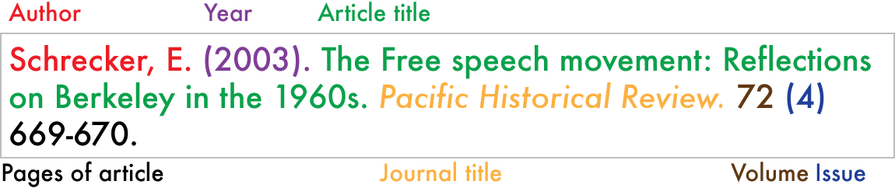

For a good summary of how to read a citation for a book, book chapter, and journal article in both APA and MLA format, see this explanation at: https://www.slideshare.net/opensunytextbooks/gathering-components-of-a-citation

4.2.3 Finding conference papers
Conference papers are often overlooked because they can be difficult to locate in full-text. Sometimes the papers from an annual proceeding are treated like an individual book, or a single special issue of a journal. Sometimes the papers from a conference are not published and must be requested from the original author. Despite publication inconsistency, conference papers may be the first place a scholar presents important findings and, as such, are relevant to your own research. Places to look for conference papers:

4.2.3.1 WorldCat
- use keywords from the conference name (NOT the article title)
- it often helps to leave out terms like: conference, proceedings, transactions, congresses, symposia/symposium, exposition, workshop or meeting
- include the year of the conference
- include the city in which the conference took place

4.2.3.2 Google Scholar
- Search by keyword and add the word ‘conference’ and the year to your search, for example: ‘conference education 2008′

4.2.3.3 Databases
- For Education: ERIC, limit to ‘Collected Works–Proceedings’ or ‘Speeches/Meeting papers’
- For Nursing: CINAHL, limit to proceedings in the “Publication Type” box
- For Education: Education Full Text, limit to ‘proceeding’ in the “Document Type” box
- PsychInfo: limit to ‘Conference Proceedings’ in the “Record Type” Box
- Web of Science: limit to ‘conference’

4.2.3.4 Professional Societies & Other Sponsoring Organizations
Check the web sites of the organizations that sponsor conferences. Listings of conference proceedings are often under a “Publications” or “Meetings” tab/link. The National Library of Medicine maintains a conference proceedings subject guide for health-related national and international conferences. Though many papers/proceedings are not available for free, the organization web site will often contain citations of proceedings that you can request through interlibrary loan.

4.2.4 Finding dissertations
In addition to journal articles, original research is also published in books, reports, conference proceedings, theses and dissertations. Both theses and dissertations are very detailed and comprehensive accounts of research work. Dissertations and theses are a primary source of original research and include “referencing, both in text and in the reference list, so that, in principle, any reference to the literature may be easily traced and followed up.” (Wallace & Wray, p. 187). Citation searching of the reference list or bibliography in a dissertation is another method for discovering the relevant literature for your own research area. Like conference papers, they are more difficult to locate and retrieve than books and articles. Some may be available electronically in full-text at no cost. Others may only be available to the affiliates of the university or college where a degree was granted. Others are behind paywalls and can only be accessed after purchasing. Both CINAHL and ERIC index dissertations. Individual universities and institutional repositories often list dissertations held locally. Other places to look for theses and dissertations include:
Dissertations Express – search for dissertations from around the world. Search by subject or keyword, results include author, title, date, and where the degree was granted. Some are available in full-text at no cost, however most requirement payment.
EThOS – the national thesis service for the United Kingdom, managed by the British Library. It is a national aggregated record of all doctoral theses awarded by UK Higher Education institutions, providing free access to the full text of many theses for use by all researchers to further their own study.
Theses Canada – a collaborative program between Library and Archives Canada (LAC) and nearly 70 accredited Canadian universities. The collection contains both microfiche and electronic theses and dissertations that are for personal or academic research purposes.

4.3 Advanced searching
Now that you have an idea of some of the places to look for information on your research topic and the form that information takes (books, ebooks, journals, conference papers, and dissertations), it’s time to consider not only how to use the specialized resources for your discipline but how to get the most out of those resources. To do a graduate-level literature review and find everything published on your topic, advanced search and retrieval skills are needed.

4.3.1 Search Operators
Literature review research often necessitates the use of Boolean operators to combine keywords. The operators – AND, OR, and NOT — are powerful tools for searching in a database or search engine. By using a combination of terms and one or more Boolean operator, you can focus your search and narrow your search results to a more specific area than a basic keyword search allows.

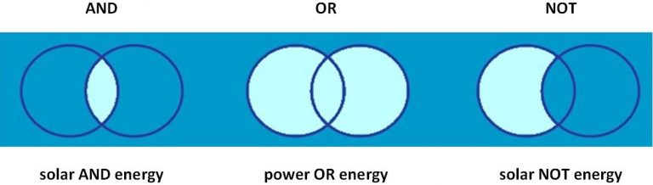

Boolean operators – allow you to combine your search terms using the keywords AND, OR and NOT. Look at the diagrams in Figure 4.6 to see how these terms will affect your results.
Truncation – If you use truncation (or wildcards), your search results will contain documents including variations of that term.
For example: light* will retrieve, of course, light, but also terms like: lighting, lightning, lighters and lights. Note that the truncation symbol varies depending on where you search. The most common truncation symbols are the asterisk (*) and question mark (?).
Phrase searching – Phrase searching is used to make sure your search retrieves a specific concept. For example “durable wood products” will retrieve more relevant documents than the same terms without quotation marks.
For a description of these more advanced search features, watch this short video tutorial on effective search strategies. (Clark, 2016).

4.3.2 Finding sources in your discipline or topic area
It’s time to put these tips and your search skills to use. This is the point, if you have not done so already, to talk to a librarian. The librarian will direct you to the resources you need, including research databases to which the library subscribes, for your discipline or subject area. Literature reviews rely heavily on data from online databases, such as CINAHL for Nursing and ERIC for Education. Unfortunately, the costs to subscribe to vendor-provided products is high. Students affiliated with large university libraries that can afford to subscribe to these products will have access to many databases, while those who do not have fewer options.
Students who do not have access to subscription databases such as CINAHL or ERIC through Ebsco and ProQuest should use PubMed for Nursing at https://www.ncbi.nlm.nih.gov/pubmed/ and the public version of ERIC at https://eric.ed.gov/ for literature review research.
Although a librarian is the best resource for learning how to use a specific tool, an online tutorial on how to search PubMed may be useful and informative for those who do not have access to a librarian or a subscription database: Likewise, this document, titled “How does the ERIC search work,” provided by the Institute of Education Sciences provides some helpful tips for searching the public version ERIC.

4.3.3 Specialized vocabulary
One major source of search terms in a database is a specialized dictionary, or thesaurus, used to index journal articles. Thesauri provide a consistent and standardized way to retrieve information, especially when different terms are used for the same concept. According to Fink (2014), “evidence exists that using thesaurus terms produces more of the available citations than does reliance on key words…Using the appropriate subject heading will enable the reviewer to find all citations regardless of how the author uses the term.” (p. 24).
In Education and Nursing, thesauri are available. In subscription databases, as well as in PubMed and the public version of ERIC, look for the thesaurus to guide you to appropriate and relevant subject terms.

4.3.4 Citation Searching
Citation searching works best when you already have a relevant work that is on topic. From the document you identified as useful for your own literature review, you can either search citations forward or backward to gather additional resources. Cited reference searching and reference or bibliography mining are advanced search techniques that may also help generate new ideas as well as additional keywords and subject areas.
For cited reference searching, use Google Scholar or library databases such as Web of Science or Scopus. These tools trace citations forward to link to newly published books, journal articles, book chapters, and reports that were written after the document you found. Through cited reference searching, you may also locate works that have been cited numerous times, indicating what may be a seminal work in your field.
With citation mining, you will look at the references or works cited list in the resource you located to identify other relevant works. In this type of search, you will be tracing citations backward to find significant books, journal articles, book chapters, and reports that were written before the document you found. For a brief discussion about citation searching, check out this article by Hammond & Brown (2008).

Practice
The two most important finding tools you will use are a library catalog and databases. Looking for information in catalogs and databases takes practice.
Get started by setting aside some dedicated time to become familiar with the process:
- Practice by locating one reference book and one ebook in your library catalog or WorldCat
- Practice searching in freely available databases such as PubMed or ERIC
- Talk to a librarian about using a subject specific subscription database like Ebsco’s CINAHL or ProQuest’s ERIC. Be sure to explore the various bells and whistles that the database provides to improve the precision of your search
  - Try some of the limiters to see what each does to your search results
  - Once you find an article, what do you need to do to get it in full-text?

- Find out how to use interlibrary loan or document delivery.
Next, complete this exercise:
- Browse through a popular or scientific publication such as the science section of the New York Times or Scientific American. Find a short article that looks interesting and is easy to understand.
- Look for the following:
  - an article that reports on a recent study published in a scholarly journal;
  - the title of the journal;
  - the name of the author(s); and
  - an indication of when the original study appeared. Note: sometimes the source will say that the research was published in a latest issue of Science or Nature.

- Once you find some of these facts (journal title and the authors should be sufficient), you can start to search for the primary source in a library catalog or the library’s databases.
- Catalog search: find out if your school subscribes to a particular journal by searching for the journal by title.
- Best case scenario: the library subscribes to the journal.. The next step is to figure out the available format(s). You might have several options:
  - Electronic subscription—great! It means you can access the journal right away. Once you get to the online (or electronic) version of the journal, you are given a choice of searching within this publication. An author search should be sufficient to locate the article.
  - Print subscription version—good! You can search in databases or a discovery service tool for your article by entering the journal title and the authors. Once you locate a record about the article, which will include volume and issue number, page numbers, the article title, you can go to the shelves where you will find the issue of the journal that includes your article.
  - Microform version—still good! Again, after searching databases and locating the exact information about the article, you should be able to locate the appropriate microfilm reel or microfiche. Before the widespread and easy access to online versions of materials, microforms were used to save space by preserving documents on film. Libraries are equipped with microform readers—if you need help using a reader, ask the library staff. (Bennard et al, 2014b)

Test Yourself

Get an article
- Access PubMed or ERIC
- Do a subject search, using the thesaurus (for ERIC) or MeSH terms (for PubMed)
- Do a keyword search
- Supplement your subject search with keywords, using advanced search tools like Boolean operators, truncation, or phrase searching
- Limit your search by language, date of publication or PICO factor
- Access the full text of an article you find.
- If full text is not available, find out how to request the article through interlibrary loan

In your general topic area, do you know:
- The core source materials?
- The most significant theories?
- The major issues and debates surrounding your topic area?
- The key political, social, economic, legal, environmental, and/or technological aspects of your topic?
- The origins of your topic?
- The definitions for your topic?
- How knowledge in your topic area is organized?
- What problems or solutions have been addressed to date?
- If you don’t know the answers to these questions, do you know how to find the answers?

References

Image attributions

Chapter 5

Chapter 5: Evaluating Sources

Learning Objectives
At the conclusion of this chapter, you will be able to:
- Critically evaluate the sources of the information you have found.
- Evaluate the content of selected material for your purposes.

5.1 Overview of evaluation of sources
Searching for information is often nonlinear and iterative, requiring the evaluation of a range of information sources and the mental flexibility to pursue alternate avenues as new understanding develops. (Association of College & Research Libraries, 2016).
You developed a viable research question, compiled a list of subject headings and keywords and spent a great deal of time searching the literature of your discipline or topic for sources. It’s now time to evaluate all of the information you found. Not only do you want to be sure of the source and the quality of the information, but you also want to determine whether each item is appropriate fit for your own review. This is also the point at which you make sure that you have searched out publications for all areas of your research question and go back into the literature for another search, if necessary.
In general, when we discuss evaluation of sources we are talking about looking at quality, accuracy, relevance, bias, reputation, currency, and credibility factors in a specific work, whether it’s a book, ebook, article, website, or blog posting. Before you include a source in your literature review, you should clearly understand what it is and why you are including it. According to Bennard et al., (2014), “Using inaccurate, irrelevant, or poorly researched sources can affect the quality of your own work.” (para. 4).
When evaluating a work for inclusion in, or exclusion from, your literature review, ask yourself a series of questions about each source.

5.1.1 Evaluating books
For primary and secondary sources you located in your search, use the ASAP mnemonic to evaluate inclusion in your literature review:

5.1.1.1 Age
Is it outdated? The answer to this question depends on your topic. If you are comparing historical classroom management techniques, something from 1965 might be appropriate. In Nursing, unless you are doing a historical comparison, a textbook from 5 years ago might be too dated for your needs.
A General Rule of Thumb:
5 years, maximum: medicine, health, education, technology, science
10-20 years: history, literature, art

5.1.1.2 Sources
Check reference or bibliography sources as well as those listed in footnotes or endnotes. Skim the list to see what kinds of sources the author used. When were the sources published? If the author is primarily citing works from 10 or 15 years ago, the book may not be what you need.

5.1.1.3 Author
Does the author have the credentials to write on the topic? Does the author have an academic degree or research grant funding? What else has the author published on the topic?

5.1.1.4 Publisher
Look for academic presses, including university presses. Books published under popular press imprints (such as Random House or Macmillan, in the U.S.) will not present scholarly research in the same way as Sage, Oxford, Harvard, or the University of Washington Press.
Other questions to ask about the book you may want to include in your literature review:
- What is the book’s purpose? Why was it written? Who is the intended audience?
- What is the conclusion or argument? How well is the main argument or conclusion supported?
- Is it relevant to your research? How is it related to your research question?
- Do you see any evidence of bias or unsubstantiated data?

5.1.2 Evaluating websites
In your research, it is likely you will discover information on the web that you will want to include in your literature review. For example, if your review is related to the current policy issues in public education in the United States, a potentially relevant information source may be a document located on the National Center for Education Statistics (NCES) website titled The Condition of Education 2017. Likewise, for nursing, an article titled Discussing Vaccination with Concerned Patients: An Evidence-Based Resource for Healthcare Providers is available through the nursingcenter.com website. How do you evaluate these resources, and others like them?
Use the RADAR mnemonic (Mandalios, 2013) to evaluate internet sources:

5.1.2.1 Relevance
How did you find the website and how is it relevant to your topic?
- Was it recommended by a reliable source?
- Was it cited in a scholarly source, such as a peer-reviewed journal?
- Was it linked from a reputable site?

5.1.2.2 Authority
Look for the About page to find information about the purpose of the website . You may make a determination of its credibility based on what you find there. Does the page exhibit a particular point of view or bias? For example, a heart association or charter school may be promoting a particular perspective – how might that impact the objectivity of the information located on their site? Is there advertising or is there a product information attached to the content?

5.1.2.3 Date
- When was the page created?
- Is it kept up to date?
- Are the links current and functional?

5.1.2.4 Appearance
- Does the information presented appear to be factual?
- Is the language formal or academic?
- How does it compare to other information you have read on the topic?
- Are references or links to cited material included?

5.1.2.5 Reason
What is the web address or URL? This can give you a clue about the purpose of the website, which may be to debate, advocate, advertise or sell, campaign, or present information. Here are some common domains and their origins:
- .org – An advocacy website for an organization
- .com – A private or commercial site
- .net – A network organization or Internet provider/no longer frequently used
- .edu – The site of a higher educational institution
- .gov – A federal government site
- .wa.us – A state government site which may include public schools and community colleges
- .uk, .ca, .jm – A country site
Mike Caulfield (2017), the author of Web Literacy for Student Fact-Checkers, recommends a few simple strategies to evaluate a website (as well as social media):
- Check for previous work: Look around to see if someone else has already provided a synthesis of the research described.
- Go upstream to the source: Go “upstream” to the source of the claim. Most web content is not original. Get to the original source to understand the credibility and reliability of the information.
- Read laterally: Read laterally. Once you get to the source of a claim, read what other people say about the source (publication, author, etc.). The truth is in the network.

5.1.3 Evaluating journal articles
It is likely that most of the resources you locate for your review will be from the scholarly literature of your discipline or in your topic area. As we have already seen, peer-reviewed articles are written by and for experts in a field. They generally describe formal research studies or experiments with the purpose of providing insight on a topic. You may have located these articles through Google, Google Scholar, a subscription or open access database, or citation searching. You now may want to know how to evaluate the usefulness for your research. As with the other resources, you are again looking for authority, accuracy, reliability, relevance, currency, and scope. Looking at each article as a separate and unique artifact, consider these elements in your evaluation:

5.1.3.1 Credibility/Authority
ASK: Who is the author? Is this person considered an expert in their field?
- Search the author’s name in a general web search engine like Google.
- What are the researcher’s academic credentials?
- What else has this author written? Search by author in the databases and see how much they have published on any given subject.
- How often or frequently has this article been cited by other scholars?
Citation analysis is the study of the impact and assumed quality of an article, an author, or an institution, based on the number of times works and/or authors have been cited by others. Google Scholar is a good way to get at this information.

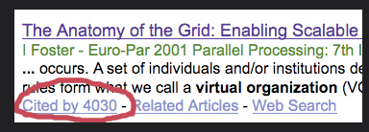

5.1.3.2 Accuracy
Check the facts. ASK:
- Can statistics be verified through other sources?
- Does this information seem to fit with what you have read in other sources?

5.1.3.3 Reliability/Objectivity
ASK: Is there an obvious bias? That doesn’t mean that you can’t use the information, it just means you need to take the bias into account.
- Is a particular point of view or bias immediately obvious, or does it seem objective at first glance?
- What point of view does the author represent? Are they clear about their point of view?
- Is the article an editorial that is trying to argue a position?
- Is the article in a publication with a particular editorial position?

5.1.3.4 Relevance
ASK: The hard questions:
- Is the information relevant to your topic/thesis?
- How does the article fit into the scope of the literature on this topic?
- Who is the intended audience for this source?
  - Is the material too technical or too clinical?
  - Is it too elementary or basic?

- Does the information support your thesis or help you answer your question, or is it a challenge to make some kind of connection?
- Does the information present an opposite point of view so you can show that you have addressed all sides of the argument in your paper?

5.1.3.5 Currency
ASK:
- When was the source published?
- How important is current information to your topic, discipline, or paper type?
- Does older material add to the history of the research? Or do you need something more current to support your thesis?

5.1.3.6 Scope and Purpose
To determine and evaluate in this category, ASK:
- Is it a general work that provides an overview of the topic or is it specifically focused on only one aspect of your topic?
- Does the breadth of the work match your expectations?
- Is the article meant to inform, explain, persuade or sell something. Be aware of the purpose as you read the content and take that into consideration when deciding whether to use it or not.
For Nursing and other medical articles ASK:
- What are the research methods used in the article?
- Where does the method fall in the evidence pyramid? Systematic reviews and meta-analyses are the most credible, with articles that are opinions the least credible.

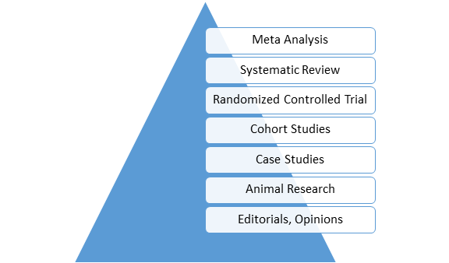

- Meta Analysis: A systematic review that uses quantitative methods to summarize the results.
- Systematic Review: An article in which the authors have systematically searched for, appraised, and summarized all of the medical literature on a specific topic.
- Randomized Controlled Trials (RCTs): RCTs include a randomized group of patients in an experimental group, as well as a control group. These groups are monitored for the variables/outcomes of interest.
- Cohort Study: Research identifies two groups (cohorts) of patients, one which did receive the exposure of interest, and one which did not, and follows these cohorts for a specified duration of time, in order to measure the outcome of interest.
- Case Study: Involves identifying patients who have the outcome of interest (cases) and control patients without the same outcome, and looks to see if they had the exposure of interest.
- Animal Research / Lab Studies: Information creation begins at the bottom of the pyramid: This is where ideas and laboratory research take place. Ideas turn into therapies and diagnostic tools, which are then tested with lab models and animals.
- Background Information / Expert Opinion: Handbooks, encyclopedias, and textbooks often provide a good foundation or introduction and often include generalized information about a condition. While background information presents a convenient summary, it typically takes about three years for this type of literature to be published.

5.1.4 Evaluating Social Media
Although social media (for example, Twitter or Facebook) is generally treated as an object under study rather than a source of information on a topic, the prevalence of social media as communication and sharing platforms must be acknowledged. It’s important to be skeptical of these sources, especially for inclusion in a literature review. However, as with any other web resource,you can evaluate a social media posting for authenticity by asking the following questions:
- Location of the source – Is the author in the place they are tweeting or posting about?
- Network – Who is in the author’s network and who follows the account?
- Content – Can the information be corroborated from other sources?
- Contextual updates – Does the author usually post or tweet on this topic? If so, what did past or updated posts say? Do they fill in more details?
- Reliability – does the author cite sources and are those sources reliable? (Sheridan Libraries, 2017)

5.2 In Summary
Another way to think about evaluation of sources is to ask the 5W questions:
- What type of document is it?
- Who created it?
- Why was the material published?
- When was it published?
- Where was the resource published?
- How was the information gathered and presented? (Radom, 2017)
Locating sources for your literature review by using discovery layers, library catalogs, databases, search engines, and other search platforms may take a great deal of time and effort. Does everything you found and retrieved have value or worth to you as you write your own literature review? If the resource has not met the criteria above and you can’t justify its place in your literature review, it doesn’t deserve to be mentioned in your work. Include high-quality materials that are current, accurate, credible, and most importantly relevant to your research question, hypothesis, or topic.

Practice

Evaluate a Website
Watch this short video:
Using a search engine like Google, do a quick search for a topic that interests you. Select a website from your list of results and evaluate it using the elements of website evaluation listed earlier in this chapter.
- How did you find the website?
- What is the domain name (the URL) of the site?
- What can you learn about the author/s of the site?
- When was the site last updated?
- Is it accurate based on what you know about the topic?
- Are there references?
- Do you notice any bias?
- Is the site functional? (re links working? Or do they lead to non-functional pages?)

Evaluate a Book
Select a subject specific book or ebook that you can access quickly and evaluate it based on the ASAP criteria.
- Author
- Sources
- Age
- Publisher

Evaluate an Article
You can practice evaluation using the attached articles. You don’t need to spend a lot of time with the article, but see if you can identify each of the elements of evaluation. Remember the elements of evaluation for articles are:
- Authority/Credibility or Study Design for Nursing
- Accuracy
- Reliability/Objectivity
- Relevance
- Currency
- Scope and Purpose
For Education: Quality standards in e-learning: A matrix of analysis (Frydenberg, 2002).
For Nursing: Beliefs and attitudes towards participating in genetic research (Kerath et al, 2013).

Test Yourself
Check the Answer Key
For Nursing students: Your topic is the relationship between autism and vaccinations. Which of the two resources would you include in your literature review? Why?
- Hviid, Anders, Michael Stellfield, Jan Wohlfart, and Mads Melbye. “Association Between Thimerosal-Containing Vaccine and Autism.” Journal of the American Medical Association 290, no. 13 (October 1, 2003): 1763–1766. http://jama.jamanetwork.com/article.aspx?articleid=197365
- Chepkemoi Maina, Lillian, Simon Karanja, and Janeth Kombich. “Immunization Coverage and Its Determinants among Children Aged 12–23 Months in a Peri-Urban Area of Kenya.” Pan-African Medical Journal 14, no.3 (February 1, 2013). http://www.panafrican-med-journal.com/content/article/14/3/full/
For Education students: Your topic is music therapy in kindergarten classrooms in the United States. Which of the two resources would you include in your literature review? Why?”
- Simpson, Kate, and Deb Keen. “Music Interventions for Children with Autism: Review of the Literature.” Journal of Autism and Developmental Disorders 41, no. 11 (November 2011): 1507-1514.
- Bowman, Robert. “Approaches for Counseling Children Through Music.” Elementary School Guidance and Counseling 21, no. 4 (April 1987): 284-91.

References

Image attribution

Chapter 6

Chapter 6: Documenting Sources

Learning Objectives
At the conclusion of this chapter, you will be able to:
- Select a citation management system that works for you
- Record and organize relevant material in a citation management system

6.1 Overview of documenting sources
A graduate-level literature review is a significant undertaking and will require some decisions about information organization, record-keeping, and notes management. Make these decisions before you begin your intensive review of the literature. Some of the decisions you will need to make include things like document-naming conventions, choosing a citation management tool that fits your needs, and setting up journal alerts.
Once you have identified and located materials for your literature review, you will organize, analyze, and synthesize them as the next step in literature review process. Here are some general guidelines for how you treat the articles at this stage:
- Skim the articles as you gather them to get an idea of the general purpose and content. Focus on the abstract, introduction, first few paragraphs, and the conclusion.
- Record notes and impressions on the article directly in the citation management tool you choose. Record specific aspects or significant keywords of the article that are relevant to your review. General remarks, such as ‘good source’ or ‘interesting idea,’ won’t help you later on.
- Pay special attention to major trends or patterns, possible gaps in the literature, and relationships among studies, especially noting or highlighting landmark studies that led to subsequent ones in the same area.
- Group the articles into categories or folders, such as topics and subtopics. Also group articles that you have placed within these categories chronologically. You can print out each article and organize the paper copies into categories or you take advantage of technology by using citation management software to store and organize your articles.

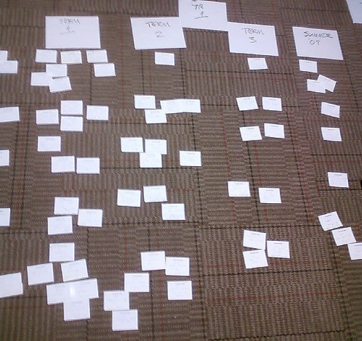

Begin to group sources into broad categories and then organize chronologically or alphabetically by author’s last name. Broad general categories might include:
- Themes or Concepts
- Theories
- Policies
- Programs
- Populations
- Methodologies
- Questions for further research
Other broad organization schemes might relate to the PICO or SPICE models mentioned in Chapter 3. We will discuss organization and synthesis in more detail in Chapter 7.
- Develop a standardized naming convention for folders and files. Names should be kept as short as possible whilst also being meaningful, concise, and standardized. For example, PolicyCttee2017 or GuidelinesRegulationsHarrison is more useful than LitReviewArticle1.
Other useful file naming conventions can be found The University of Edinburgh Records Management Office (2017). Examples include:
- Avoid unnecessary repetition and redundancy in file names and file paths.
- Use capital letters to delimit words, not spaces or underscores
- When including a personal name in a file name give the family name first followed by the initials.
- Avoid using common words such as ‘draft’ or ‘letter’ at the start of file names, unless doing so will make it easier to retrieve the record.
- Order the elements in a file name in the most appropriate way to retrieve the record.
- Avoid using non-alphanumeric characters in file names.
Take the time to think about your organizational system before you begin researching and compiling sources in earnest. “Organizing now will save much time and heartache later.” (Machi & McEvoy, 2012, p. 31).

6.2 Citation Management Tools
One of your first decisions – after selecting your topic – will be to determine which citation manager will work the best for you. Citation managers are software packages, such as EndNote or Zotero, used to create personalized databases of citations and notes. Citation management tools help users:
- import citations from databases, websites, and library catalogs
- create bibliographies
- format citations in a variety of styles such as APA, MLA, Chicago, and more
- manage, categorize, and organize citations and documents
- attach PDFs, images, and notes to citations in your collection.
While most current citation managers are generally similar, individual workflow may determine which tool to use. For example, if you will be working from multiple computers and locations, a web-based tool such as RefWorks and Mendeley will work better for you than a client-based or centrally hosted website. Other needs to consider when evaluating different citation managers:
- I need to work offline.
- I’ll be doing a lot of my research on freely available websites and need to be able to save copies of webpages.
- I’m working on a group project and need to share my references with others.
- I’m not so comfortable with technology and may potentially need a lot of help with my tool.
- I will be working on a mobile device.

6.2.1 Tips for choosing the right tool
There are many tools to choose from and you want to experiment with a few as well as discuss with professional colleagues, fellow students, or faculty before making a final decision on which to use. Choosing a tool ultimately depends on your personal workflow preferences and your needs.
General tips for choosing the right citation management tool:
- Consult Wikipedia’s detailed and updated comparison chart of citation management tools to determine if any tool is clearly the best fit for you.
- Talk to people in your department. Do individuals in your discipline tend to use one tool more often than another? Does your department or university already provide access to a specific tool?
- Talk to your subject librarian; s/he can recommend a tool based on your needs.
- Critically assess your technology skills and interests. Although all the tools advertise ease of use, there is a learning curve. Take a look at the free tutorials, help documents, and instruction manuals and rate your level of understanding and confidence.
Choose your citation management tool carefully. Try some out. Talk to colleagues. Once you’ve chosen a tool and started using it, changing to a different tool is problematic on several levels. If you save citations in two different products, it can be difficult to keep track of citations. Learning a new product or migrating information from one citation tool to another when you are in the middle of a project can also be difficult, time-consuming, and stressful. Choose carefully, but do choose and then stick with it.

6.2.2 Alerts
Alerts are an excellent way to keep up with the literature of your discipline. Alerts allow you to stay up to date with current research relevant to your topic. Once an alert is set up, you will automatically receive an email when an author’s publication, keywords, affiliations, or other search criteria appear in a database. You will be able to connect to the citation, download the citation and full text (when available) from the alert, and (if relevant) save to your citation manager. Alerts are a way to save time AND stay up-to-date in your topic area.

6.2.2.1 Why use alerts?
- Do you ever feel overwhelmed by the amount of time it takes to stay aware of the latest research and trends in your discipline?
- Do you have so many articles and journals in your “to read” pile that they end up being irrelevant by the time you get to them?
- Do you have a due date for your literature review, but can’t find time to check back for the latest updates on the topic?
If you answered yes to any of these questions, note that a number of database aggregators like ProQuest and EBSCO, as well as individual databases, such as ERIC and CINAHL, offer free alert services informing you of new journal issues, recently published articles related to your interests, and more. Most databases and journals use e-mail alerts to inform users of new content. Many researchers set up alerts through Google Scholar. For tips on how to set up alerts in Google Scholar, see the help page at: https://scholar.google.com/intl/en/scholar/help.html#alerts

6.2.2.2 Types of alerts
- Table of Contents (TOC) Alerts – These alerts inform users about new journal issues. Depending on the database and your preferred method of delivery, you will receive a table of contents for the issue or links to the full-text articles. Most TOC alerts are delivered via email, but they can also be subscribed to via RSS. A directory of thousands of current and scholarly TOCs is browsable at http://www.journaltocs.hw.ac.uk/. For a short 2 minute tutorial on how to set up journal alerts through PubMed, see https://www.nlm.nih.gov/bsd/viewlet/myncbi/jourup/index.html
- Saved Searches – A saved search alert will notify you when the database identifies new articles related to a customized search. You can specify how often you would like to receive updates (weekly, monthly, etc.).
- Citation Alerts – These alerts will inform you when a specified article is cited in a new publication.
Within your citation manager, you can set up custom folders to not only store new articles but also to share both alerts and articles with colleagues or fellow students researching similar topics.

6.3 Bibliographic citation format
Once you begin gathering sources for your literature review, you will need to organize and document them. Citations document the source of an idea, statement, or study. A uniform citation style helps both the reader and the writer. A standardized editorial style removes the distraction and confusion of puzzling over the correct punctuation for every reference or the proper formatting for numbers and other data in text. Those elements are codified in the rules of the format style, allowing the reader to focus energy on the substance of the research, rather than how the paper is constructed.
An author writing for publication must follow the rules established by the publisher to avoid inconsistencies. Without established rules of style, each manuscript might use different spellings, notations, and citations, which would confuse and distract readers. The need for a consistent style becomes more apparent and more visible when complex material is presented, such as tables or statistics. Without standardized rules for presentation of data, the reader would spend too much time and energy looking for meaning among the structure.
Likewise, a systematic and standardized bibliographic citation format helps the writer of the literature review keep track of references as they accumulate and find them more efficiently later in the process. “You will be rewarded for your hard work, if not in heaven, then certainly when you come to write your report. You will be able to locate information easily, to regroup and reclassify evidence and to produce referenced quotations to support your arguments.” (Bell, 2005, p. 74).
There are numerous different bibliographic citation format styles. APA (American Psychological Association), MLA (Modern Language Association), Chicago, Turabian, ACS (American Chemical Society), AMA (American Medical Association) , and IEEE (Institute of Electrical and Electronic Engineers) are some of the more common formats in use, but there are many more. The different styles, and different versions within each style, are a source of stress for generations of students and researchers in all disciplines, including those in the health sciences and education. In the social sciences, APA style is frequently used as the default citation style. Your department or discipline may require another format and, if so, that is the one you should accustom yourself with using to document your sources.

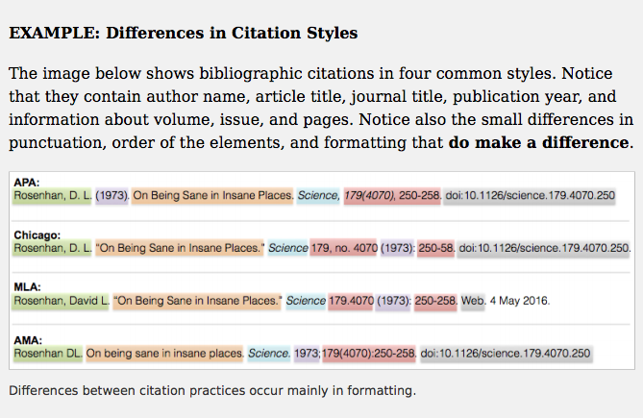

As there are over a dozen different citation styles and different disciplines prefer different styles, always check to see if your instructor requires a particular style. Also because the rules for citation styles can change and can be extensive, it is best to refer to the official handbooks/style guides when you can. (Teaching & Learning, 2015, p. 6).
Whatever citation style and format you decide to use, now is the time to make that decision. Consistently documenting your sources as you read is another way to plan and organize information as you go along, rather than at the end or in the middle.
In addition to print and online manuals detailing the specifics of each citation style, there are numerous websites and other resources that provide document citation formatting help. The Online Writing Lab (OWL) at Purdue University, for example, can answer most questions about APA, MLA, and Chicago style. University writing labs and subject specialist librarians may also help with correctly documenting sources and formatting style.
A useful open resource for graduate students in the social sciences is Professional Writing in the Health Disciplines by Sandra Collins (2016). In addition to discussing how to structure a graduate-level paper, a chapter on APA citation and reference formatting provides extensive detail on how to document sources. Additionally, Choosing & Using Sources: A Guide to Academic Research (Teaching & Learning, 2015) provides examples and advice for documenting sources using APA style formatting.

Practice
- Review a short introductory tutorial or brochure from each of these 4 citation management tools:
  - EndNote
  - Mendeley
  - RefWorks
  - Zotero

- Decide which citation management tool you are going to use and request a free trial or download/install a free version to test.
- Using the JournalTOCs website (www.journaltocs.hw.ac.uk), create an account, locate a journal in your topic area, and set up an email alert.

Test Yourself
See the Answer Key for the correct response.

QUESTION 1 – Choose a good folder and file naming convention:
- MyLitReview/Miscellaneous1
- RandomTheories/Supporting
- Guidelines/State
- Regulations/OtherStuff

QUESTION 2 – The advantage of choosing and using a citation management program is:
- import citations from databases, websites and library catalogs with a few clicks
- create bibliographies in APA style
- format citations in APA style
- manage, categorize and organize citations
- attach PDFs, images and other files to citations
- add notes, highlight text, share with colleagues
- all of the above

QUESTION 3 – In APA style documentation, what is the correct in-text, parenthetical format for a direct quotation?
- (Barrett, 1991, p. 17)
- (Barrett, p. 17, 1991)
- (Barrett : 17)
- (M.P. Barrett [1991]: 17)

QUESTION 4 – For journal articles included in the References list, does citation 1 or citation 2 use the correct APA format style:
- Poortman, Ann-Rigt. “How Work Affects Divorce: The Mediating Role of Financial and Time Pressures.” Journal of Family Issues 26.2 (2005): 168-180.
- Poortman, A. (2005). How work affects divorce: The mediating role of financial and time pressures. Journal of Family Issues 26(2), 168-180.

QUESTION 5 – Select the answer that best describes the function of the reference page
- Sources cited in the paper must appear on the reference page in alphabetical order.
- Books and articles read, but not cited in the paper, should be included on the reference page.
- Videos and blogs should be cited in the paper, but not included on the reference page.
- Sources listed on the reference page do not need to be cited within the paper.
For more practice deciphering APA citations, see the self-test exercises in Choosing & Using Sources.

References

Image attributions

Chapter 7

Chapter 7: Synthesizing Sources

Learning Objectives
At the conclusion of this chapter, you will be able to:
- synthesize key sources connecting them with the research question and topic area.

7.1 Overview of synthesizing

7.1.1 Putting the Pieces Together
Combining separate elements into a whole is the dictionary definition of synthesis. It is a way to make connections among and between numerous and varied source materials. A literature review is not an annotated bibliography, organized by title, author, or date of publication. Rather, it is grouped by topic to create a whole view of the literature relevant to your research question.



Your synthesis must demonstrate a critical analysis of the papers you collected as well as your ability to integrate the results of your analysis into your own literature review. Each paper collected should be critically evaluated and weighed for “adequacy, appropriateness, and thoroughness” (Garrard, 2017) before inclusion in your own review. Papers that do not meet this criteria likely should not be included in your literature review.
Begin the synthesis process by creating a grid, table, or an outline where you will summarize, using common themes you have identified and the sources you have found. The summary grid or outline will help you compare and contrast the themes so you can see the relationships among them as well as areas where you may need to do more searching. Whichever method you choose, this type of organization will help you to both understand the information you find and structure the writing of your review. Remember, although “the means of summarizing can vary, the key at this point is to make sure you understand what you’ve found and how it relates to your topic and research question” (Bennard et al., 2014).

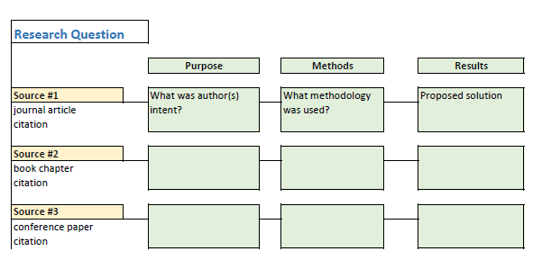

As you read through the material you gather, look for common themes as they may provide the structure for your literature review. And, remember, research is an iterative process: it is not unusual to go back and search information sources for more material.
At one extreme, if you are claiming, ‘There are no prior publications on this topic,’ it is more likely that you have not found them yet and may need to broaden your search. At another extreme, writing a complete literature review can be difficult with a well-trod topic. Do not cite it all; instead cite what is most relevant. If that still leaves too much to include, be sure to reference influential sources…as well as high-quality work that clearly connects to the points you make. (Klingner, Scanlon, & Pressley, 2005).

7.2 Creating a summary table
Literature reviews can be organized sequentially or by topic, theme, method, results, theory, or argument. It’s important to develop categories that are meaningful and relevant to your research question. Take detailed notes on each article and use a consistent format for capturing all the information each article provides. These notes and the summary table can be done manually, using note cards. However, given the amount of information you will be recording, an electronic file created in a word processing or spreadsheet is more manageable. Examples of fields you may want to capture in your notes include:
- Authors’ names
- Article title
- Publication year
- Main purpose of the article
- Methodology or research design
- Participants
- Variables
- Measurement
- Results
- Conclusions
Other fields that will be useful when you begin to synthesize the sum total of your research:
- Specific details of the article or research that are especially relevant to your study
- Key terms and definitions
- Statistics
- Strengths or weaknesses in research design
- Relationships to other studies
- Possible gaps in the research or literature (for example, many research articles conclude with the statement “more research is needed in this area”)
- Finally, note how closely each article relates to your topic. You may want to rank these as high, medium, or low relevance. For papers that you decide not to include, you may want to note your reasoning for exclusion, such as ‘small sample size’, ‘local case study,’ or ‘lacks evidence to support assertion.’
This short video demonstrates how a nursing researcher might create a summary table.

7.2.1 Creating a Summary Table

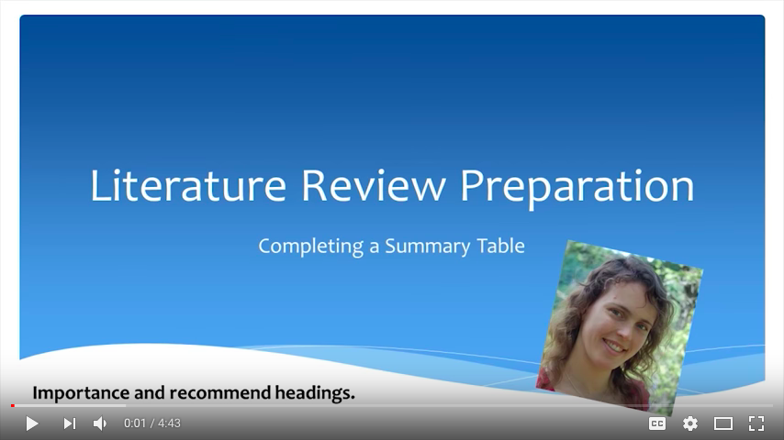

Killam, Laura (2013). Literature review preparation: Creating a summary table. Includes transcript.
Summary tables can be organized by author or by theme, for example:
Author/Year | Research Design | Participants or Population Studied | Comparison | Outcome
Smith/2010 | Mixed methods | Undergraduates | Graduates | Improved access
King/2016 | Survey | Females | Males | Increased representation
Miller/2011 | Content analysis | Nurses | Doctors | New procedure
For a summary table template, see http://blogs.monm.edu/writingatmc/files/2013/04/Synthesis-Matrix-Template.pdf

7.3 Creating a summary outline
An alternate way to organize your articles for synthesis it to create an outline. After you have collected the articles you intend to use (and have put aside the ones you won’t be using), it’s time to identify the conclusions that can be drawn from the articles as a group.
Based on your review of the collected articles, group them by categories. You may wish to further organize them by topic and then chronologically or alphabetically by author. For each topic or subtopic you identified during your critical analysis of the paper, determine what those papers have in common. Likewise, determine which ones in the group differ. If there are contradictory findings, you may be able to identify methodological or theoretical differences that could account for the contradiction (for example, differences in population demographics). Determine what general conclusions you can report about the topic or subtopic as the entire group of studies relate to it. For example, you may have several studies that agree on outcome, such as ‘hands on learning is best for science in elementary school’ or that ‘continuing education is the best method for updating nursing certification.’ In that case, you may want to organize by methodology used in the studies rather than by outcome.
Organize your outline in a logical order and prepare to write the first draft of your literature review. That order might be from broad to more specific, or it may be sequential or chronological, going from foundational literature to more current. Remember, “an effective literature review need not denote the entire historical record, but rather establish the raison d’etre for the current study and in doing so cite that literature distinctly pertinent for theoretical, methodological, or empirical reasons.” (Milardo, 2015, p. 22).
As you organize the summarized documents into a logical structure, you are also appraising and synthesizing complex information from multiple sources. Your literature review is the result of your research that synthesizes new and old information and creates new knowledge.

7.4 Additional resources:
Literature Reviews: Using a Matrix to Organize Research / Saint Mary’s University of Minnesota
Literature Review: Synthesizing Multiple Sources / Indiana University
Writing a Literature Review and Using a Synthesis Matrix / Florida International University
Sample Literature Reviews Grid / Complied by Lindsay Roberts

Practice
Select three or four articles on a single topic of interest to you. Then enter them into an outline or table in the categories you feel are important to a research question. Try both the grid and the outline if you can to see which suits you better. The attached grid contains the fields suggested in the video.

Literature Review Table
 |  |  |  |  | Findings | Gaps

Test Yourself
- Select two articles from your own summary table or outline and write a paragraph explaining how and why the sources relate to each other and your review of the literature.
- In your literature review, under what topic or subtopic will you place the paragraph you just wrote?

References

Image attribution

Chapter 8

Chapter 8: Writing the Literature Review

Learning Objectives
At the conclusion of this chapter, you will be able to:
- Begin to write your literature review
- Understand and be able to use the appropriate publication guidelines

8.1 Writing the literature review
You have discovered, retrieved, evaluated, synthesized, and organized the information you need for your literature review. It’s time to turn that stack of articles and papers and notes into a literature review. It’s time to start writing.



The graduate-level literature review is about both content and form. In terms of content, keep in mind that your literature review is intended to:
- Set up a theoretical framework for your own research
- Show a clear understanding of the key concepts/ideas/studies/models related to your topic
- Demonstrate knowledge about the history of your research area and any related controversies
- Illustrate that you are able to evaluate and synthesize the work of others
- Clarify significant definitions and terminology
- Develop a space in your discipline for your research
In other words, literature reviews
…clearly describe the questions that are being asked. They also locate the research within the ongoing scholarly dialogue. This is done by summarizing current understandings and by discussing why what we already knows leads to the need for the present research. Literature reviews also define the primary concepts. While this information can appear in any order, these are the elements in all literature reviews. (Loseke, 2017, p.67)
Some questions to ask yourself when you begin to write your first draft include:
- How will my literature review be organized: Chronologically, thematically, conceptually, methodologically or a combination?
- What section headings will I be using?
- How do the various studies relate to each other?
- What contributions do they make to the field?
- What are the limitations of a study/where are the gaps in the research?
- And finally but most importantly, how does my own research fit into what has already been done?
Some questions to ask after the first draft:
- Is there a logical flow from section to section, paragraph to paragraph, sentence to sentence?
- Does the content proceed from topic to topic?
- Does your conclusion match your introduction?
- Were you consistent in documenting and using the correct citation style?

8.2 Main features
No matter how you decide to organize your literature review (chronologically, thematically, etc.), it follows a format you will immediately recognize: Introduction, Body, Conclusion. We will look at each section individually.

8.2.1 Introduction
The introduction to the literature review contains a statement or statements about the overall topic of your dissertation or theses. This might be an paragraph or section that lets your reader know what your literature review is going to address. You will describe how the literature review will be organized (for example, what are the main points you are going to address and in what order will they appear?). You may choose to briefly describe search criteria (keywords, databases, journals) in this section, or you may do it in different parts of the review. It is suggested that this introductory section be no longer than two pages in length. The purpose is to lead your reader further into the body of the literature review.
In the introduction, you will:
- Define or identify the general topic, issue, or area of concern thereby providing an appropriate context for the remainder of the review
- Point out overall trends in what has been previously published on the topic; or conflicts in theory, methodology, evidence, conclusions, or gaps in research and scholarship
- Establish your reason for reviewing this research (point of view); explain the criteria used to search the literature; the organization of the review (sequence); and – if necessary – why certain literature either is or is not included (scope)
- Demonstrate how your research either closes a gap in the literature, extends earlier work, or replicates an important study thereby contributing new knowledge to your discipline.
More tips for the Introduction:
- Consider presenting a historical frame of reference
- Point out a landmark or seminal study
- Provide definitions for important terms
- Describe how your literature review was conducted
- Describe any inclusion or exclusion criteria used

8.2.2 Body

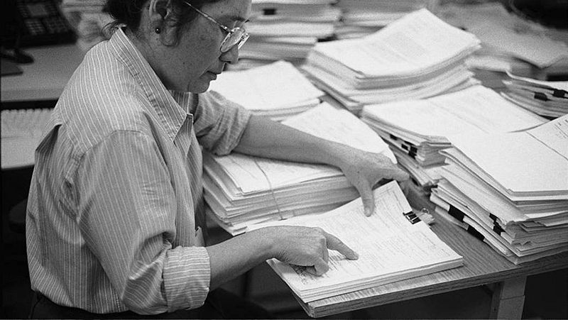

Some general tips for writing the body of your literature review:
- Start broad and then narrow to show how past research relates to your project.
- Make it clear to your reader where you’re going, follow a logical progression of ideas
- When appropriate, cite two or more sources for a single point but avoid long strings of references for a single point.
- Use quotes sparingly.
- Keep your own formal academic voice throughout and keep the review focused and objective, following a logical structure.
- Point out consistent findings AND emphasize stronger studies over weaker ones. Point out important strengths and weaknesses of research studies OR contradictions and inconsistent findings.
- Implications and suggestions for further research, or where there are gaps in the current literature, should be specific.

8.2.3 Conclusion
Summarize your literature review, discuss implications, and create a space for future or further research needed in this area. Like the introduction, this section should be around 3-5 pages in length. How do you know when you’re done? Can you answer these 11 questions:
- Have you clearly defined your topic and audience?
- Did you search and re-search the literature?
- Took notes while reading?
- Chosen the type of review you want to write?
- Have you kept the review focused throughout?
- Were you critical and consistent in your evaluation and synthesis?
- Is the structure of your review logical?
- Did you make use of feedback?
- Were you able to stay relevant and objective throughout?
- Did you maintain an objective voice?
- Did you cite current and older studies? (Pautasso, 2013).

8.2.4 List of references
The reference list of publications used in your literature review serves two purposes. First, it provides your reader with a means to evaluate the quality of your research. Second, accurately and correctly citing all the sources used in your work protects you from possible accusations of plagiarism. Using the words or ideas of others without referencing your source is a very serious academic offense.
The reference list is a reflection of the thoroughness of your review. It also allows others to retrieve the publications you cite. Errors made in authors’ names, journal or article titles, page numbers and dates may present barriers to retrieval of articles and may prevent giving credit to authors for their work. Each reference should be checked carefully for errors. Every in text citation must have a listing in the references and every title in the reference list should connect to an in-text citation.

8.3 Tips for Structure
The literature reviews generally move from general to more specific, taking in all the elements mentioned previously.



Build your story by identifying areas of consensus and areas of divergence. For example
- It seems there is agreement among researchers…
- Much debate exists on the issue of…
Possible structures:
Distant to close – the most distantly related to your work leading to the most closely related to your work.
Chronological – earliest related work to most recent related work.
Compare and contrast valid approaches, features, characteristics, theories – that is, one approach, then a 2nd approach, followed by a 3rd approach.
Finally, consider the use of summary paragraphs throughout the body of the review. For example:
- In summary, the evidence presented demonstrates that…
- Rather, this literature supports the theory that…
- Consequently, the population studied may experience…
- However, alternative ideas and findings suggest…

8.4 An Example and A Checklist
An example of the possible structure for a literature review:
Introduction
Establish the importance of the topic
Number and type of people affected
Seriousness of the impact
Physical, psychological, economic, social aspects
Definitions of key terms
Literature review strategies
Description of the extent and nature of the literature
Overview of the organization of the rest of the review
Body of the review
Topic 1
Supporting evidence
Topic 2
Supporting evidence
Topic 3
Supporting evidence
Summary of the review
Discussion
Conclusions
Implications
Suggestions for future research
List of references
After you have written your first draft, use this checklist to review your progress:
- Fill in the topic outline with brief notes.
- Do not write a string of annotations.
- Cite two or more sources for a single point, but avoid long strings of references for a single point. Consider using e.g. when there are a large number of sources for a single point.
- Use quotations sparingly.
- Emphasize stronger studies over weaker ones.
- Point out strengths and weaknesses of the research cited.
- Point out consistent findings in a body of literature.
- Point out contradictions or inconsistent findings as well.
- Identify gaps.
- Indicate when previous literature reviews are cited.
- Implications and suggestions for future research should be specific, not just ‘more research is needed.’

8.5 In Summary
Like any effective argument, the literature review must have some kind of structure. For example, it might begin by describing a phenomenon in a general way along with several studies that demonstrate it, then describing two or more competing theories of the phenomenon, and finally presenting a hypothesis to test one or more of the theories. Or it might describe one phenomenon, then describe another phenomenon that seems inconsistent with the first one, then propose a theory that resolves the inconsistency, and finally present a hypothesis to test that theory. In applied research, it might describe a phenomenon or theory, then describe how that phenomenon or theory applies to some important real-world situation, and finally suggest a way to test whether it does, in fact, apply to that situation.
Looking at the literature review in this way emphasizes a few things. First, it is extremely important to start with an outline of the main points that you want to make, organized in the order that you want to make them. The basic structure of your argument then should be apparent from the outline itself. Second, it is important to emphasize the structure of your argument in your writing. One way to do this is to begin the literature review by summarizing your argument even before you begin to make it, “In this article, I will describe two apparently contradictory phenomena, present a new theory that has the potential to resolve the apparent contradiction, and finally present a novel hypothesis to test the theory.” Another way is to open each paragraph with a sentence that summarizes the main point of the paragraph and links it to the preceding points. These opening sentences provide the “transitions” that many beginning researchers have difficulty with. Instead of beginning a paragraph by launching into a description of a previous study, such as “Williams (2004) found that…,” it is better to start by indicating something about why you are describing this particular study. Here are some simple examples:
Another example of this phenomenon comes from the work of Williams (2004).
Williams (2004) offers one explanation of this phenomenon.
An alternative perspective has been provided by Williams (2004).
We used a method based on the one used by Williams (2004).
Finally, remember that your goal is to construct an argument for why your research question is interesting and worth addressing—not necessarily why your favorite answer to it is correct. In other words, your literature review must be balanced. If you want to emphasize the generality of a phenomenon, then of course you should discuss various studies that have demonstrated it. However, if there are other studies that have failed to demonstrate it, you should discuss them too. Or if you are proposing a new theory, then of course you should discuss findings that are consistent with that theory. However, if there are other findings that are inconsistent with it, again, you should discuss them too. It is acceptable to argue that the balance of the research supports the existence of a phenomenon or is consistent with a theory (and that is usually the best that researchers in psychology can hope for), but it is not acceptable to ignore contradictory evidence. Besides, a large part of what makes a research question interesting is uncertainty about its answer. (University of Minnesota, 2016).

8.6 Additional resources
Doing a literature review / University of Leicester
Get Lit: The Literature Review / Texas A&M Writing Centre

Practice
- What writing problems do you see in the following introductory paragraph? See the Answer Key for the correct response.
In the opening chapter I have attempted to outline and motivate my study of graduate student writing in a school of nursing [or education]. The purpose of this chapter is to relate my study to previous scholarly attempts to describe, analyze and explain academic writing and the processes of its acquisition. One purpose here is to establish what has been revealed in other academic contexts as a basis for the findings of my study. Another purpose is to attempt a critical evaluation of the research so far.
- Write a 3-sentence statement when this is all that is known:
- There are 5 studies
- 3 describe online programs
- 1 study looks at outcomes; one is positive and one is negative
- No studies compare outcomes with in-class teaching

Test Yourself
Read through this summary webpage on literature and make sure you have answered or are able to answer all the questions posed:
Structuring your assignment / Queensland University of Technology Australia
Writing a Literature Review / RMIT University Australia

References

Image Attribution

Chapter 9

Conclusion
When you began looking through this book, you may have already been an accomplished researcher and writer. As a student, you may have had both research and writing experiences as an undergraduate that prepared you for your first graduate-level literature review. For most graduate students, however, many of the concepts and skills needed to successfully complete this high-stakes document will be new. And, while developing these skills is not always a linear process, the effort put into acquiring them will serve you throughout both your academic and professional life.
Here is a quick review of the main points from each of the chapters in this book:
- The purpose of a literature review is to survey the current state of knowledge in the area of inquiry; to identify key authors, articles, theories, and findings in that area; and to identify gaps in knowledge in that research area. (Chapter 1)
- Some common errors in many first-time literature reviews include:
  - Accepts another researcher’s finding as valid without evaluating methodology and data
  - Neglects to consider or mention contrary findings and alternative interpretations
  - Findings are not clearly related to one’s own study or findings are too general.
  - Allows insufficient time to define best search strategies and writing
  - Simply reports individual studies rather than synthesizing the results
  - Problems with selecting and using most relevant keywords and descriptors are evident.
  - Relies too heavily on secondary sources
  - Does not record or report search procedures
  - Summarizes rather than synthesizes (Chapter 1)

- By understanding what the literature in your field is, as well as how and when it is generated, you begin to know what is available and where to look for it. (Chapter 2)
- Most graduate-level literature reviews begin with choosing a relevant, appropriate, interesting topic and then changing it. (Chapter 3)
- Search and discovery of the literature is an iterative process. There are many places to look and many tools and techniques to use to find resources. Advanced researchers master this skill early on and refine it with each project. (Chapter 4)
- You searched the literature and found lots of relevant resources. How do you now determine whether each item is an appropriate fit for your own review? (Chapter 5)
- How will your resources be organized (alphabetically or chronologically)? By broad general theme or theory? Based on a type of methodology or population? What citation management program or software are you going to use to keep track of all your references? (Chapter 6)
- Your literature review is not a summary of all the articles you read but rather a synthesis that demonstrates a critical analysis of the papers you collected as well as your ability to integrate the results of your analysis into your own literature review. (Chapter 7)
- Like any effective argument, the literature review is about both content and form. It should have logical and smooth flow, a clear introduction and conclusion, and use a consistent citation style throughout. (Chapter 8)
Remember: Writing a good literature review takes time. Start early. Begin thinking about your topic and collect references even while you work on other tasks. Write a first draft and then revise. Go over the language, style, and form. Focus, sharpen, clarify, and search again. When you are satisfied with the result, you’re done.

How is the literature review evaluated?
It is usually judged in three main areas:
- Selection of the literature
  - Have you clearly indicated the scope and purpose of the review?
  - Have you included a balanced coverage of what is available?
  - Have you included the most recent and relevant studies?
  - Have you included enough material to show the development and limitations in this area?
  - Have you indicated the source of the literature by referencing accurately?
  - Have you used mostly primary sources or appropriate secondary sources?

- Critique of the literature
  - Have you clearly (and logically) ordered and sorted the research, focusing on themes or ideas rather than the authors?
  - Does the review move from broader concepts to a more specific focus?
  - Is there adequate critique of research limitations, including design and methodology?
  - How do the studies compare or contrast with debates or controversies highlighted?
  - Is the relevance to your problem clear?

- Summary and interpretation of the literature
  - Have you made an overall interpretation of what is available?
  - Do the implications provide theoretical or empirical justification for your own research questions/hypothesis?
  - Do the implications provide a rationale for your research design? (RMIT University)

Many instructors use rubrics to evaluate literature reviews. For a sample of a literature review rubric that may also serve as a checklist for evaluating your own review before submitting, see Holmlund (2019) also listed in the Additional Resources section for this chapter.
We hope that this discussion about literature reviews is useful. After reading this guide, and reviewing the additional resources and activities in each chapter, we hope you have a better understanding of the research and writing process. What conclusions have you reached regarding the content and structure of a literature review that can answer the question, “How do I write a graduate-level literature review?”

Additional Resources
Bell, J. (2005). Doing Your Research Project: A Guide for First-Time Researchers in Education, Health and Social Science (4th ed.). New York: Open University Press.
Booth, A., Sutton, Anthea, & Papaioannou, Diana. (2016). Systematic Approaches to a Successful Literature Review (2nd ed.). Los Angeles: Sage Publications.
Collins, S. (2016). Professional Writing in the Health Disciplines. http://epub-fhd.athabascau.ca/professionalwriting/ CC-BY-NC-SA 4.0
Coughlan, M., & Cronin, Patricia. (2017). Doing a Literature Review in Nursing, Health and Social Care (2nd ed.). Los Angeles: Sage Publications.
Fink, A. (2014). Conducting Research Literature Reviews (4th ed.). Los Angeles, CA: Sage Publications.
Galvan, J.L. (2009). Writing Literature Reviews: A Guide for Students of the Social and Behavioral Sciences. Glendale, CA : Pyrczak
Garrard, J. (2017). Health Sciences Literature Review Made Easy: The Matrix Method. Burlington, MA: Jones & Bartlett Learning.
Holmlund, T. (2019). Sample Literature Review. Washington State University Vancouver. CC-BY-NC 4.0
Machi, L.A., & McEvoy, B.T. (2012). The Literature Review: Six Steps to Success. Thousand Oaks, CA: Corwin.
Milardo, R.M. (2015). Crafting Scholarship in the Behavioral and Social Sciences: Writing, Reviewing, and Editing. New York: Routledge.
Pautasso M. (2013). Ten simple rules for writing a literature review. PLoS Computational Biology 9(7): e1003149. https://doi.org/10.1371/journal.pcbi.1003149
Petticrew, M., & Roberts, H. (2006). Systematic Reviews in the Social Sciences. Malden, MA: Blackwell Publishing.
Wallace, M., & Wray, A. (2016). Critical Reading and Writing for Postgraduates (3rd ed.). Los Angeles, CA: Sage Publications.

References
RMIT University (n.d.). Writing the literature review/Using the literature. https://www.dlsweb.rmit.edu.au/lsu/content/2_assessmenttasks/assess_pdf/PG%20lit%20review.pdf

1

Appendix

Answer Key

Chapter 1: Practice
Abstract 1: Integrative. Frequently the type of literature review will be clearly given in either the article title or in the abstract. In this case, the authors describe their work as “An integrative literature review between 2004 and 2015…” Additionally, the methodology section of the article may further describe the research methodology and why the integrative approach was chosen.
Abstract 2: Meta-analysis. The authors describe their methodology in this way: “The research design of this study is meta-analysis. Instead of students or schools, we use prior studies as our unit of analysis. Meta-analysis allows researchers to gather information about prior studies and then estimate effect sizes of various components of the combined research studies.”

Chapter 1: Test Yourself
- False. A graduate-level literature review is a compilation of the most significant previously published research on your topic
- True
- Narrative. “During the preparation of this narrative review, the literature on e-cigarettes available within the network PubMed was retrieved and examined.”
- Focused. “She wishes to construct a narrowly-focused and succinct literature review of thinkers who have donned a feminist lens to analyze Dewey’s approaches to education…”

Chapter 2: Practice
- Good places to find basic information on any topic are textbooks, and encyclopedia. You may also find a book chapter that will be able to give you the basics. If you were looking for a quick answer or definition, the Web can give you some ideas though you would need to be more critical of the source.
- Often these radio broadcasts, or news items in newspapers or magazines will give you enough information to find a study. They may state where a study was published, the names of the researchers, where the study was conducted, etc. Using these clues you can do a web search for more details and find a citation for a journal article or conference proceeding. Another way to find the study is to go to a subject specific database that indexes articles from scholars in that discipline and use your clues and search terms about the study and see what you find.
- Trade publications are a good place to find practical information about how professionals are applying research to everyday practice. For some issues you might find monographs that cover practical application, too. Always be aware of who is writing these articles and books. Are qualified to speak on the topic?
- Grant applications will require you to show what is being published on the research topic you want to explore. They will require you to cite studies from journals that are scholarly and peer reviewed. It is also possible to cite conference proceedings and professional websites but journal articles will likely be the bulk of your evidence that the topic is of interest and that you have checked to see if anyone else has done this study before.
- Remember that primary sources are those that came first. You could look for newspaper articles or advertisements from the time period you are studying. Diaries might also be a source of information as well as medical books published during that time. Historical societies and museums also have artifacts and old print material. There are some encyclopedias and monographs that contain historical documents and there are many that are digitized and can be found on the Web.
- To be sure there are no other theses like the one you want to write you can look in dissertation and theses databases, such as ProQuest’s Dissertation Express or search the web to see if any are available.
- Check any Facebook hyperlinks to determine the quality and authenticity of the source. You can also look at fact-checking sites such as Snopes.com, FactCheck.org or PolitiFact.com to determine the veracity or accuracy of a posting.

Chapter 2: Test Yourself
- Match the type of periodical to its content:
- Magazine – contains articles about a variety of topics of popular interest and contains advertising.
- Trade publication – has information about industry trends and practical information for professionals in a field.
- Scholarly journal – written by scholars in an academic field and reviewed by experts in that field.
- Put the following information sources in order from the least accurate and reliable to the most accurate and reliable. (1 least accurate/4 most accurate)
- News broadcasts and social media directly following an event.
- Analysis of an event in the news media or popular magazine weeks after an event.
- Articles written by scholars and published in a journal.
- Books and encyclopedias
- What is the information called that is either a diary, a speech, original research, data, artwork, or a religious book?
Primary
- To find the best information in databases you need to use keywords that are used by the scholars. Where do you find out what keywords to try?
All of the above
- Which of the following is NOT true about scholarly journals?
They are of interest to the general public

Chapter 3: Practice
- Which of the following questions seems the most viable for further study and why?
- Defines and describes a population (rural adult learners) and sets up a comparison with another population (adult learners in general). Potential to broaden or narrow scope and depth as needed.
Questions b) and c) are more descriptive and lack specifics.
- Can you spot the research question? What are the PICO factors for each?
- What types of workplace hazards do nursing assistants face? Population (nursing assistants in the US); Outcome (prevention, improved training)
- What are the family needs of children affected by parental mental health problems? Population (families affected by mental health issues); Comparison (needs of parents/needs of children)
- What are the contributions of music to peacebuilding? Intervention (music); Comparison (peacekeeping/violence)
- What health literacy programs are available for older adults? Population (older adults); Intervention (health literacy programs)
- Are reading instruction programs effective for English language learners? Population (English language learners); Intervention (reading instruction programs)
- Are cultural interventions effective in treating addictions? Population (indigenous people with addictions); Intervention (culture-based programs); Outcomes (dimension of wellness)

Chapter 3: Test Yourself
- False
- B
- A
- D
- No
- 2

Chapter 4: Practice
Self-guided study

Chapter 4: Test Yourself
Self-guided study

Chapter 5: Practice
Self-guided study

Chapter 5: Test Yourself
For Nursing students: #1 is the correct answer. Although article #2 concerns vaccinations, it does not appear to link to autism.
For Education students: #2 is the correct answer. Although #1 concerns music intervention, your topic is about therapy, not vaccinations.

Chapter 6: Practice
Self-guided study

Chapter 6: Test Yourself
- Guidelines/State
- All of the above
- (Barrett, 1991, p. 17)
- Poortman, A. (2005). How work affects divorce: The mediating role of financial and time pressures. Journal of Family Issues 26(2), 168-180.
- Sources cited in the paper must appear on the reference page in alphabetical order

Chapter 7: Practice
Self-guided study

Chapter 7: Test Yourself
Self-guided study

Chapter 8: Practice
- For example: This introductory paragraph does state an overall topic (graduate student writing among nursing or education students) however:
- The tone and style of a literature review is formal, generally written in the third person
- In the first sentence, ‘motivate’ may not be the correct term. Perhaps ‘inform’ would be more appropriate here
- Although ‘purpose’ of the chapter is mentioned several times, it is unclear if the literature review has one purpose or several purposes. If the only purpose of this review is to critically evaluate previous research, that should be stated more clearly
- Later sentences and paragraphs must also:
  - Establish your reason for undertaking this research and your point of view. The reader doesn’t know from this paragraph what ‘my study’ means
  - Define the general topic and thereby provide an appropriate context for the remainder of the review
  - Point out gaps in the existing literature that your research will fill
  - Describe how the lit review will be organized

- Review this module for more ideas on how to prepare an introduction to your own literature review.
- For example: The search strategy yielded five different studies. Three described online programs in general; 1 looked specifically at positive outcomes of online programs, the other described negative aspects. No studies that assessed outcomes for in-class compared to online teaching were found.

Chapter 8: Test Yourself
Self-guided study

Literature Review Example for Education
Kose, L. K. (2013). Challenges of charter schools with special education: Issues of concern for charter school authorizers and services providers. Mid-Atlantic Education Review 1(1), 36-45. http://maereview.org/index.php/MAER/article/view/7/7
Author retains copyright and grants license of first publication to the Mid -Atlantic Education Review. Article published under a Creative Commons BY-NC license. Readers may copy and distribute for non-commercial purposes provided they indicate original authorship and original publication.

Literature Review Example for Nursing
Balzer, K., Bremer, M., Schramm, S., Luhmann, D., & Raspe, H. (2012). Falls prevention for the elderly. GMS Health Technology Assessment 8, 1-18. http://www.egms.de/static/en/journals/hta/2012-8/hta000099.shtml
This is an Open Access article distributed under the terms of the Creative Commons Attribution License (http://creativecommons.org/licenses/by-nc-nd/3.0/deed.en). You are free: to Share – to copy, distribute and transmit the work, provided the original author and source are credited.

2

References (By Chapter)

Chapter 1
Amundsen, C., & Wilson, M. (2012). Are we asking the right questions? A conceptual review of the educational development literature in higher education. Review of Educational Research, 82(1), 90-126. doi: 10.3102/0034654312438409
Bendermacher, G., Egbrink, M., Wolfhagen, I., & Dolmans, D. (2017). Unraveling quality culture in higher education: A realist review. Higher Education 73(1), 39-60. doi:10.1007/s10734-015-9979-2
Bhattacherjee, A., (2012). Social science research: Principles, methods, and practices. Textbooks Collection. 3. http://scholarcommons.usf.edu/oa_textbooks/3
Boote, D., & Beile, P. (2005). Scholars before researchers: On the centrality of the dissertation literature review in research preparation. Educational Researcher 34(6), 3-15.
Brock, A., & Ryan, T. (2016). Exploring the gap between teacher certification and permanent employment in Ontario: An integrative literature review. Canadian Journal of Educational Administration and Policy 175. http://files.eric.ed.gov/fulltext/EJ1086899.pdf
Capar, G., & Tarim, K. (2015). Efficacy of the cooperative learning method on mathematics achievement and attitude: A meta-analysis research. Educational Sciences: Theory and Practice 15(2), 553-559. http://files.eric.ed.gov/fulltext/EJ1060189.pdf
Cuttance, P. (1981). School effects research: A synoptic review of past efforts and some suggestions for the future. Journal of Sociology 17(3), 65-69.
Dohn, N. (2010). The formality of learning science in everyday life: A conceptual literature review. Nordic Studies in Science Education. https://www.journals.uio.no/index.php/nordina/article/view/250/303
Duncan, G., Leak, J., Li, W., Magnuson, K., Schindler, H., & Yoshikawa, H. (2011). Timing issues with early childhood education programs: How effect sizes vary by starting age, program duration and persistence of effects. Society for Research on Educational Effectiveness. https://eric.ed.gov/?q=%22a+meta-analysis%22&ft=on&id=ED519340
Fear, W., & Erikson-Brown, A. (2014). Good quality discussion is necessary but not sufficient in asynchronous tuition: A brief narrative review of the literature. Journal of Asynchronous Learning Networks 18(2). http://files.eric.ed.gov/fulltext/EJ1036265.pdf
Fragkos, K. (2016). Reflective practice in healthcare education: An umbrella review. Education Sciences 6(27). http://files.eric.ed.gov/fulltext/EJ1116801.pdf
Franklin, C., Bernhardt, J., Lopez, R., Long-Middleton, E., & Davis, S. (2015). Interprofessional teamwork and collaboration between community health workers and healthcare teams: An integrative review. Health Services Research and Managerial Epidemiology. https://www.ncbi.nlm.nih.gov/pubmed/28462254
Ghaicha, A. (2016). Theoretical framework for educational assessment: A synoptic review. Journal of Education and Practice 7(24), 212-231. http://files.eric.ed.gov/fulltext/EJ1112912.pdf
Hartmann, S., Braae, L., Pedersen, S., & Khalid, M. (2017). The potentials of using cloud computing in schools: A systematic literature review. Turkish Online Journal of Educational Technology – TOJET 16(1), 190-202. http://files.eric.ed.gov/fulltext/EJ1124903.pdf
Hattie, J., Marsh, H. W., Neill, J. T., & Richards, G. E. (1997). Adventure education and Outward Bound: Out-of-class experiences that make a lasting difference. Review of Educational Research, 67(1), 43-87. doi: 10.3102/00346543067001043
Hemsley-Brown, J., & Sharp, C. (2003). The use of research to improve professional practice: a systematic review of the literature. Oxford Review of Education, 29(4), 449-471. doi: 10.1080/0305498032000153025
Houser, J., (2018). Nursing Research Reading, Using, and Creating Evidence (4th ed.). Burlington, MA: Jones & Bartlett.
Imberger, G., Thorlund, K., Gluud, C., & Wetterslev, J. (2016). False-positive findings in Cochrane meta-analyses with and without application of trial sequential analysis: an empirical review. BMJ Open, 6(8). https://www.ncbi.nlm.nih.gov/pubmed/27519923
Jankowski, M., Brożek, G., Lawson, J., Skoczyński, S., & Zejda, J. (2017). E-smoking: Emerging public health problem? International Journal of Occupational Medicine and Environmental Health, 30(3), 329-344. doi: 10.13075/ijomeh.1896.01046
Khanassov, V., Pluye, P., Descoteaux, S., Haggerty, J., Russell, G., Gunn, J., & Levesque, J. (2016). Organizational interventions improving access to community-based primary health care for vulnerable populations: a scoping review. International Journal for Equity in Health. https://www.ncbi.nlm.nih.gov/pubmed/27724952
Khunti, S., Davies, M., & Khunti, K. (2015). Clinical inertia in the management of type 2 diabetes mellitus: a focused literature review. British Journal of Diabetes and Vascular Disease, 15, 65-69. http://www.bjd-abcd.com/index.php/bjd/article/view/69
Lee, J., Lee, Y, Gong, S., Bae,J., & Choi, M. (2016). A meta-analysis of the effects of non-traditional teaching methods on the critical thinking abilities of nursing students. BMC medical education, 16(1). https://www.ncbi.nlm.nih.gov/pubmed/27633506
Levy, Y. & Ellis, T. (2006). A systems approach to conduct an effective literature review in support of information systems research. Informing Science Journal, 9, 181-212. http://www.inform.nu/Articles/Vol9/V9p181-212Levy99.pdf
Machi, L., & McEvoy, B. (2012). The Literature Review: Six Steps to Success (2nd ed). Thousand Oaks, CA: Corwin.
Majumder, K. (2015). A young researcher’s guide to a system review. http://www.editage.com/insights/a-young-researchers-guide-to-a-systematic-review#
Mazzocato P, Savage C, Brommels M, Aronsson, H., & Thor, J. (2010). Lean thinking in healthcare: a realist review of the literature. Quality and Safety in Health Care, 19, 376-382. http://qualitysafety.bmj.com/content/19/5/376.long
Morris, S., King, C., Turner, M., & Payne, S. (2015). Family carers providing support to a person dying in the home setting: A narrative literature review. Palliative Medicine, 29(6), 487-495. https://www.ncbi.nlm.nih.gov/pmc/articles/PMC4436280/
Mwakyusa, W., & Mwalyagile, N. (2016). Impediments of e-learning adoption in higher learning institutions of Tanzania: An empirical review. Journal of Education and Practice, 7(30), 152-160. http://files.eric.ed.gov/fulltext/EJ1118921.pdf
Nowrouzi, B., Giddens, E., Gohar, B., Schoenenberger, S., Bautista, M. C., & Casole, J. (2016). The quality of work life of registered nurses in Canada and the United States: a comprehensive literature review. International Journal Of Occupational & Environmental Health, 22(4), 341-358. doi:10.1080/10773525.2016.1241920
O’Gorman, K., & MacIntosh, R. (2015). Research Methods for Business & Management: A Guide to Writing Your Dissertation. (2nd ed.). Oxford: Goodfellow Publishers.
Pal K, Eastwood S., Michie S., Farmer A., Barnard M., Peacock R, Wood B, Inniss J., & Murray E. (2013). Computer‐based diabetes self‐management interventions for adults with type 2 diabetes mellitus. Cochrane Database of Systematic Reviews 2013, Issue 3. Art. No.: CD008776. doi:10.1002/14651858.CD008776.pub2.
Pimpin L., Wu J., Haskelberg H, Del Gobbo L., & Mozaffarian D. (2016) Is butter back? A systematic review and meta-analysis of butter consumption and risk of cardiovascular disease, diabetes, and total mortality. PLoS ONE 11(6): e0158118. Doi: 10.1371/journal.pone.0158118
Ridde, V., & Morestin, F. (2011). A scoping review of the literature on the abolition of user fees in health care services in Africa. Health Policy and Planning, 26(1), 1-11. doi: 10.1093/heapol/czq021.
Rocco, T. & Plathotnik, M. (2009). Literature reviews, conceptual frameworks. Human Resource Development Review, 8(1), 120-130. p. 128, 2009. http://citeseerx.ist.psu.edu/viewdoc/download?doi=10.1.1.1023.5634&rep=rep1&type=pdf
Rosario, R. A. M., & Widmeyer, G. R. (2009). An exploratory review of design principles in constructivist gaming learning environments. Journal of Information Systems Education, 20(3), 289-300. http://jise.org/Volume20/20-3/Pdf/20N3P289-abs.pdf
Schuetzenmeister, F. (2010). University research management: An exploratory literature review. Institute of European Studies. UC Berkeley: Institute of European Studies. Retrieved from: http://escholarship.org/uc/item/77p3j2hr
Seida, J. K., Ospina, M. B., Karkhaneh, M., Hartling, L., Smith, V., & Clark, B. (2009). Systematic reviews of psychosocial interventions for autism: an umbrella review. Developmental Medicine & Child Neurology, 51(2), 95-104. doi:10.1111/j.1469-8749.2008.03211.x.
Stainton, C. (1992). Language awareness: Genre awareness-a focused review of the literature. Language Awareness, 1(2), 109-121
Thomson, P. (2013), Not all literature reviews are the same. https://patthomson.net/2013/05/23/not-all-literature-reviews-are-the-same/
Tonhäuser, C. & Büker, L. 2016). Determinants of transfer of training: A comprehensive literature review. International Journal for Research in Vocational Education and Training (IJRVET), 3(2), 127-165. http://files.eric.ed.gov/fulltext/ED568698.pdf. doi: 10.13152/IJRVET.3.2.4
Vanstone, M., Hibbert, K., Kinsella, E., McKenzie, P., Pitman, A., & Lingard, L. (2013). Interdisciplinary doctoral research supervision: A scoping review. Canadian Journal of Higher Education, 43(2), 42-67. http://files.eric.ed.gov/fulltext/EJ1013587.pdf
Webster, J., & Watson, R. (2002). Analyzing the past to prepare for the future: Writing a literature review. MIS Quarterly, 26(2), xiii-xxiii. https://web.njit.edu/~egan/Writing_A_Literature_Review.pdf
Wegner, W., Silva, M., Peres, M., Bandeira, L., Frantz, E., Botene, D., & Predebon, C. (2017). Patient safety in the care of hospitalised children: Evidence for paediatric nursing. Revista gaúcha de enfermagem, 38(1). doi: 10.1590/1983-1447.2017.01.68020.
Williams, E. S., & Skinner, A. C. (2003). Outcomes of physician job satisfaction: a narrative review, implications, and directions for future research. Health care management review, 28(2), 119-139.
Whittemore, R., & Knafl, K. (2005). The integrative review: Updated methodology. Journal of Advanced Nursing 52(2), 546-53. http://onlinelibrary.wiley.com/doi/10.1111/j.1365-2648.2005.03621.x/epdf
Vorsino, M. (2015). Re-reading Dewey through a feminist lens. Educational Perspectives, 47(1-2), 50-54. http://files.eric.ed.gov/fulltext/EJ1088345.pdf

Chapter 2
Great Schools Partnership. (2016). The Glossary of Education Reform. http://edglossary.org/action-research/
Hansen, K., & Paul, N. (2015). Disciplines of knowledge. In Information Strategies for Communicators. http://open.lib.umn.edu/infostrategies/chapter/6-7-disciplines-of-knowledge/
Hansen, K., & Paul, N. (2015). Scholarly sources. In Information Strategies for Communicators. http://open.lib.umn.edu/infostrategies/chapter/6-4-scholarly-sources/
Houser, J., (2018). Nursing Research Reading, Using, and Creating Evidence (4th ed.). Burlington, MA: Jones & Bartlett.
Wallace, M., & Wray, A. (2016). Critical Reading and Writing for Postgraduates (3rd ed.). Thousand Oaks, CA: Sage Publications.
Writing for Success (2015). Strategies for gathering reliable information. http://open.lib.umn.edu/writingforsuccess/chapter/11-4-strategies-for-gathering-reliable-information/

Chapter 3
D’Antoni, A. V., & Pinto Zipp, G. (2006). Applications of the mind map learning technique in chiropractic education: A pilot study and literature review. Journal of Chiropractic Humanities, 13, 2-11.
Dhanga, N., & Taheri, S. (2017). A narrative review of obesity and hearing loss. International Journal of Obesity. doi: 10.1038/ijo.2017.32
Dittman, M. (2005). Starting the dissertation. gradPSYCH 3(1). http://www.apa.org/gradpsych/2005/01/starting.aspx
Early Childhood Longitudinal Program (ECLS). (2011). Example research questions. https://nces.ed.gov/ecls/researchquestions2011.asp
Kefalianos, E., Onslow, M., Block, S., Menzies, R., & Reilly, S. (2012). Early stuttering, temperament and anxiety: Two hypotheses. Journal of Fluency Disorders 37(3), 151-163.
Leslie, M., Floyd, J., & Oermann, M. (2002). Use of MindMapper software for research domain mapping. Computers, informatics, nursing : CIN, 20(6), 229-35.
Manafo, E., & Wong, S. (2012). Health literacy programs for older adults: A systematic literature review. Health Education Research 27(6), 947-960.
Pain, E. (2016). How to (seriously) read a scientific paper. http://www.sciencemag.org/careers/2016/03/how-seriously-read-scientific-paper
Rowan, M., Poole, N., Shea, B., Gone, J., Mykota, D., Farag, M., Hopkins, C., Hall, L. Mushquash, C., & Dell, C. (2014). Cultural interventions to treat addictions in indigenous populations: Findings from a scoping study. Substance Abuse Treatment, Prevention, and Policy 9(34). doi: 10.1186/1747-597X-9-34.
Sandoval, E. (2016). Music in peacebuilding: A critical literature review. Journal of Peace Education 13(3), 200-217.
Snyder, E., Witmer, S., & Schmitt, H. (2017). English language learners and reading instruction: A review of the literature. Preventing School Failure 61(2), 136-145.
Walton, A., & Rogers, B. (2017). Workplace hazards faced by nursing assistants in the United States: A focused literature review. International Journal of Environmental Research and Public Health, 14(5). https://www.ncbi.nlm.nih.gov/pubmed/28534859
Wahl P, Bruland D, Bauer U, Okan O, & Lenz A. (2017). What are the family needs when a parent has mental health problems? Evidence from a systematic literature review. Journal of Child and Adolescent Psychiatric Nursing, 30, 54–66. https://doi.org/10.1111/jcap.12171

Chapter 4
Bernnard, D., Bobish, G., Hecker, J., Holden, I., Hosier, A., Jacobson, T., Loney, T., & Bullis, D. (2014a). Scoping: Knowing what is available. In Bobish, G., & Jacobson, T. (eds.) The Information Literacy Users Guide: An Open Online Textbook. https://milnepublishing.geneseo.edu/the-information-literacy-users-guide-an-open-online-textbook/chapter/gather-finding-what-you-need/
Bernnard, D., Bobish, G., Hecker, J., Holden, I., Hosier, A., Jacobson, T., Loney, T., & Bullis, D. (2014b). Science literacy: Information literacy in the sciences. In Bobish, G., & Jacobson, T. (eds.) The Information Literacy Users Guide: An Open Online Textbook. https://milnepublishing.geneseo.edu/the-information-literacy-users-guide-an-open-online-textbook/chapter/science-literacy-information-literacy-in-the-sciences/
Clark, S. (2016). Online Research: Tips for Effective Search Strategies. CC BY https://www.youtube.com/watch?v=LTJygQwYV84
Fink, A. (2014). Conducting Research Literature Reviews (4th ed.). Los Angeles, CA: Sage.
Hammond, C. & Brown, S. (2008). Citation searching: Search smarter & find more. Information Today 28(5). http://www.infotoday.com/cilmag/may08/Hammond_Brown.shtml

Chapter 5
Association of College & Research Libraries (2016). Framework for Information Literacy for Higher Education. CC BY-NC-SA 4.0. http://www.ala.org/acrl/standards/ilframework
Bernnard, D., Bobish, G., Hecker, J., Holden, I., Hosier, A., Jacobson, T., Loney, T., & Bullis, D. (2014). Scoping: Knowing what is available. In Bobish, G., & Jacobson, T. (eds.) The Information Literacy Users Guide: An Open Online Textbook. https://milnepublishing.geneseo.edu/the-information-literacy-users-guide-an-open-online-textbook/chapter/evaluate-assessing-your-research-process-and-findings/
Blendell, R.L., & Fehr, J.L. (2012). Discussing vaccination with concerned patients: An evidence-based resource for healthcare providers. Journal of Perinatal and Neonatal Nursing 26(3), 230-241. Retrieved from http://www.nursingcenter.com/evidencebasedpracticenetwork/home/journalarticle.aspx?Article_ID=1405702
Caulfield, M. (2017). Web Literacy for Student Fact-Checkers. CC BY. https://webliteracy.pressbooks.com/
Frydenberg, J. (2002). Quality standards in e-learning: A matrix of analysis. The International Review Of Research In Open And Distributed Learning, 3(2). CC BY-SA 4.0. doi: http://dx.doi.org/10.19173/irrodl.v3i2.109
Kerath, S., Klein, G., Kern, M., Shapira, I., Witthuhn, J., Norohna, N., Kline, M., Baksh, F. Gregersen, P., and Taioli, E. (2013). Beliefs and attitudes towards participating in genetic research: A population based cross-sectional study. BMC Public Health 13 (114). https://doi.org/10.1186/1471-2458-13-114
Mandalios, J. (2013). RADAR: An approach for helping students evaluate Internet sources. Journal of Information Science 39(4), 470-478. doi: https://doi.org/10.1177/0165551513478889
McFarland, J., Hussar, B., de Brey, C., Snyder, T., Wang, X., Wilkinson-Flicker, S., Gebrekristos, S., Zhang, J., Rathbun, A., Barmer, A., Bullock Mann, F., and Hinz, S. (2017). The Condition of Education. Retrieved from https://nces.ed.gov/pubsearch/pubsinfo.asp?pubid=201714
Radom, R. (2017). Evaluating Information Sources Using the 5 Ws”. OER Commons. Institute for the Study of Knowledge Management in Education. CC BY-NC 4.0 https://www.oercommons.org/authoring/19364-evaluating-information-sources-using-the-5-ws
Sheridan Libraries, Johns Hopkins University. (2017). Evaluating Social Media. CC BY. http://guides.library.jhu.edu/c.php?g=202581&p=1335031.

Chapter 6
Bell, J. (2005). Doing Your Research Project: A Guide for First-Time Researchers in Education, Health and Social Science (4th ed). New York: Open University Press.
Collins, S. (2016). Professional Writing in the Health Disciplines. http://epub-fhd.athabascau.ca/professionalwriting/ CC-BY-NC-SA 4.0
Machi, L.A., & McEvoy, B.T. (2012). The Literature Review: Six Steps to Success. Thousand Oaks, CA: Corwin.
Teaching & Learning, Ohio State University Libraries. (2015). Choosing & using sources: A guide to academic research. CC BY 4.0 https://osu.pb.unizin.org/choosingsources/
University of Edinburgh Records Management (2017). Electronic record naming conventions. http://www.ed.ac.uk/records-management/records-management/staff-guidance/electronic-records/naming-conventions

Chapter 7
Bernnard, D., Bobish, G., Hecker, J., Holden, I., Hosier, A., Jacobson, T., Loney, T., & Bullis, D. (2014). Presenting: Sharing What You’ve Learned. In Bobish, G., & Jacobson, T. (eds.) The Information Literacy Users Guide: An Open Online Textbook. https://milnepublishing.geneseo.edu/the-information-literacy-users-guide-an-open-online-textbook/chapter/present-sharing-what-youve-learned/
Garrard, J. (2017). Health Sciences Literature Review Made Easy: The Matrix Method. Burlington, MA: Jones & Bartlett Learning.
Klingner, J., Scanlon, D., & Pressley, M. (2005). How to publish in scholarly journals. Educational Researcher 34(8): 14-20.
Milardo, R.M. (2015). Crafting Scholarship in the Behavioral and Social Sciences: Writing, Reviewing, and Editing. New York: Routledge.

Chapter 8
Loseke, D. (2017). Methodological thinking: Basic principles of social research design (2nd ed.). Los Angeles, CA: Sage.
Pautasso M (2013) Ten simple rules for writing a literature review. PLoS Computational Biology 9(7): e1003149. https://doi.org/10.1371/journal.pcbi.1003149
University of Minnesota Libraries Publishing. (2016). This is a derivative of Research Methods in Psychology by a publisher who has requested that they and the original author not receive attribution, which was originally released and is used under CC BY-NC-SA. This work, unless otherwise expressly stated, is licensed under a Creative Commons Attribution-NonCommercial-ShareAlike 4.0 International License.

3

Image Attributions (By Chapter)

Chapter 1
Figure 1.1 Concept map (2009). CC SA 3.0. https://commons.wikimedia.org/wiki/File:Section_2_Concept_Map.JPG
Figure 1.2 Magnifying glass (2007). Public domain. https://commons.wikimedia.org/wiki/File:Lupa.na.encyklopedii.jpg
Figure 1.3 Rolfe, V. (n.d.). Systematic approach to desk-top research. CC BY SA. http://vivrolfe.com/blog/methods-for-conducting-effective-desk-top-research/
Figure 1.4 Youngson, N. (2016). Research. CC BY-SA 3.0. http://www.thebluediamondgallery.com/wooden-tile/r/research.html

Chapter 2
Figure 2.1 geralt (n.d.). Knowledge CC0. https://pixabay.com/en/board-learn-note-skills-career-597190/
Figure 2.2 University of Winnipeg Libraries. Scholarly Communication: The Scientific Publication Cycle. https://library.uwinnipeg.ca/scholarly-communication/index.html
Figure 2.3 Bernnard, D., Bobish, G., Hecker, J., Holden, I., Hosier, A., Jacobson, T., Loney, T., & Bullis, D. (2014). Scoping: Knowing what is available. https://milnepublishing.geneseo.edu/the-information-literacy-users-guide-an-open-online-textbook/chapter/scope-knowing-what-is-available/

Chapter 3
Figure 3.1 Thompson, S. (2013). “Doodling your search words.” CC BY-SA 2.0 https://www.flickr.com/photos/epist/8488603839/
Figure 3.2 author generated

Chapter 4
Figure 4.1 Colin (2015). City Hall, London, Spiral Staircase CC BY-SA-4.0 https://commons.wikimedia.org/wiki/File:City_Hall,_London,_Spiral_Staircase_-_1.jpg
Figure 4.2 Richards, G. (2004). Old library card catalog system. CC BY 2.0 https://www.flickr.com/photos/tryingyouth/2456237/
Figure 4.3 OCLC WorldCat. (2017). Basic Search Screen. https://www.worldcat.org/
Figure 4.4 How to read citations. (2016). CC BY-NC 4.0 http://guides.lib.berkeley.edu/citations
Figure 4.5 Search operators (2017).CC BY 4.0 https://tulib.tudelft.nl/searching-resources/search-operators/

Chapter 5
Figure 5.1 Palreeparit, I. (2008). The anatomy of the grid. CC BY-NC 2.0 https://www.flickr.com/photos/isriya/2189574180/in/photolist-a9Aag6-dkHnih-a9AaeP-8Zp6Uj-aPaf9T-dnWd4t-akvThj-aGy9Un-bkTacm-3GRVMW-nQvuoX-6tZCiK-s6vUhN-fmnN9M-6S5See-tokn5N-nETnGy-nEUyTv-4ku97Y
Figure 5.2 Frederiksen, L. (2017). Evidence pyramid. Public domain.

Chapter 6
Figure 6.1 Christmas w/a K (2008). ”External Memory-Analog Saved Me” CC BY-SA 2.0 https://www.flickr.com/photos/christmaswithak/2739204549/
Figure 6.2 Teaching & Learning, Ohio State University Libraries. (2015). “Differences in citation styles.” CC-BY 4.0 https://osu.pb.unizin.org/choosingsources/chapter/citation/

Chapter 7
Figure 7.1 Rawdonfox (2012). Odd One Out. CC BY 2.0 https://www.flickr.com/photos/34739556@N04/6802867364/in/photostream/
Figure 7.2 Frederiksen, L. (2017). Synthesis matrix. Public domain.

Chapter 8
Figure 8.1 https://commons.wikimedia.org/wiki/File:Content-writing-services1.jpg CC BY-SA 4.0 International
Figure 8.2 https://commons.wikimedia.org/wiki/File:ScientificReview.jpg Public domain
Figure 8.3 https://www.flickr.com/photos/hikingartist/5279794647 Extracting knowledge. Used with permission

4

About the Authors
Linda Frederiksen is the Head of Access Services at Washington State University Vancouver. She has a Master of Library Science degree from Emporia State University in Kansas. Linda is active in local, regional and national organizations, projects and initiatives advancing open educational resources and equitable access to information.
Sue F. Phelps is the Health Sciences and Outreach Services Librarian at Washington State University Vancouver. Her research interests include information literacy, accessibility of learning materials for students who use adaptive technology, diversity and equity in higher education, and evidence based practice in the health sciences

5

Accessibility Assessment

A note from the Rebus Community
We are working to create a new, collaborative model for publishing open textbooks. Critical to our success in reaching this goal is to ensure that all books produced using that model meet the needs of all students who will one day use them. To us, open means inclusive, so for a book to be open, it must also be accessible.
As a result, we are working with accessibility experts and others in the OER community to develop best practices for creating accessible open textbooks, and are building those practices into the Rebus model of publishing. By doing this, we hope to ensure that all books produced using the Rebus Community are accessible by default, and require an absolute minimum of remediation or adaptation to meet any individual student’s needs.
While we work on developing guidelines and implementing support for authoring accessible content, we are making a good faith effort to ensure that books produced with our support meet accessibility standards wherever possible, and to highlight areas where we know there is work to do. It is our hope that by being transparent on our current books, we can begin the process of making sure accessibility is top of mind for all authors, adopters, students and contributors of all kinds on all our open textbook projects.
Below is a short assessment of eight key areas that have been assessed during the production process. The checklist has been drawn from the BCcampus Accessibility Toolkit. While a checklist such as this is just one part of a holistic approach to accessibility, it is one way to begin our work on embedded good accessibility practices in the books we support.
Wherever possible, we have identified ways in which anyone may contribute their expertise to improve the accessibility of this text.
We also welcome any feedback from students, instructors or others who encounter the book and identify an issue that needs resolving. This book is an ongoing project and will be updated as needed. If you would like to submit a correction or suggestion, please do so using the Rebus Community Accessibility Suggestions form.

Webbook Checklist
Area of focus | Requirements | Pass?
Organizing Content | Contents is organized under headings and subheadings | Yes
 | Headings and subheadings are used sequentially (e.g. Heading 1, heading 2, etc.) | Yes
Images | Images that convey information include Alternative Text (alt-text) descriptions of the image’s content or function | Yes
 | Graphs, Charts, and Maps also include contextual or supporting details in the text surrounding the image | Yes
 | Images do not rely on colour to convey information | No
 | Images that are purely decorative contain empty alternative text descriptions. (Descriptive text is unnecessary if the image doesn’t convey contextual content information) | Yes
Tables | Tables include row and column headers | No
 | Table includes title or caption | No
 | Table does not have merged or split cells | Yes
 | Table has adequate cell padding | Yes
Weblinks | The weblink is meaningful in context, does not use generic text such as “click here” or “read more” | Yes
 | Weblinks do not open new windows or tabs | Yes
 | If weblink must open in a new window, a textual reference is included in the link information | n/a
Embedded Multimedia | A transcript has been made available for a multimedia resource that includes audio narration or instruction* | n/a
 | Captions of all speech content and relevant non-speech content are included in the multimedia resource that includes audio synchronized with a video presentation | n/a
 | Audio descriptions of contextual visuals (graphs, charts, etc) are included in the multimedia resource | n/a
Formulas | Formulas have been created using MathML | n/a
 | Formulas are images with alternative text descriptions, if MathML is not an option | n/a
Font Size | Font size is 12 point or higher for body text | Yes
 | Font size is 9 point for footnotes or endnotes | Yes
 | Font size can be zoomed to 200% | Yes
*Transcript includes:
- Speaker’s name
- All speech content
- Relevant descriptions of speech
- Descriptions of relevant non-speech audio
- Headings and subheadings

6

Review Statement
Literature Reviews for Education and Nursing Graduate Students was produced with support from the Rebus Community, a non-profit organisation building a new, collaborative model for publishing open textbooks. Critical to the success of this model is including mechanisms to ensure that open textbooks produced with the Community are high quality, and meet the needs of all students who will one day use them.
As a result, this book has undergone peer review by subject experts from seven institutions, each reviewing one to two chapters of the book. The reviewers were largely librarians at research institutions, with specialized experience in either Education or Nursing. Reviews were structured around considerations of the intended audience of the book, and examined the comprehensiveness, accuracy, and relevance of content. See the Rebus Community Review Guide for more details.
Linda, Sue, and the team at Rebus would like to thank the review team for the time, care and commitment they contributed to the project. We recognize that volunteering to review the book without compensation is a generous act of service on their part. This book would not be the robust, valuable resource that it is were it not for their feedback and input.
Reviewers included:
- Stephanie Roth, Temple University
- Jackie Sipes, Temple University
- Elizabeth Yates, Brock University
- Agnieszka Gorgon, Seneca College
- Manisha Khetarpal, Maskwacis Cultural College
- Megan Lowe, University of Louisiana Monroe
- Lindsay Roberts, University of Colorado

7

Version History
This page provides a record of edits and changes made to this book since its initial publication. Whenever edits or updates are made in the text, we provide a record and description of those changes here. If the change is minor, the version number increases by 0.1. If the edits involve substantial updates, the version number increases to the next full number.
The files posted alongside this book always reflect the most recent version. If you find an error in this book, please let us know in the Rebus Community forum.
Version | Date | Change | Affected Web Page
1.1 | Feb 18, 2019 | added sample rubric | Conclusions
1.2 | May 11, 2020 | Updated broken link: “A Young Researcher’s Guide to a Systematic Review” article. | Chapter 1

