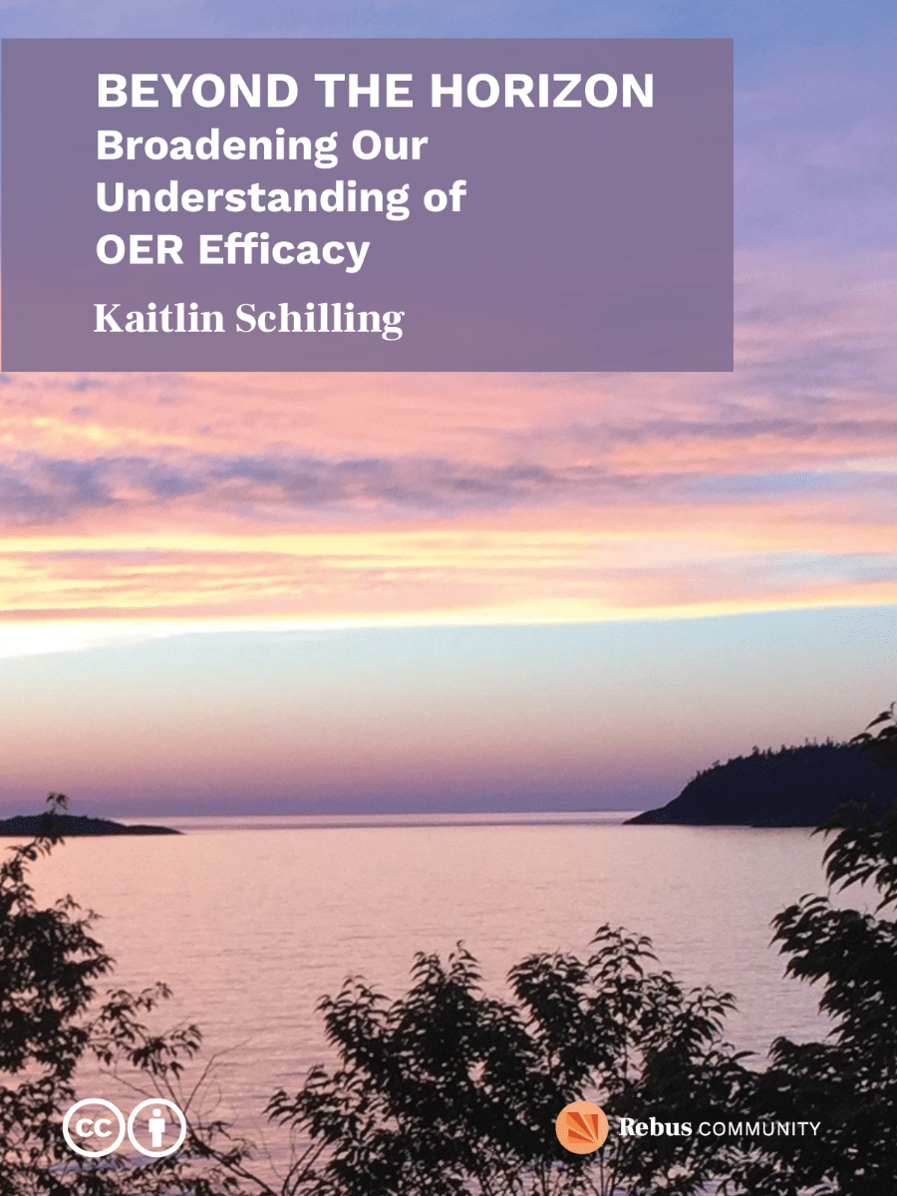

Beyond the Horizon: Broadening Our Understanding of OER Efficacy

Beyond the Horizon: Broadening Our Understanding of OER Efficacy

Kaitlin Schilling
Rebus Community

Beyond the Horizon: Broadening Our Understanding of OER Efficacy Copyright © 2023 by Rebus Community (Kaitlin Schilling, Apurva Ashok) is licensed under a Creative Commons Attribution 4.0 International License, except where otherwise noted.
The CC licence permits you to retain, reuse, copy, redistribute, and revise this book—in whole or in part—for free providing the author is attributed as follows:
by Rebus Community (Kaitlin Schilling, Apurva Ashok), and is used under a
license.
If you redistribute all or part of this book, it is recommended the following statement be added to the copyright page so readers can access the original book at no cost:
Download this guide for free from the
.
This textbook can be referenced. In APA citation style, it should appear as follows:
Rebus Community (Kaitlin Schilling, Apurva Ashok). (2023)
. Rebus Community.

Contents
- Acknowledgments
- A Note on the Cover
- Introduction
- OER Landscape
- OER Efficacy Frameworks
- Observations and Analysis
- Looking Beyond: Landscape
- Opportunities in OER Efficacy
- Principles and Recommendations
- Customize Adapt
- Connect Organize
- Equity Social Justice
- Multifaceted Versatile
- Share Your Stories
- Looking Beyond: Opportunities
- Looking Beyond the Horizon
- Appendix: Approaching OER Efficacy with Equity in Mind Activity
- References
- Feedback and Suggestions
- Version History
- Licensing Attribution Statement
- Accessibility Assessment

1

Acknowledgments
Beyond the Horizon: Broadening our Understanding of OER Efficacy was produced by the Rebus Community, an initiative of The Rebus Foundation.
The Rebus Foundation is a non-profit organization that helps educational institutions build human capacity in OER publishing through professional development. Through our work at Rebus, we aim to cultivate an emerging generation of OER leaders, increase the representation of many academic perspectives, and prioritize student learning and experience in order to increase equity in education. We think an engaged community is the most powerful tool in open education, and we’ve witnessed the impact of bringing creators together under a common framework of support.
Rebus is supported by generous funding from the William and Flora Hewlett Foundation, a leader in philanthropic support for education, environment, and global development. We are deeply thankful for The Hewlett Foundation’s support in our work and vision.
What you are about to read is a small synthesis of some equitable practices around OER efficacy reporting. It is unmistakably not the creation of a single person, but rather a collection of stories and insights from my experience in open education. Who is cited and quoted in this guide has been chosen with great care and thought.
Many thanks to all participants, facilitators, and partners in the Textbook Success Program cohorts in Louisiana (in the Interactive OER for Dual Enrollment project) and Massachusetts (via the Remixing Open Textbooks through an Equity Lens grant), whose contributions, ideas, and insights shaped and inspired this Guide.
Special thanks to Virginia Clinton-Lisell, whose invaluable expertise, guidance, and insights were instrumental in the creation of this resource. We appreciate your knowledge sharing and support of this project.

2

A Note on the Cover

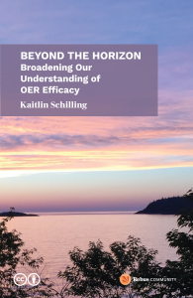

Beyond the Horizon: Broadening the Impact of Open Educational Resources (OER) attempts to capture the idea of exploring the expanded potential and influence of OER. It suggests a focus on how OER can reach beyond traditional boundaries and make a significant impact in education. Presently, the majority of materials published around OER efficacy are either scholarly journals, research articles, or geared towards institutions and administrators. This practical guidebook zooms into how creators can be mindful of OER efficacy throughout the creation process, as well as how to measure impact.



The rationale behind the cover choices for Rebus’ guidebooks is to symbolically represent the core themes and concepts discussed within each publication. The front cover image in Figure 1 features a photograph I took just outside of Wawa, Ontario, Canada. It is a west-facing image of Lake Superior during sunrise. The sky has purple, pink, yellow, and blue hues that reflect onto the open water. In the foreground of the image are shore-lined trees that surround the Great Lake.
In the case of the Rebus Guide to Publishing Open Textbooks (So Far), Figure 2, the image of a tree-lined road is chosen. Just as trees provide a stable and grounded environment, the guide aims to offer a reliable and comprehensive resource for individuals involved in open textbook publishing. The tree-lined road symbolizes the journey and progression towards open textbook creation, emphasizing the importance of a strong foundation.
On the other hand, the cover of Making Ripples: A Guidebook to Challenge Status Quo in OER Creation, Figure 3, features an image of a puddle with ripples caused by the rain. The purpose of this choice is to capture the fluidity and impact of water. Water, in this context, represents life and the transformative power of Open Educational Resources (OER). The image suggests that by challenging the status quo in OER creation, one can create ripples of change that have a far-reaching impact. Additionally, the metaphor of a puddle signifies the potential for growth and expansion, indicating that small actions can lead to significant effects.

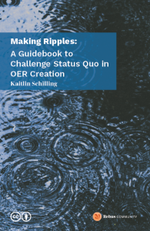

The reference to the horizon here further reinforces the symbolic interpretation. The horizon represents the line separating the Earth from the sky, where the known and unknown meet. There are multiple types of horizons. A true horizon is one where it’s completely flat – you can see everything, and that’s usually attached to water. So when you think about the water in the series of Guides being representative of equity, if you have an equity lens, you have a clearer visual of the horizon. By looking at the impact of OER through a DEI (Diversity, Equity, and Inclusion) lens, one can gain a clearer picture of the horizon. This perspective suggests that considering DEI in measuring the impact of OER allows for a broader and more comprehensive understanding of its effects. The analogy of beaches as the best vantage points for viewing the unobstructed horizon illustrates that by looking at the impact of OER through a DEI lens, one can have a more complete and unbiased assessment.
In summary, the cover choices and the associated rationale aim to visually represent the fundamental concepts and themes of each guidebook. The tree-lined road signifies a solid foundation for open textbook publishing, while the puddle and horizon symbolize the fluidity, transformative power, and broad perspective of OER creation when approached with an equity lens.

Media Attributions
- Beyond the Horizon Cover © Kaitlin Schilling is licensed under a CC BY (Attribution) license
- The Rebus Guide to Publishing Open Textbooks (So Far) Cover © Apurva Ashok is licensed under a CC BY (Attribution) license
- Making Ripples: A Guidebook to Challenge Status Quo in OER Creation Cover © Kaitlin Schilling is licensed under a CC BY (Attribution) license

3

Introduction
We know some of the benefits of creating and using OER: student savings and adaptability. But are there some other ways to measure impact and efficacy? What does this look like for OER creators? How does equity fit into these frameworks for assessing OER impact?
A lot of materials out there for OER efficacy are either scholarly journals, research articles, or geared towards institutions and administrators. This practical guidebook zooms into how creators can be mindful of OER efficacy throughout the creation process, as well as how to measure impact.

Laying Common Ground: Defining Key Terms
Before we begin, it’s important to first define what we mean when we are talking about OER efficacy. First, let’s start with OER. Overall what we’ve seen in research is that a big challenge of looking at the efficacy of OER is an inconsistency in definition and an inconsistency in how we measure impact.
OER efficacy refers to the effectiveness of OER in achieving their intended educational goals.
The Hewlett Foundation defines OER as “teaching, learning, and research materials that are either (a) in the public domain or (b) licensed in a manner that provides everyone with free and perpetual permission to engage in the 5R activities– retaining, remixing, revising, reusing and redistributing the resources.” Open educational resources can be entire courses, a small subset of course materials such as modules, textbooks, streaming videos, tests, software, or could refer to any other tools, materials, or techniques used to support access to knowledge.
UNESCO has a similar definition. “Open Educational Resources (OER) are learning, teaching, and research materials in any format and medium that reside in the public domain or are under copyright that have been released under an open license, that permit no-cost access, re-use, re-purpose, adaptation and redistribution by others.”
Pearson defines efficacy as having “a measurable impact on learners’ lives.”
As a result, OER efficacy refers to the effectiveness of OER in achieving their intended educational goals.

How do you define and measure the efficacy of Open Educational Resources (OER)? How do our definitions of goals also inform the design process? How does considering our goals beforehand impact the design outcome?

Broadening our Understanding of OER Efficacy
When we think about the efficacy of OER, our minds tend to immediately think of student savings – that is, how much money students save on textbooks by using OER over traditional textbooks.
Rebecca V. Ortiz (2022) notes that “the idea of low cost, or saving money, really is arbitrary” (Ortiz) because “those price tags may be irrelevant for those who don’t have access to clean water, right, or safe soil. So an important point in looking at open pedagogy helps us step beyond that model of economics that disproportionately impacts students of colour and others marginalized and allows us to step into spaces that allow for the community creation of knowledge and the transmission of that knowledge.”
It’s worth highlighting that our focus in Beyond the Horizon extends beyond DEI. We also delve into establishing objectives, crafting OER to meet these objectives, and subsequently assessing their attainment. OER creation doesn’t occur in isolation. What’s the underlying intent of individual projects? What drives extensive statewide initiatives? OER efficacy involves creating connections between these puzzle pieces.

Guide Roadmap and Goals
In this Guide, we lay out a roadmap on how to plan for, act, and reflect on reporting OER’s impact. In order to get a clear picture of your OER efficacy research, you first must deeply reflect on the purpose of what you’re doing. From there, you’ll begin to understand the story you are trying to tell with your research. Next, you can contemplate how you’ll go about conducting your research and ways you can prevent biases in your research (such as incorporating equitable practices into your research methodology). Finally – and arguably most importantly – you want to think about how this research (whether the findings themselves or the methodologies) can be used to support communities outside of your own classroom, institution, or state system.
Simply said, the goal of this guide is to help broaden your understanding of OER efficacy. With the projects we’ve supported, we’ve spent many months conducting research, developing materials, resolving issues, sharing joys and sorrows, and more – all the while being receptive to their needs and learning from both them and the larger OER community. This guide is our endeavor to distill that wealth of knowledge and experience into a comprehensively documented process. You’re welcome to utilize it wholly or partially, staying as close to it or departing from it as much as you like.

Learning Objectives
After reading this guide, readers will be able to:
- Evaluate how to measure the impact of OER within your own educational institution.
- Discover effective strategies for sharing the impact of OER with the wider open education community or other key stakeholders.
- Gain an understanding of various OER efficacy models implemented across different global regions.
- Find inspiration to envision and implement long-term OER initiatives that can bring lasting benefits to your educational community.
- Identify and address the challenges and opportunities associated with the adoption and usage of OER.

I

OER Landscape
Open Educational Resources (OER) have gained significant traction as a promising approach to education in recent years, with the goal of providing access to quality learning materials while reducing barriers to education. The effectiveness and impact of OER have become an increasingly popular subject in educational research as their usage spreads across platforms and educational institutions around the globe. Examining the themes in OER efficacy studies offer valuable insights into understanding the real advantages and potential negative consequences of using these open resources. We want to explore these issues in order to show the diverse impacts of OER on education, as well as how effective they are in various settings and where they might be improved.
Current measures of impact typically offer a valuable but limited perspective on the effectiveness and significance of OER. While student savings, retention rates, and faculty attitudes toward OER are unquestionably crucial indicators, there is a broader and more complex terrain of impact that deserves investigation. Student satisfaction, perceptions of DEI measures in OER development, labour costs associated with developing, adapting, and implementing OER, and external factors that influence the impact of OER (such as institutional policies, programs, funding, government buy-in, state legislation, etc.) are just a few examples. This widening of the focus can provide insightful information on the multiple benefits and implications of OER.

Learning Objectives
By the end of this section, readers will be able to:
- Summarize key themes and trends in OER efficacy research.
- Critically analyze the benefits and drawbacks of the present OER efficacy research and reporting.
- Propose potential areas for future research in OER efficacy.

1

OER Efficacy Frameworks
To effectively measure the impact of OER, researchers in the field have developed frameworks. We’ll review some of these frameworks in this section to ground the remainder of our conversations in the guide. Three frameworks stood out as most popular: COUP Framework, S3 Framework, and Investment to Impact Framework.

COUP Framework
Bliss, Robinson, Hilton, and Wiley (2013) provide the COUP framework as a model for studying the impact of Open Educational Resources (OER) and open pedagogy in secondary and postsecondary education. COUP stands for:
- Cost – What are the financial impacts for students and other stakeholders of OER adoption?
- Outcomes – How does OER influence student academic performance?
- Usage – In what ways do faculty members, as well as learners use OER?
- Perceptions – What do faculty and students think about, and feel toward, OER?
John Hilton III (2017) offers an excellent overview of some of the studies conducted using the COUP framework, broken down into each category of the framework, in Special Issue: Outcomes of Openness: Empirical Reports on the Implementation of OER. This framework is widely used in the field, as numerous experts observe that the COUP framework highlights four critical aspects in OER research (Clinton, 2019).

S3 Framework
This framework (Wiley, 2020) features three components to evaluate the impact of OER: success, scale, and savings. Wiley offers an explanation of how each component is measured:
- Success: Letter grades are used as the metric/indicator of success in this framework. Wiley suggests taking an average of grades across terms before the OER was introduced compared to after — noting that data from multiple terms would offer a more stable measurement.
- Scale: Wiley explains that scale is determined by counting the number of students enrolled in OER course sections. This includes the total number of students in all sections of courses, such as Intro to Psychology using OER, as well as the number of students in particular portions of such courses.
- Savings: The last element in this framework is savings. Wiley notes that “when calculated accurately, the savings measure takes into account several factors” including diverse pricing of materials and instances of zero spending on course materials. Savings are assessed by comparing the average expenditure of OER users with that of control students.
Three questions that the S3 framework focus on are:
- How much does this innovation improve student success?
- How many students are benefiting from this innovation?
- How much money does this innovation save students?

Investment to Impact Framework
Ebner et al (2022) offer a robust overview of some of the OER impact studies conducted.This includes a study by Jenkins et al. (2020) and their findings which show that OER can improve social justice in higher education.
After a robust literature review, Ebner et al (2022) highlight what they consider “important new insights” around OER impact assessment:
- Diversity in OER purposes in universities
- Invisibility of the re-usage
- Overlooking innovations
- Differences in the OER infrastructure and maturity of the implementation
- Huge methodological variety
- Visualization and presentation of results
Ebner et al (2022) provide a framework for OER impact assessment, based on their research. They note how imperative it is to clearly define OER and distinguish the ways in which OER will be measured. They use UNESCO’s definition of OER (2019). Their framework also clearly connects to open educational practices. Ebner et al. suggest a practical approach to get started: look at existing OER policies or similar strategies for purposes, arguments or aims related to OER. This framework has developed a good argument for helping institutions understand that there’s no one way to measure impact, rather it does show all the aspects people need to think about and need to think within their unique context, whether institutional or geographical. This will support researchers as they’re looking into the specifics of what their institution’s OER should achieve and who is the target audience.

Analysis of Frameworks
We found the S3 Framework and COUP Framework focus too much on the quantitative and looking at impact after the fact, rather than preparing for measuring impact while planning out initiatives. The Investment to Impact Framework provides a more holistic tool for examining the complex and very often context-dependent impact of OER in higher education. Ebner et al. (2022) present this framework, emphasizing the importance of looking at OER efficacy not as an after piece but rather as something that has to be part of the planning as you are setting up your initiative and it has to match your own goals/research and examination for efficacy to their own vision and goals.

2

Observations and Analysis
During our analysis of existing research on the effectiveness of OER, we came across intriguing themes. The following section will delve deeper into the key themes we observed.

Cost-Saving Narrative
One of the main observations from our research for this Guide is how the narrative surrounding OER efficacy is presented – the story of OER efficacy. Storytelling is a pivotal piece of OER efficacy research; how you discuss and describe your work is important, as it informs the decisions you make. As we mention in The Rebus Guide to Publishing Open Textbooks (So Far), “Storytelling is a meaningful tool to help you communicate the people, purpose, and vision of your work. We subscribe to the idea that stories are a series of connections.”
A large chunk of the articles we read tell a story of OER being effective in reducing costs for students, expanding access to materials, and perceptions of OER (both for faculty and students). This is definitely a big win in the broader fight to make education more accessible and affordable. Frameworks that highlight the role of OER in reducing costs to students and institutions sometimes fail to answer the question, “why does this matter?” In other words, what is the next chapter of the cost-savings story? What is the trickle-down impact or the snowball effect? What financial implications will this have over time?
We ask similar questions in The Rebus Guide to Publishing Open Textbooks (So Far): “given the care and thought to bring a student-centered and equity-based approach to OER creation, are there also ways to carry this forward to look at other measures of assessing student “success” beyond grades?” If you complete the narrative with the cost-savings lens, are there other protagonists who can tell the same story in a different voice and offer a more nuanced view?

Outside of student savings, why does the impact of OER matter? What material conditions change once we make the switch to OER? How can you dig deeper to understand the impact of OER?

Lack of Social Justice Lens
Not many articles were found to look at OER’s efficacy with a social justice lens.
Lambert (2018), Colvard et al. (2018), Figlio, Rush, and Yin (2013), and Levy Tila (2022) were some of the few that specifically focused on the impact of open educational resources on student impact.
Levi Tila (2022) noted that by disaggregating data, they found “the educational hardships posed by high textbook prices were even more significant, however, for historically underserved student groups – particularly in regard to stress, (first-day) access, class choice, and academic performance. Thus, the disproportionately negative effect of course material costs on historically underserved students reemphasizes textbook affordability as a redistributive social justice issue.” (pg. 10)

. Are you looking at how OER impacts different demographics (race, disability, gender, socioeconomic status, immigration status, etc.) – why or why not?
If you answered no, what can you do differently to incorporate this practice into your research? (If it’s a knowledge gap, consider seeking collaborations with members of the open community who have knowledge in these areas, in particular lived experience – however, you need to be mindful of labour and knowledge extraction – pay people equitably and uplift their voices rather than taking their knowledge and claiming it as your own.) As pointed out by Jenkins et al. (2018), “such a gap in OER literature not only perpetuates the higher education system’s neglect of historically underserved students, but also overlooks the potential for textbook affordability to promote social justice values.”
In Using open educational resources to promote social justice, Ivory et al. (2022) offer an overview of some of the other social justice gaps outside of affordability and access. They point out that the open education field has been good at addressing access to educational materials, however, diverse participation and representation in OER have lagged behind. In addition, Ivory et al. (2022) make the observation that in the West, it’s common for us to think we possess unique knowledge and, as a result, we sometimes feel compelled to represent others instead of letting them express their own lived experiences and perspectives.

Missing Worldviews
The majority of the frameworks we researched had a decidedly North American focus. While North American studies often look at contexts in the Global North, there is a lot of insight, progress, and inspiration from OER work being done globally (specifically in Africa and Asia) that these studies tend to miss. This is unfortunate, because the expansive worldviews can help us:
- Define OER and OER efficacy more consistently;
- Better understand overlapping challenges and success;
- Create a shared future of OER that decenter whiteness (both in content and practices) and advance equity for all.
The Understanding the Impact of OER: Achievements and Challenges UNESCO report looks at the implementation and usage of OER in several countries around the world, highlighting both challenges and successes. To our surprise, many countries face similar challenges with regards to OER — meaning that shared conversations could lead to better problem-solving.
Data from the surveyed countries indicate that OER is not widely accepted globally. Rather than being properly incorporated into educational systems, OER initiatives are frequently viewed as distinct enterprises. Instead of being a core component of a strategy for developing and using educational materials, OER initiatives frequently take the form of add-ons.
Respondents noted there were several key research questions and issues that need to be explored regarding OER in their country. Suggested areas for further research included categories such as: educational effectiveness, understanding costs and developing viable OER models, policy development and implementation, and improving diversity of OER. Learning more about these different pieces could help paint a fuller picture of OER efficacy in these regions and therefore help us compare themes and patterns across regions.
Considering the worldwide scope of open education, it is essential to connect and engage with international knowledge networks to expand our perspectives on education by examining, questioning, and enhancing them through the unique prisms of diverse cultures, religions, and regions. This helps expand the perspectives provided in educational materials, while allowing students (and educators, more broadly) to be represented in materials.

Are you looking at how OER impacts different regions and ways in which OER efficacy is looked at globally- why or why not?
If you answered no, how might you be able to modify your approach to integrate this methodology into your research?

3

Looking Beyond: Landscape
In the process of examining the themes and patterns that emerged from our research, it became clear that these insights offer us more than just observations; they give us chances to improve. It’s noteworthy that the recurring themes have a very human-centered quality, reinforcing the crucial role of human experience and collaboration within the broader context of open education.
While some studies are beginning to look into factors beyond the traditional success metrics, there is room to move beyond the cost-saving narrative. This entails integrative worldviews into not only OER materials, methodologies, and research but also ensuring that a social justice lens is applied.

II

Opportunities in OER Efficacy
In similar fashion to creating or adapting an OER, measuring the impact of OER requires planning upfront. Embedding impact measuring while in the project design can alleviate a lot of undue burden and frustration. As noted by Ebner, Orr, and Schön (2022), OER efficacy is not an afterthought – it has to be a part of the planning as you are setting up your initiative and it must match your own goals/research and examination for efficacy to their own vision and goals.
When it comes to OER efficacy research, Apurva Ashok asks a powerful question: “What future do we want to build and what questions are we asking to get there?” A good way to start is determining your purpose. Activity 1, located below, is a visual hotspot that lays out some reflection questions to think through while you’re planning your OER initiative.
An interactive H5P element has been excluded from this version of the text. You can view it online here:
https://press.rebus.community/beyond-the-horizon/?p=161#h5p-1

Activity 1: Approaching OER Efficacy with Equity in Mind (Note: If you are not using the online version of
, you can find the Knowledge Check questions and answers in the
.)
The questions presented in this activity aim to inspire you to think deeply about your motivations and methods for assessing the effectiveness of OER. The rationale behind these reflection questions being located here is that now that you have an understanding of the three themes noted in the previous chapter, you can note any obstacles or incentives to investigating efficacy of OER within your specific region. Are you hoping to learn more about how educators and students use OER? Is your aim to delve into the educational impact of OER? Are you interested in exploring ways to fund and sustain your OER initiatives? Do you aspire to gain insights into enhancing and advocating for the diversity of OER initiatives, encompassing both content and participation?
With proper planning and reflection, we can look at OER efficacy with a fresh lens, paying close attention to:
- Measures of impact that go beyond cost-savings
- Research partners and collaborators who can bring in a global perspective
- The narrative of our OER Efficacy that is anchored in equity

Learning Objectives
By the end of this section, readers will be able to:
- Identify and describe the opportunities and benefits of customizing and adapting OER for diverse educational contexts.
- Consider the significance of connecting and organizing within educational ecosystems.
- Articulate the role of equity and social justice in OER efficacy research.

4

Principles and Recommendations

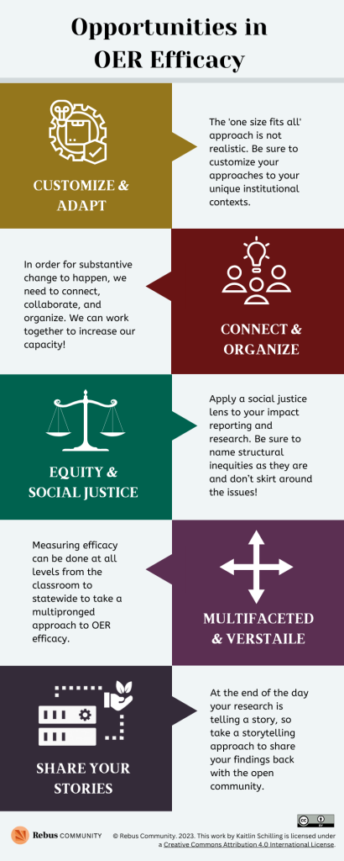

True to the open education ethos, there is no need to reinvent the wheel! The following recommendations are our attempt to distill the overlapping principles we noticed throughout our research.
This list can serve as a primer for anyone designing larger scale initiatives or undertaking OER efficacy research. Our research findings can be grouped into 5 broad principles and recommendations:
- Customize and Adapt
- Connect and Organize
- Equity and Social Justice
- Multifaceted and Versatile
- Share Your Stories
In the following chapters, we will elaborate on each theme and explain how they can help you broaden your perspective, and widen the horizon on your OER efficacy research.

Media Attributions
- Opportunities in OER Efficacy © Kaitlin Schilling is licensed under a CC BY (Attribution) license

5

Customize Adapt
McCoy-Simmons (2022) writes that “a one-size-fits-all approach to OER is infeasible” because many people in higher education still encounter barriers, and these barriers can widely differ between departments, institutions, and states. “For example, while introducing OER policies can be a successful step in implementing OER in one institution, this could be detrimental in another that is less trusting of administration or relies more on a bottom-up approach (Cox Trotter, 2016)” (McCoy-Simmons, 2022).
The customization of approaches to OER efficacy, and OER more generally, was a recurring theme throughout the research conducted to write this guide. The ‘one size fits all’ approach is not realistic. What works for your institution may not work for another institution. Many educators and researchers have dedicated their time to looking at this. Grimaldi et al., notes that the success of intervention “will almost always depend on the context in which it is implemented.” (2019)
Ebner et al. stress the significance of designing evaluation metrics that take into account aspects specific to your OER activities (2022). In order to help clearly define an institution’s OER purpose and goals, they also recommend educators, researchers, and administrators to look at current OER policies and measurements of efficacy. Be sure to customize your research to your own unique institutional context, so that it aligns with your vision and goals. OER advocates should tailor their information to audiences and the decisions those audiences make (Zaback, 2022).

6

Connect Organize
In order for substantive change to happen, you need to connect, collaborate, and organize. Expand your network well beyond your own region – the open education movement is a global movement and we can learn a lot from one another and share our experiences.
A quote we share in Making Ripples: A Guidebook to Challenge Status Quo in OER Creation, is “Individually, we are one drop. Together, we are an ocean.” (Ryunosuke Satoro). As individuals, our ability to substantially change educational systems is constrained by our resources and capacities. However, we can work together to increase our capacity as a whole!
The exciting part is that when we collaborate and combine our strengths, skills, and perspectives, we can dramatically increase our collective capacity. By working together, we can create an agile collaborative effort that enables us to develop multifaceted strategies by utilizing a range of viewpoints, skills, and resources. This coordinated effort enables us to approach the complexities of education from various angles, ultimately resulting in a larger impact.
Examples of this include organizations like SPARC, the Scholarly Publishing and Academic Resources Coalition. While based in North America, SPARC has coalitions in Africa, Europe, and Japan as well as individual member organizations in Australia, Hong Kong, and Saudi Arabia. SPARC utilizes this international network to advocate for policy change, support member action, and cultivate communities whose work examines the ways that colonialism, racism, and other forms of injustice have excluded people and groups in knowledge sharing.

7

Equity Social Justice
While it’s great to have data and conversations about how OER saves students money, at the end of the day, you also want the material conditions for students and communities to improve so they can do better too. Zaback (2022) suggests that focusing solely on student cost savings carries the potential to perpetuate existing inequalities and that it’s “imperative for state and institutional decision-makers to create conditions where students have equitable access to the materials they need to succeed.”
We all live complex lives and as Audre Lorde says, “we do not live single issue lives”, so the idea that focusing on student savings or grades alone will improve the learning experiences of students is a bit of a fallacy. Students can do well in classes and save money thanks to OER, but do they feel safer in classrooms? On campus? In their communities? Hoosen et al. (2019) remind us that “we cannot analyze OER in a vacuum, and we cannot continue to think about, create, and use OER without social justice in mind.” There also has to be a collective effort to shift the narrative of the broader education ecosystem for open education to show its true potential.
The need to apply an equitable lens while conducting research around OER efficacy is incredibly important. With the current legislation in 2023 being passed across many countries globally, it is understandable that there is hesitance and fear of personal safety over taking an equitable stance in many matters including education. That said, it is of utmost importance that educators, especially those with privilege and power, apply an equitable approach to open education as a whole – from program and resource development, to research, pedagogy, and practice. Apply a social justice lens to your impact reporting and research. Be sure to name structural inequities as they are and don’t skirt around the issues!
McDermott (2020) suggests that future OER efficacy studies could incorporate more qualitative data to center students’ voices and that by using an action research approach – a type of methodology that is based on action and reflection and harmonizes well with critical pedagogy approaches – would be a valuable contribution to the existing literature.

8

Multifaceted Versatile
There are multiple ways to measure OER efficacy, from the classroom level to statewide level, resulting in a multipronged approach. Please note that there may be overlap between these various levels, depending on your location or context. These are simply broad categories to help you think about different ways to measure the impact of OER at various levels of education.
How do you assess efficacy on different levels? In a classroom? As someone running an OER initiative? How can you look at efficacy at these different levels while also keeping equity in mind? Similar to above, these broad categories listed below offer some examples for you to look at to get inspiration of the different approaches to measuring OER efficacy from different regions. Depending on your unique context, some of these categories may overlap, such as the OER initiative and state/provincial/territorial levels.

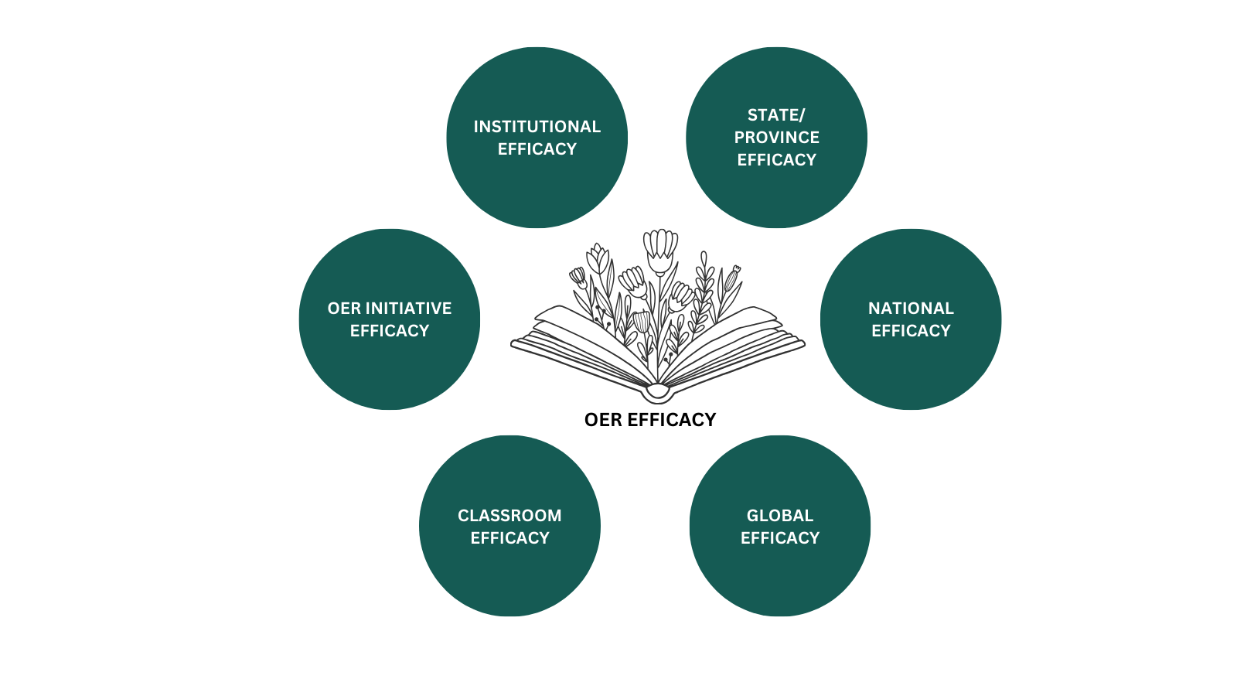

At the classroom level, OER efficacy is measured based on their impact on individual students and educators. Some efficacy indicators may include improved student engagement, student sense of belonging, better learning outcomes, increased educator satisfaction, and cost savings for students.
OER initiatives are organized efforts by educational institutions or organizations to adopt and promote OER adoption. At an OER initiative level, impact can be assessed by tracking the success of specific initiatives, such as increased OER adoption rates, faculty training, and increased resource development.
Institutional efficacy evaluates the impact of OER within a specific educational institution, such as a school, college, or university. Key indicators include cost savings for the institution, student retention rates, faculty buy-in, and changes in institutional policies and practices related to OER.
In some countries, national policies and funding may support the widespread adoption of OER. National-level efficacy focuses on assessing the impact of OER on the country’s education system as a whole, including factors like equity, access, and improved educational outcomes.
Finally, OER can transcend national boundaries, and global initiatives aim to promote the creation and sharing of open educational resources on a global scale. Efficacy at the global level may involve tracking the reach and impact of OER repositories and international collaborations to improve access to education worldwide.

Media Attributions
- Levels of OER Efficacy © Kaitlin Schilling is licensed under a CC BY (Attribution) license

9

Share Your Stories
The majority of research has found that OER not only saves students money, but students are able to access their class materials sooner than traditional textbooks, and there are lower withdrawal rates in postsecondary courses with OER (Clinton Khan, 2019). Levy Tila (2022) make a compelling argument that care needs to be factored into these benefits as well. Drawing from other educational research, they note that “students are more likely to be engaged, participate, and perform better in a course when they feel that their instructor cares about them.” Furthermore, how do we capture this care while reporting OER impact?
Emphasizing the narrative is a way to effectively encapsulate care when reporting on the impact of OER. At the end of the day your research is telling a story, so intentionally/mindfully taking a storytelling approach to share your findings back with the open community can imbue the readers with inspiration, curiosity, motivation, belief, pride, and spurn them to action. In your efficacy research, reports, presentations, you can start by highlighting the unique features of your approach. Much like in the release preparation guidance provided in The Rebus Guide to Publishing Open Textbooks (so far), it’s essential to craft a narrative that delves into the inception of the idea, the nature of the finished work, and the compelling reasons for generating interest. Essentially, what makes your approach and content different from others?
Be sure to highlight the collaboration efforts of the team working with you and offer pathways for people to learn from and grow on your research. While doing so, we encourage you to think deeply and critically about the stories, rules, representation, and ways of knowing in your day to day interactions, as well as your field. In Making Ripples: A Guidebook to Challenge Status Quo in OER Creation we also highlight the importance of sharing back your learning. As Maya Angelou once said, “when you learn, teach. When you get, give.”
By empowering individuals to share their own stories, we construct a mosaic of knowledge, insights, and viewpoints that collectively contribute to a more robust and powerful story landscape. This approach not only enhances our own learning but also fosters greater empathy, understanding, and constructive change within our communities and society as a whole.

10

Looking Beyond: Opportunities
The research conducted for this guide has shed light on the limitations and narrow scope of OER efficacy research to date. This learning serves as a resounding call to action, aimed at motivating educators, administrators, and other stakeholders involved in OER initiatives to contribute significantly to this critical area of study.
It’s abundantly clear that while the existing body of research on OER efficacy has some benefit, we can delve deeper into the impact of OER and leverage this impact to create structural changes in education more broadly.

1

Looking Beyond the Horizon
The horizon leans forward, offering you space to place new steps of change.
— Maya Angelou (1993)
While it is undeniable that open education initiatives have improved education by lowering financial barriers for students and increasing access to learning materials, their true impact and effectiveness can only be fully realized when they are integrated into a larger ecosystem that values openness, collaboration, and learner-centered approaches.
Open education needs not be a niche subset of education, or even limited only to the post-secondary level. Open education, along with open educational practices and open pedagogy, have the potential to play a pivotal role in equitable access to education. As Matt Voigts notes, “OER are becoming increasingly important in the education sector. They have proven their benefits by providing democratic and equitable access to knowledge, supporting lifelong learning and informal learning and offering diversified sources of knowledge.” (UNESCO, 2022)
The horizon is always in relation to a fixed viewpoint, so it’s going to keep moving as that perspective or that viewpoint changes. So for us, as researchers or educators working in this field trying to document OER impact, it’s not just about fixating on one horizon point and saying “we’ve reached this destination.” We need to keep moving forward, adjusting our goals, and consider how much more change, growth, and value we can continue to add through our work. In that sense, we constantly endeavor to aim beyond that horizon.

2

Appendix: Approaching OER Efficacy with Equity in Mind Activity
Note: The following questions are the same questions listed in Activity 1 in Opportunities for OER Efficacy.



Purpose
- What is the purpose of your OER initiative?
- What purpose does collecting data and measuring the effectiveness of OER serve for your unique context? (Are you reporting this back to your institution or funder? Are you using this data to encourage more OER usage?)

Storytelling
- What is the story you are trying to tell? How might you take a humanized approach to telling this story?
- Who is your audience for this story? (Are you presenting this to various audiences? If so, how might your narrative change depending on the audience?)

Practices
- What will you be looking for when looking at this data? What can you look at in addition to cost savings?
- Who will be involved in examining and reporting the efficacy of OER? What are some ways that you include a richer array of voices?

Beyond
- How can you bring back lessons learned from these findings into departmental and institutional conversations? Can these findings be used to support communities outside of the classroom/institution?
- What does the horizon of OER impact look like for you?

Media Attributions
- Beyond Horizon Graphic © Kaitlin Schilling is licensed under a CC BY (Attribution) license

3

References
Bliss, T., Robinson, T. J., Hilton, J., Wiley, D. A. (2013). An OER coup: College teacher and student perceptions of open educational resources. Journal of Interactive Media in Education, 2013(1), 4. https://doi.org/10.5334/2013-04
Clinton, V. (2019). Cost, outcomes, use, and perceptions of open educational resources in psychology: A narrative review of the literature. Psychology Learning Teaching, 18(1), 4-20. https://journals.sagepub.com/doi/pdf/10.1177/1475725718799511
Clinton-Lisell, V. (2022). How does OER efficacy vary based on student age and course modality? A multi-institutional analysis. American Journal of Distance Education, 1–17. https://doi.org/10.1080/08923647.2022.2077061
Ebner, M., Orr, D. Schön, S. (2022). OER Impact Assessment: A framework for higher education institutions and beyond. Approaches to assess the impact of Open Educational Resources. Open Education Studies, 4(1), 296-309. https://doi.org/10.1515/edu-2022-0018
Grimaldi, P. J., Basu Mallick, D., Waters, A. E., Baraniuk, R. G. (2019). Do open educational resources improve student learning? Implications of the access hypothesis. PloS one, 14(3), e0212508.
Herbert, M. J., Clinton-Lisell, V., Stupnisky, R. H. (2022). Faculty motivation for OER Textbook Adoption and future use. Innovative Higher Education, 48(2), 371–388. https://doi.org/10.1007/s10755-022-09625-6
Hoosen, S., Butcher, N., OER, A. (2019). Understanding the impact of OER: Achievements and challenges. UNESCO Institute for Information Technologies in Education: Moscow, Russia. https://iite.unesco.org/publications/understanding-the-impact-of-oer-achievements-and-challenges/
Howard, V. J., Whitmore, C. B. (2020). Evaluating student perceptions of open and commercial psychology textbooks. Frontiers in Education, 5. https://doi.org/10.3389/feduc.2020.00139
Ivory, C. J. Pashia, A. (Eds.). (2022). Using open educational resources to promote social justice. Association of College and Research Libraries. Retrieved from https://www.ala.org/acrl/sites/ala.org.acrl/files/content/publications/booksanddigitalresources/digital/9780838936771_OA.pdf
Korstange R., LaMagna M., V. Ortiz R. (2022, December 12). Measuring the impact of open education [Conference presentation]. OEGlobal Conference, Nantes, France. https://youtu.be/8EN8bs6gxak
Levy, D. Tila, D. (2022). An overlooked benefit of OER: Showing students we care. International Journal of Research in Education, Humanities, and Commerce, 3(3). Retrieved from https://ijrehc.com/doc/ijrehc03_41.pdf.
McDermott, I. (2020). Open to what? A critical evaluation of OER efficacy studies. https://www.inthelibrarywiththeleadpipe.org/2020/open-to-what/
Nusbaum, A. T. (2020). Who gets to wield academic mjolnir?: On worthiness, knowledge curation, and using the power of the people to diversify OER. Journal of Interactive Media in Education, 2020(1). https://doi.org/10.5334/jime.559
UNESCO. (2022, October 5). Open Educational Resources Dynamic Coalition engages a dialogue on the potential of OER for access to information. UNESCO.org. https://www.unesco.org/en/articles/open-educational-resources-dynamic-coalition-engages-dialogue-potential-oer-access-information?hub=785
Zaback, K. (2022). Toward convergence: Creating clarity to drive more consistency in understanding the benefits and costs of OER. Midwestern Higher Education Compact. https://www.mhec.org/sites/default/files/resources/2022MHECOER-Toward-Convergence.pdf?utm_source=msdynmktgutm_medium=emailutm_campaign=22towardconvergence#msdynttrid=VmvtnKKQChDysdy-aIj7yfOOyxcm8b2-mfmsls0m8hQ

4

Feedback and Suggestions
We are actively and enthusiastically soliciting feedback from instructors, faculty, administrators, OER program managers, librarians, instructional designers, students, and others using this book. If you find any mistakes, issues, or areas for improvement within this guide please fill out our Feedback and Suggestions Form below to let our team know so we can improve this book in the future.

One or more interactive elements has been excluded from this version of the text. You can view them online here: https://press.rebus.community/beyond-the-horizon/?p=32

5

Version History
This page provides a record of edits and changes made to this book since its initial publication. Whenever edits or updates are made in the text, we provide a record and description of those changes here. If the change is minor, the version number increases by 0.1. If the edits involve substantial updates, the edition number increases to the next whole number.
The files posted alongside this book always reflect the most recent version. If you find an error in this book, please let us know in the Feedback Suggestions page.
Version History
Version | Date | Change
1.0 | 21 September, 2023 | Original

6

Licensing & Attribution Statement
This book is licensed under a Creative Commons Attribution 4.0 International license except where otherwise noted.
This license allows for reuse, adaptation, remixing, and redistribution of content, so long as you attribute it to the original authors, indicate if changes are made, and link to the original, free content, found at https://press.rebus.community/beyond-the-horizon/

Please credit us as follows:
The CC licence permits you to retain, reuse, copy, redistribute, and revise this book—in whole or in part—for free providing the author is attributed as follows:
by Rebus Community (Kaitlin Schilling, Apurva Ashok), and is used under a
license.
If you redistribute all or part of this book, it is recommended the following statement be added to the copyright page so readers can access the original book at no cost:
Download this guide for free from the
.
This textbook can be referenced. In APA citation style, it should appear as follows:
Rebus Community (Kaitlin Schilling, Apurva Ashok). (2023)
. Rebus Community.

7

Accessibility Assessment

A note from the Rebus Community
We are working to create a new, collaborative model for publishing open textbooks. Critical to our success in reaching this goal is to ensure that all books produced using that model meet the needs of all those who will one day use them. To us, open means inclusive, so for a book to be open, it must also be accessible.
As a result, we are working with accessibility experts and others in the OER community to develop best practices for creating accessible open textbooks, and are building those practices into the Rebus model of publishing. By doing this, we hope to ensure that all books produced using the Rebus Community are accessible by default, and require an absolute minimum of remediation or adaptation to meet any individual reader’s needs.
While we work on developing guidelines and implementing support for authoring accessible content, we are making a good faith effort to ensure that books produced with our support meet accessibility standards wherever possible, and to highlight areas where we know there is work to do. It is our hope that by being transparent on our current books, we can begin the process of making sure that accessibility is top of mind for all authors, adopters, students, and contributors of all kinds on all our open textbook projects.
Below is a short assessment of eight key areas that have been assessed during the production process. The checklist has been drawn from the BCcampus Open Education Accessibility Toolkit. While a checklist such as this is just one part of a holistic approach to accessibility, it is one way to begin our work on embedded good accessibility practices in the books we support. Wherever possible, we have identified ways in which anyone may contribute their expertise to improve the accessibility of this text.
We also welcome any feedback from anyone who encounters the book and identifies an issue that needs resolving. This book is an ongoing project and will be updated as needed. Although there are currently no known accessibility issues in this directory, we do link to external resources within it, and we cannot guarantee that the resources we are linking to conform to accessibility guidelines. If you encounter an accessibility barrier or would like to submit a correction or suggestion, please do so using the Rebus Community Accessibility Suggestions form.

Accessibility Checklist
Checklist for Accessibility in Webbook
Area of Focus | Requirements | Pass?
Organizing Content | Content is organized under headings and subheadings | Yes
Organizing Content | Headings and subheadings are used sequentially (e.g. Heading 1. Heading 2, etc.) as well as logically (if the title if Heading 1 then there should be no other Heading 1 styles as the title is the uppermost level) | Yes
Images | Images that convey information include Alternative Text (alt-text) descriptions of the image’s content or function | Yes
Images | Graphs, charts, and maps also include contextual or supporting details in the text surrounding the image | Yes
Images | Images do not rely on colour to convey information | Yes
Images | Images that are purely decorative contain empty alternative text descriptions. (Descriptive text is unnecessary if the image doesn’t convey contextual content information) | Yes
Tables | Tables include row and column headers | Not Applicable
Tables | Tables include a title or caption | Not Applicable
Tables | Tables do not have merged or split cells | Not Applicable
Tables | Tables have adequate cell padding | Not Applicable
Weblinks | The weblink is meaningful in context, and does not use generic text such as “click here” or “read more” | Yes
Weblinks | Weblinks do not open new windows or tabs | Yes
Weblinks | If weblinks must open in a new window, a textual reference is included in the link information | Not Applicable
Embedded Multimedia | A transcript has been made available for a multimedia resource that includes audio narration or instruction* | Not Applicable
Embedded Multimedia | Captions of all speech content and relevant non-speech content are included in the multimedia resource that includes audio synchronized with a video presentation | Not Applicable
Embedded Multimedia | Audio descriptions of contextual visuals (graphs, charts, etc.) are included in the multimedia resource | Not Applicable
Formulas | Formulas have been created using MathML | Not Applicable
Formulas | Formulas are images with alternative text descriptions, if MathML is not an option | Not Applicable
Font Size | Font size is 12 point or higher for body text | Yes
Font Size | Font size is 9 point for footnotes or endnotes | Yes
Font Size | Font size can be zoomed to 200% | Yes
*Transcript includes:
- Speaker’s name
- All speech content
- Relevant descriptions of speech
- Descriptions of relevant non-speech audio
- Headings and subheadings

Other Formats Available
In addition to the web version, this book is available in a number of file formats, including PDF, EPUB (for eReaders), MOBI (for Kindles), and various editable files. The Digital PDF has passed the Adobe Accessibility Check.

